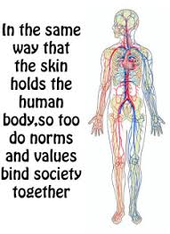

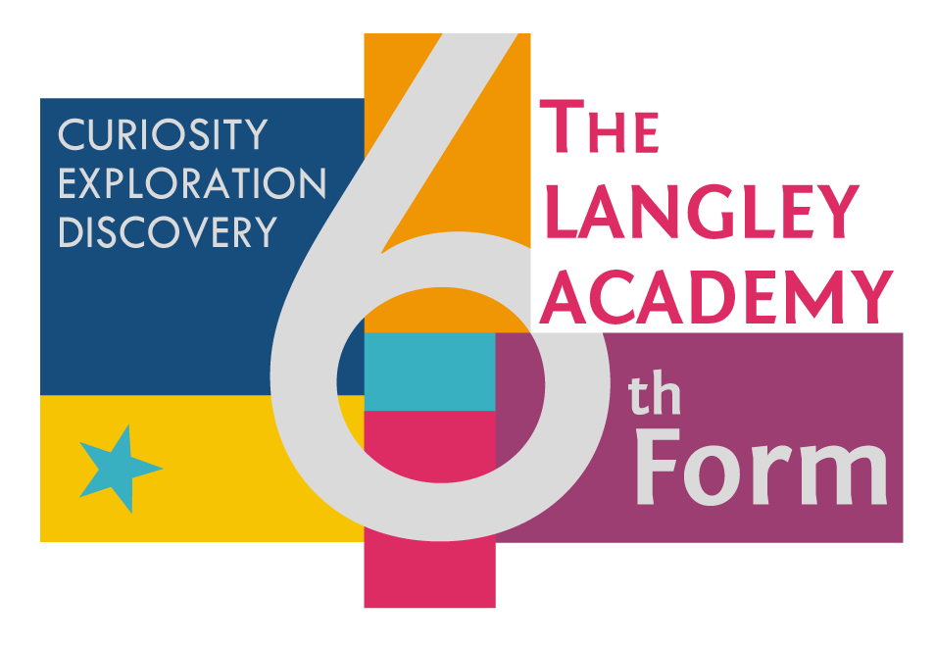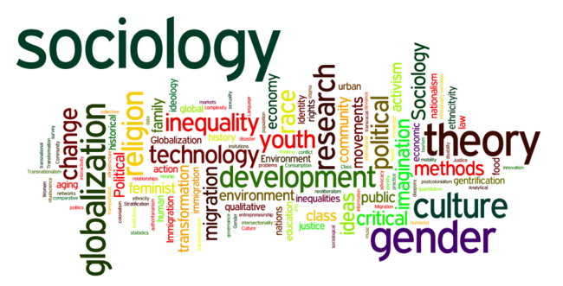

**Subject Transition Booklet**

**Subject: Sociology**

**Teachers: Miss Blackmore and Miss Tank**

**Student Name:**

**Overview of the Programme**

* The exam board which Psychology follows is AQA.
* There is no coursework requirement and you will only be assessed through exams.
* There are three exams you will sit at the end of year 13 which will determine your final grade for the course.
* Details of these papers are below:

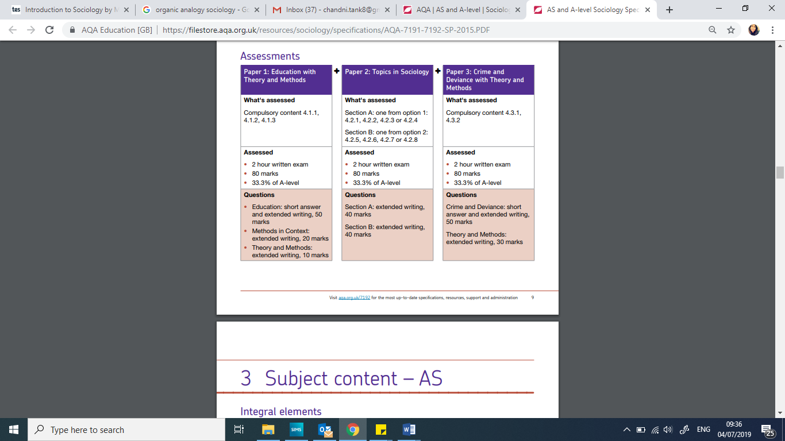**Paper 1: Education**

Education Students are expected to be familiar with sociological explanations of the following content:

• The role and functions of the education system, including its relationship to the economy and to class structure

• Differential educational achievement of social groups by social class, gender and ethnicity in contemporary society

• Relationships and processes within schools, with particular reference to teacher/pupil relationships, pupil identities and subcultures, the hidden curriculum, and the organisation of teaching and learning

• The significance of educational policies, including policies of selection, marketisation and privatisation, and policies to achieve greater equality of opportunity or outcome, for an understanding of the structure, role, impact and experience of and access to education; the impact of globalisation on educational policy

**Methods in Context**

Students must be able to apply sociological research methods to the study of education.

**Theory and Methods**

Students must examine the following areas:

• Quantitative and qualitative methods of research; research design

• Sources of data, including questionnaires, interviews, participant and non-participant observation, experiments, documents and official statistics

• The distinction between primary and secondary data, and between quantitative and qualitative data

• The relationship between positivism, interpretivism and sociological methods; the nature of ‘social facts’

• The theoretical, practical and ethical considerations influencing choice of topic, choice of method(s) and the conduct of research

• Consensus, conflict, structural and social action theories

• The concepts of modernity and post-modernity in relation to sociological theory

• The nature of science and the extent to which Sociology can be regarded as scientific

• The relationship between theory and methods

• Debates about subjectivity, objectivity and value freedom

• The relationship between Sociology and social policy.

**Paper 2: Topics in Sociology**

**We study Families and Households in year 12 and we study Beliefs in Society in OR The Media year 13**

The study of these topics should engage students in theoretical debate while encouraging an active involvement with the research process.

The study should foster a critical awareness of contemporary social processes and change, and draw together the knowledge, understanding and skills learnt in different aspects of the course.

**Families and Households** **– *first year A level***

Students are expected to be familiar with sociological explanations of the following content:

• The relationship of the family to the social structure and social change, with particular reference to the economy and to state policies

• Changing patterns of marriage, cohabitation, separation, divorce, childbearing and the life course, including the sociology of personal life, and the diversity of contemporary family and household structures

• Gender roles, domestic labour and power relationships within the family in contemporary society

• The nature of childhood, and changes in the status of children in the family and society

• Demographic trends in the United Kingdom since 1900: birth rates, death rates, family size, life expectancy, ageing population, and migration and globalisation.

**Beliefs in Society *– second year A level***

Students are expected to be familiar with sociological explanations of the following content:

• Ideology, science and religion, including both Christian and non-Christian religious traditions

• The relationship between social change and social stability, and religious beliefs, practices and organisations

• Religious organisations, including cults, sects, denominations, churches and New Age movements, and their relationship to religious and spiritual belief and practice

• The relationship between different social groups and religious/spiritual organisations and movements, beliefs and practices

• The significance of religion and religiosity in the contemporary world, including the nature and extent of secularisation in a global context, and globalisation and the spread of religions

**The Media**

Students are expected to be familiar with sociological explanations of the following content:

• The new media and their significance for an understanding of the role of the media in contemporary society

• The relationship between ownership and control of the media

• The media, globalisation and popular culture

• The processes of selection and presentation of the content of the news

• Media representations of age, social class, ethnicity, gender, sexuality and disability

• The relationship between the media, their content and presentation, and audiences.

**Paper 3: Crime and Deviance with Theory and Methods**

The study of the topics in this paper should engage students in theoretical debate while encouraging an active involvement with the research process.

The study should foster a critical awareness of contemporary social processes and change, and draw together the knowledge, understanding and skills learnt in different aspects of the course. In their study of this topic, students should examine:

• Topic areas in relation to the two core themes (socialisation, culture and identity; and social differentiation, power and stratification)

• Both the evidence of and the sociological explanations for the content listed in the topic areas below. Throughout, students should be encouraged to use examples drawn from their own experience of small-scale research. Attention should be given to drawing out links with other topics studied in this specification.

**Crime and Deviance**

Students are expected to be familiar with sociological explanations of the following content:

• Crime, deviance, social order and social control

• The social distribution of crime and deviance by ethnicity, gender and social class, including recent patterns and trends in crime

• Globalisation and crime in contemporary society; the media and crime; green crime; human rights and state crimes

• Crime control, surveillance, prevention and punishment, victims, and the role of the criminal justice system and other agencies.

**Theory and Methods**

Students must examine the following areas:

• Quantitative and qualitative methods of research; research design

• Sources of data, including questionnaires, interviews, participant and non-participant observation, experiments, documents and official statistics

• The distinction between primary and secondary data, and between quantitative and qualitative data

• The relationship between positivism, interpretivism and sociological methods; the nature of ‘social facts’

• The theoretical, practical and ethical considerations influencing choice of topic, choice of method(s) and the conduct of research

• Consensus, conflict, structural and social action theories

• The concepts of modernity and post-modernity in relation to sociological theory

• The nature of science and the extent to which Sociology can be regarded as scientific

• The relationship between theory and methods

• Debates about subjectivity, objectivity and value freedom

• The relationship between Sociology and social policy

**Assessment weightings**

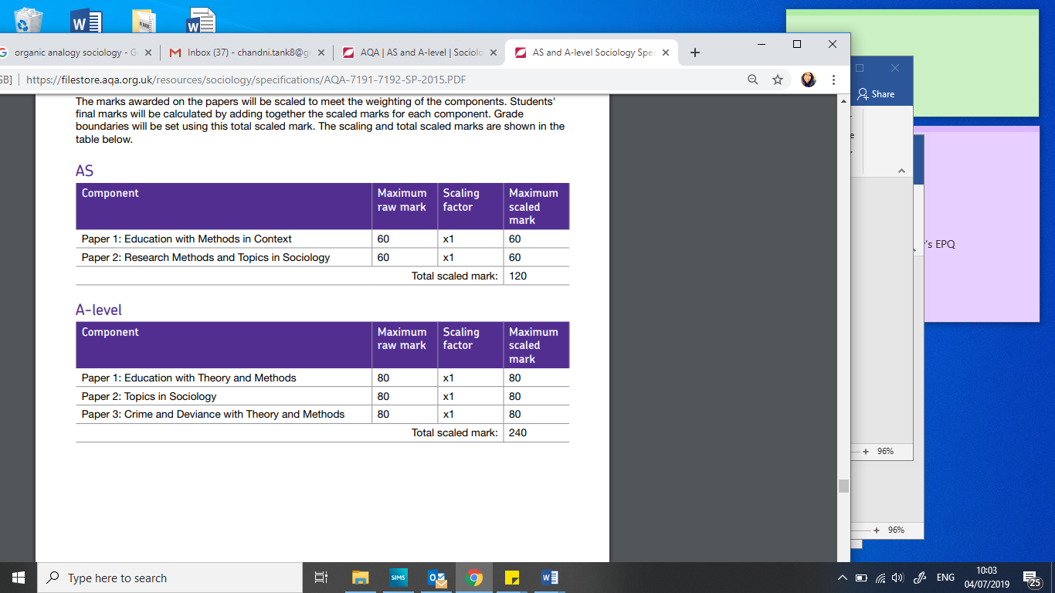

**Textbook(s) for the course**

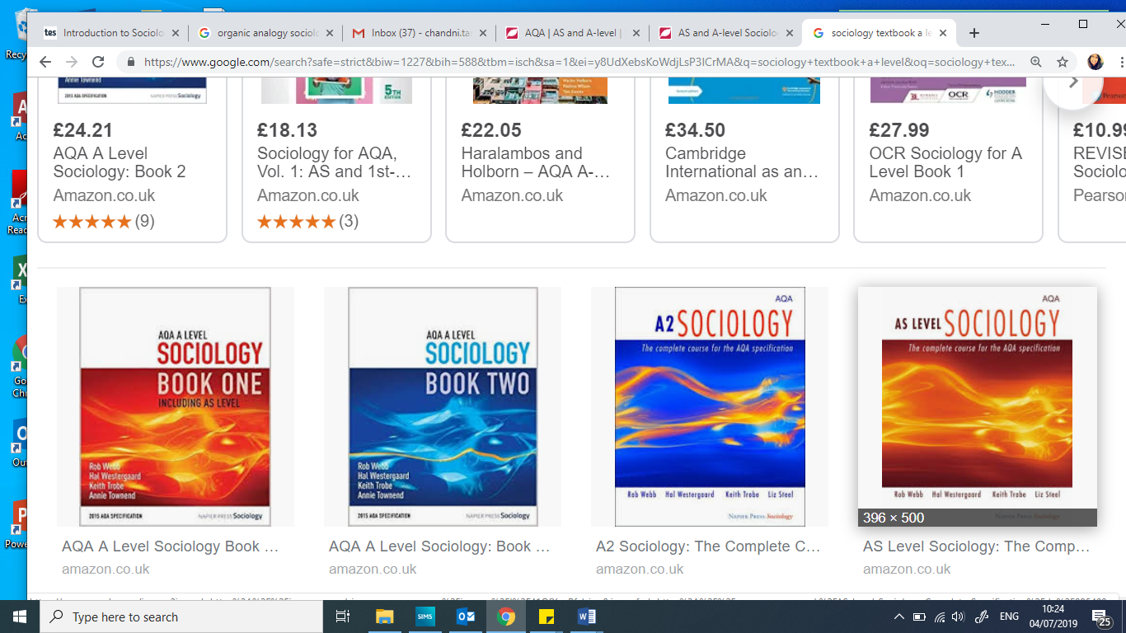

**Suggested reading list**

|  |  |
| --- | --- |
| **Title** | **Author** |
| The Sociological Imagination | C. Wright Mills |
| [Freakonomics: A Rogue Economist Explores the Hidden Side of Everything](https://www.goodreads.com/book/show/1202.Freakonomics) | [Steven D. Levitt](https://www.goodreads.com/author/show/798.Steven_D_Levitt) |
| On Suicide: A study in Sociology | Emile Durkheim |
| Gang Leader for a Day: A Rogue Sociologist Takes to the Streets | [Sudhir Venkatesh](https://www.goodreads.com/author/show/4315245.Sudhir_Venkatesh) |

**Introductory Quiz**

**1. What is Sociology?**

A.  Study of society.

B.  Study of sociopaths.

C. Systematic study of human society and social interaction.

D. Systematic study of sociological perspectives.

**2.** [**What is Capitalism?**](https://www.proprofs.com/discuss/q/1398590/what-is-capitalism-86f)

A. Is the values, beliefs, behavior, and material objects that, together, form a people’s way of life

B. Is the economic system that is directed at earning a profit for a few, selling the profits to many people, and keeping workers wages low in order to increase profits

C. Social cohesion (unity) results from the various parts of society functioning as parts of society functioning as an integrated whole.

D. A theory that uses the concept of gender, class, and race to study and challenge power and inequality

[**3. What is Society?**](https://www.proprofs.com/discuss/q/1068742/what-is-society)

A. Refers to people who interact in a defined territory and share a culture

B. Is the values, beliefs, behavior, and material objects that, together, form a people’s way of life

C. Social cohesion (unity) results from the various parts of society functioning as parts of society functioning as an integrated whole.

D. Culturally defined standards by which people asses desirability, goodness, and beauty and that serve as broad guidelines for social living

**4. What is the Social- conflict approach (Marx)?**

A. Refers to the particular experience of African Americans where in which they are forced to see themselves their status as citizens who are never able to escape identification based on the color of their skin

B. Is the ability to “think ourselves away” from the familiar routine in order to see things from a different, more sociological perspective

C. Says the organization of society (stratifications based on class, ethnicity, gender, age, etc.) and the changes in society can be explained by the conflicts inherent to social relations.

D. Is a theory that focuses on the social structures that shape society as a whole. It sees society as a complex system whose parts work together to maintain stability and to promote solidarity.

**5. What is the Functionalism (Durkheim – Merton)?**

A. Is a theory that focuses on the social structures that shape society as a whole. It sees society as a complex system whose parts work together to maintain stability and to promote solidarity.

B. Is the ability to “think ourselves away” from the familiar routine in order to see things from a different, more sociological perspective

C. says the organization of society (stratifications based on class, ethnicity, gender, age, etc.) and the changes in society can be explained by the conflicts inherent to social relations.

D.  a theory that uses the concept of gender, class, and race to study and challenge power and inequality

**6. Which founding sociologist identified the bourgeoisie and proletariat classes?**

A. Herbert Spencer

B. Karl Marx

C. Emile Durkheim

D. Max Weber

**7. Which is an example of a "master status"?**

A. Woman

B. President

C. College Graduate

D. Elementary School Teacher

**Subject Specific Task**

**Introduction Task: Look at the nature vs nuture debate –**

1. **Task: Nature debate: watch this clip https://www.youtube.com/watch?v=qw3S35wGgT8 JimTwins**

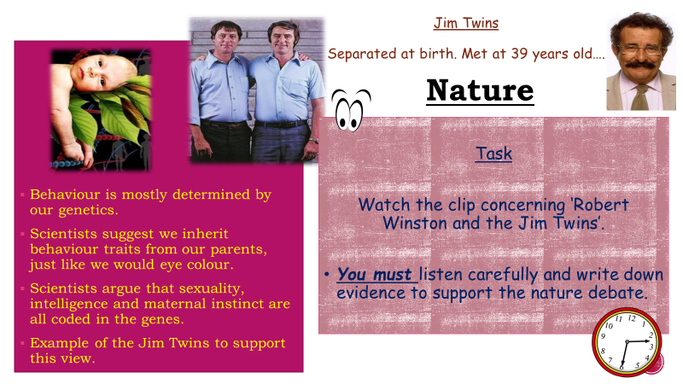

1. **Task: Now watch this nurture debate: https://www.youtube.com/watch?v=cymZq1VblU0**

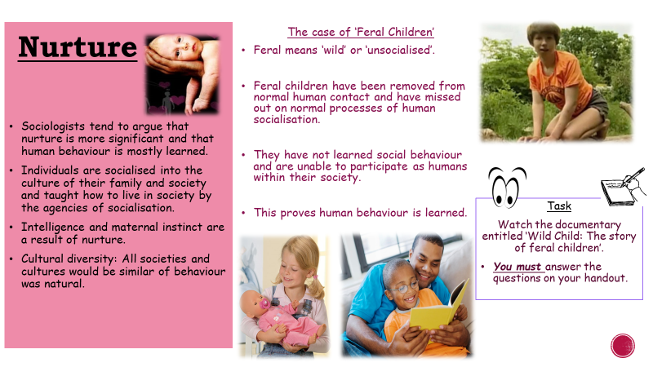

**Answer the following questions:**

**Task:**

1. **Do you think genetic influenced the Jim Twins personality?**
2. **Do you think the case of the Jim Twins is just coincidence?**
3. **What examples of non-human behaviour did Oxana display?**
4. **Why did she not act like a ‘normal’ child?**
5. **Is loving a child natural or learned behaviour? Why?**
6. **Oxana was found ages eight. Do you think she will have been able to learn how to be human?**

**Task: Create a mind up of ideas/research answering the question below**

**Is our behaviour genetic or taught?**

**Wider-world relevance of subject**

*Students will need to find an example of the subject having an impact in real/daily life.*

**Post-18 link**

**Sociology Degrees**

* The best Sociology degree courses at Nottingham; LSE; Cambridge; Briston; Warwick; Durham.
* Often students combine sociology with other subjects at university, this includes; Psychology; Criminology; History; Politics; Anthropology

**Transferable Skills:**

* Public Speaking
* Creative thinking
* Good Writing Skills
* Problem Solving
* Debating
* Effective Arguments

**Careers that lead on from Sociology**

* Guidance Counsellor.
* Teaching
* Working for NGO
* Human Resources (HR) Representative.
* Lawyer.
* Management Consultant.
* Market Research Analyst.
* Media Planner.
* Policy Analyst.
* Public Relations (PR) Specialist.
* Social Worker