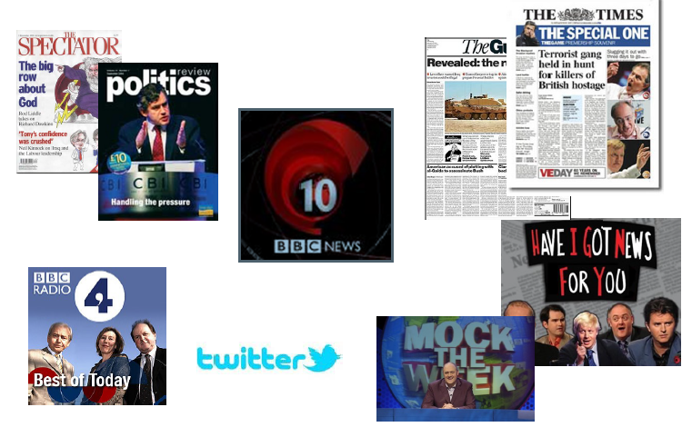

**Politics Transition Booklet**

**Subject:** Politics

**Teachers:** BCH email: brett.chinchen@langleyacademy.org

Student Name and Surname: ___________________________

**Entry Requirements for subject:**

* English Language at Grade 6 minimum.
* Ideally English Literature at Grade 6 as well; this will be important as the source analysis and evaluation necessary for the A Level is SIGNIFICANTLY harder than the GCSE.
* The examinations are all essay based questions and considerable reading and research is therefore required.
* A 5 in GCSE History if History was taken would certainly be a good indication of ability.

**Why Politics**

* Most relevant and current A level you can study
* It is different to any GCSE you have studied
* You will learn how our system of government and politics works, and compare this with that of the USA.
* Universities love it – it shows you are an engaged and critical human being
* We debate and discuss
* Excellent career prospects – it works well with everything
* You will have lots to talk about with your parents and family!
* Politics is a lively, popular subject and A-level politics suits a variety of individuals and their interests.
* A-level politics is the perfect course for those who keep their finger on the pulse of news and current affairs and extends and develops your debating skills when expressing your opinions.

**Is it the right course for me?**

* **Passionate about current affairs** – examiners reward students for contemporary and up to date knowledge.
* **Essay writing ability** – all but one of the questions on the exam paper are between 12 and 30 mark essays. You ideally need to be getting a 6 in GCSE English.
* **Contributions –** politics lessons are built on debate and discussion. It is absolutely vital that you are an individual that feels confident sharing your ideas and opinions.

**What will the course cover and how is it structured?**

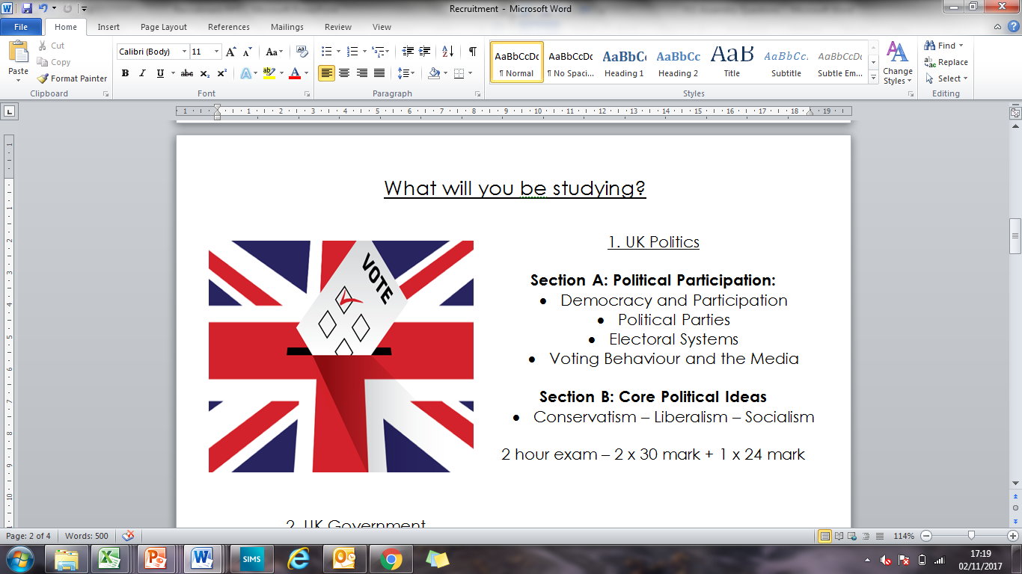

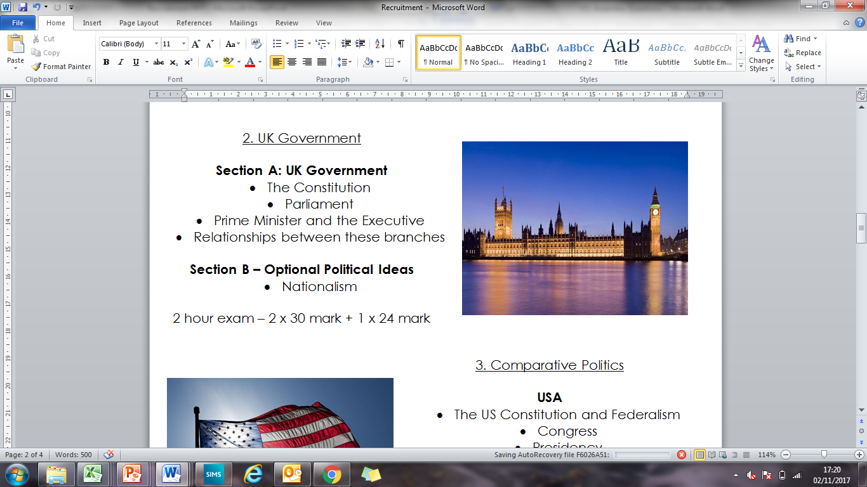

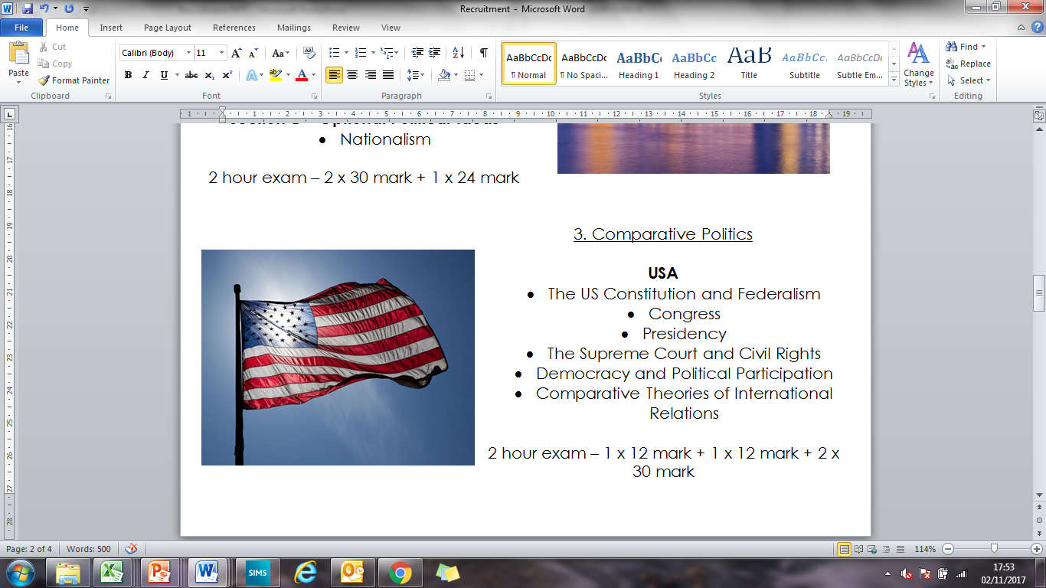

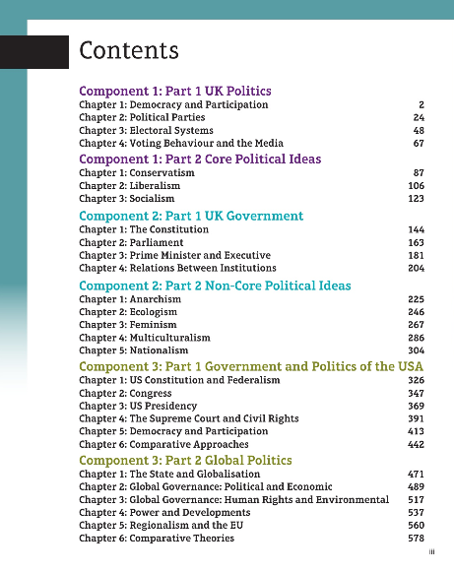

**Key skills needed to be successful on the course:**

* Good work ethic; this course is not easy.
* Critical reasoning and analytical skills, including the capacity for solving problems and thinking creatively.
* Intellectual rigour and independence, including the ability to conduct detailed research
* Ability to construct an argument and communicate findings in a clear and persuasive manner, both orally and in writing.
* Capability to work without direct supervision and manage your time and priorities effectively.
* Ability to discuss ideas in groups, and to negotiate, question and summarise.
* Capacity to think objectively and approach problems and new situations with an open mind.
* Appreciation of the different factors that influence the activities of groups and individuals in society.

**Future pathways:**

Remember that many employers accept qualifications from graduates with any degree subject, so don't restrict your thinking to the jobs listed here. Some politics graduates go on to further study at Masters Level in order to specialise in an area of politics of interest to them. A politics degree opens doors to a broad range of careers, including political work, social and political research, journalism, HR and marketing. For instance: campaigning organisations or pressure groups and UK-based charities with an international presence are particularly suitable if you wish to pursue an international career.

**Jobs directly related to your degree include:**

* Politician
* Academic
* Author
* Civil Service
* Government social research officer
* Politician's assistant
* NGOs
* Public affairs consultant
* Public relations account executive
* Social researcher
* Secondary school teacher
* Management roles
* Academic librarian
* Broadcast journalist
* Charity officer
* Diplomatic Services operational officer
* Forensic accountant
* Human resources officer
* Local government officer
* Market researcher
* Marketing executive
* Newspaper journalist
* Public relations officer
* Stockbroker
* Policy officer
* Solicitor and related Law fields
* Editorial assistant
* Human resources officer

**Transition Tasks**

Enrolment onto the course is subject to completion of this work.

**Task 1: The Political Spectrum**

There are many different political outlooks; one may even be tempted to say that there as many different political outlooks as there are different people. Human beings find it convenient to group objects into categories, and this tendency is displayed just as much in describing political opinion as in any other field. While it may be convenient to name political opinions by the philosophy or ideology that governs them—conservatism, liberalism, socialism, etc.—it is sometimes also useful to have another measure, which allows us to see how these opinions are similar to each other: for example, is a conservative more likely to agree with a socialist or a liberal on any particular issue? You have probably heard people talking about ‘left-wing’ and ‘right wing’ politics. These terms are quite common, yet very few people understand what they mean. Moreover, because these terms are a simplification, they are sometimes not the most accurate way to think about politics. Nonetheless, it is worthwhile to understand what somebody means when they say that a politician is ‘on the left’.

As an introduction which will hopefully build a bit of intuition for these definitions, read each of the statements below. On a piece of paper, write down the number of each statement and whether you strongly agree, somewhat agree, don’t really care, somewhat disagree, or strongly disagree with that statement:

1 Property is theft—everything you own is something that someone else lacks.

2 Tradition and maintaining one’s culture are important political goals.

3 The working class, the poor and the oppressed are in need of special political privilege to compensate for their suffering.

4 The law exists to keep society in order and prevent people lapsing into savagery.

5 The rich and the upper class should share some of their immense wealth with the poor.

6 Law should be based the customs of the people, not on theoretical ideas about what an ideal state might be like.

7 Society would be better if there weren’t any difference between the rich and the poor, if everyone had the same as everyone else.

8 My culture represents the pinnacle of human achievement.

9 The only legitimate power is power wielded by the people, for the people.

10 Rights should not be about morals, but rather about how people can be treated by the law.

11 Human beings are all born with a set of basic rights, which should not be denied to them.

12 Private property is necessary for society to function; if some people have more, it is not anyone’s place to take it away from them.

13 Progress is always possible, but sometimes it needs a revolution or sweeping reform to occur.

14 A man’s home is his castle, and the individual’s wishes are more important than those of the group.

15 All people are equal: not just before the law, but equal in worth and value as well.

16 Some people have more value than others, whether because of their social station or their ability.

17 Nationalism leads to wars; if all the nations on Earth were to join hands in peace and unity, the world would be a better place.

18 Human beings are, on the whole, not perfect or ideal, and the state has to take this into account when forming laws. You cannot fight human nature.

19 The government has the responsibility to look after the poor, through welfare systems, free education, free medicine, etc.

20 There always have been and always will be ‘haves’ and ‘have nots’, and this is necessary; it certainly isn’t wrong.

Now, calculate your ‘score’ as follows (and don’t worry, there is nothing like ‘the higher you score the better’; the point here is just to separate out the various opinions). For each of the odd numbered questions, score –2 if you strongly agree, –1 if you somewhat agree, 0 if you don’t care, 1 if you somewhat disagree, and 2 if you strongly disagree. For each of the even numbered questions it works the other way around, so score –2 if you strongly disagree, –1 if you somewhat disagree, 0 if you don’t care, 1 if you somewhat agree, and 2 if you strongly agree. Add up your score: you should have a number between –40 and 40.

On a scale like the one below, place a mark at the point given by your score (2mm for each score point). Survey a few friends and family, and place (labelled!) marks at the places which represent their political positions.

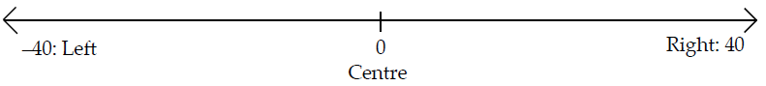

It must be said that this categorisation is not fool-proof, but it does give an indication of the general pattern of beliefs typical of the right, the left, and the centre. In reality, we often find that particular individuals or parties which are very clearly left or right wing may believe only certain of the ideas on the list above; thus, the Conservative Party in the UK, which is ‘right-of-centre’ (i.e. slightly right wing), firmly holds 2, 4, 6 12, and 20 to be important, but is less

stringent on the others, while the Labour Party (a left wing party), thinks 3, 7, 11 and 13 are crucial, but might think, for example, that 1 is going a little bit too far.

It is also possible to find a ‘left’ and ‘right’ wing within individual parties: in other words, not everyone in the party necessarily believes the same way, so the ‘left wing’ of the Labour Party mentioned above may well accept 1, but the ‘right wing’ of the same party may even dispute 11. Similarly, even Lenin declared that some of the Bolsheviks, who insisted on ‘too much socialism’ were too far on the left to be trusted, and wrote a treatise called Left Wing Communism: An Infantile Disorder to discredit them!

The terms ‘left’ and ‘right’ are said to come from the time just before the French Revolution, when the representatives of the ‘third estate’ (the peasants etc.) sat on the King’s left in parliament, while the nobility and clergy sat on his right, so the spatial positions of the parties came to be identified with the opinions they espoused and the arguments they raised.

**Task 2: Core Ideology Essays**

In order to prepare you for Year 12, you are required to complete the following three essays, one on each of the core ideologies you will be studying. This requires independent research and self-tuition.

**Essay 1- Conservatism**

To what extent do conservatives agree that human nature is imperfect? (24 marks) **NB. You must use appropriate thinkers you have studied support your answer.**

|  |  |
| --- | --- |
| **Introduction** | In your introduction define the term in the question and clearly introduce the debate |
| **Para 1** | Use this paragraph to ensure you link your argument to the different stands of conservatism and begin a careful analysis of exactly what is meant by human imperfection |
| **Para 2** | Use this paragraph to develop you understanding of what is human imperfection and how it affects the conservative view of the role of the state and law |
| **Para 3** | Use this paragraph to link human imperfection with other key themes of conservatism, (such as hierarchy, equality, state and individual liberty) but with a close focus on the question. Ensure in this paragraph there is a close focus on ‘to what extent’. You need to explain there is NOT agreement, as New Right conservatives reject the belief in human imperfection. (look at work on Ayn Rand and Bob Nozick for example) |
| **Conclusion** | In your conclusion you need to provide a focused conclusion that reaches a logical judgement based on the arguments made in your essay. |

**Essay 2- Liberalism**

To what extent do liberals believe in equality? (24 marks) **NB. You must use appropriate thinkers you have studied to support your answer.**

|  |  |
| --- | --- |
| **Introduction** | In your introduction provide an excellent definition, explain the debate and YOUR line of argument. Remember although there is *some* agreement overall liberals **do not agree** over equality |
| **Para 1** | Use this paragraph to suggest tensions within liberalism and the principal of equality. Ensure you mention the role of the state, (which is central to the debate). Try to use sophisticated political terminology such as egoistical individualism and atomistic individualism. Ensure that you link to each different type of liberalism AND their approaches to equality |
| **Para 2** | Use this paragraph to have more of an explanation between developmental individualism and equality. Ensure that you link to each different type of liberalism AND their approaches to equality |
| **Para 3** | Use this paragraph link freedom and equality in an analytical way and include thinkers such as J.S. Mill, T. H. Green and Betty Friedan. Ensure that you link to each different type of liberalism AND their approaches to equality |
| **Para 4** | Use this paragraph look at justice and fairness in this paragraph from point of view of both classical and modern liberals **but make an explicit to equality.** Rawls would be a good thinker to mention here. Ensure that you link to each different type of liberalism AND their approaches to equality |
| **Para 5** | Us this paragraph to look at the role of the state according to modern liberals such as Rawls and classic liberals who believe in the free market. Make explicit links back to the question. Ensure that you link to each different type of liberalism AND their approaches to equality |
| **Conclusion** | In your conclusion you need it to be detailed and analytical and one that clearly weighs up the arguments and reaches a judgement |

**Essay 3- Socialism**

To what extent have socialists agreed that the existing state must be destroyed in order to achieve socialism? (24 marks) **NB. You must use appropriate thinkers you have studied support your answer.**

|  |  |
| --- | --- |
| **Introduction** | In your introduction set out your line of argument and explain why the question has been asked-because there is a division within socialist ideology. Ensure you define the terms revolutionary and evolutionary |
| **Para 1** | Focus this paragraph on explaining revolutionary socialism and ensure you keep to the question, use appropriate terminology such as bourgeoisie and class consciousness, ensure relevant thinkers are included |
| **Para 2** | Focus this paragraph on Marx’s scientific theory of why revolutions happen based on the sequence of historical events. Look at how one of Marx’s and Engle’s predicted revolutions came about (Russia) and how it **inspired** other revolutions such as China with Mao and in Cuba with Che Guevara |
| **Para 3** | Focus this paragraph on gradualism, clearly and accurately define it and mention the criticism of each method of achieving socialism. Ensure relevant thinkers are included |
| **Para 4** | Focus this paragraph on how revolutionary socialists argue evolutionary socialism will be a failure. Look at work of Rosa Luxemburg on non-revolutionary socialism and how evolutionary socialists respond to what would happen if a revolution takes place. Ensure you make the key point that during most of the 20th century there was a great division between revolutionary and evolutionary socialism in order to achieve socialist goals. Make sure you link clearly back to the question and include reference to a least one key thinker on each of the two approaches to socialism |
| **Para 5** | Focus this paragraph very clearly on examining how the division in socialism between revolutionary and evolutionary socialism has declined and why. Look at after WW2 and after the collapse of communism in 1989-90. Make the key point that revolutionary socialist ideas are still influential in some parts of the world, there is much less debate over the means of achieving socialism than there was between say 1900-1945**.** |
| **Conclusion** | In your conclusion make sure you answer the question AND give your point of view**.** |

**Task 3: Media Awareness**

To become a good student of Government and Politics you need to be up to date with current affairs. Being able to consider what politicians, political parties and government have been up to will be key to your success? What have they been saying in parliament or on twitter? How this been reported in the media?

Find some examples of sources you can use to keep up to date with current affairs. The task is to keep a log of events you have looked at. You do not require in-depth detail for this. Below is a sample of how you could set this log out. Ideally you should only focus on UK and or US politics.

|  |
| --- |
| **Date:**  **Event and or issue or topic:**  **Politician/s and or Political organisations involved:**  **Brief details of what happened (think significance):**  **View and or bias portrayed in the reporting (think bias, point of view and or message):** |

**Consider the following:**

|  |  |  |  |  |  |  |  |  |  |  |  |  |  |  |  |  |  |  |  |  |  |  |  |  |  |  |  |  |  |  |  |  |  |  |  |  |  |  |  |  |  |  |  |  |  |  |  |  |  |  |  |  |  |  |  |  |  |  |  |  |  |  |  |  |  |  |  |  |  |  |  |  |  |  |  |  |  |  |  |  |  |  |  |  |  |  |  |  |  |  |  |  |  |  |  |  |  |  |  |  |  |  |  |  |  |  |  |  |  |  |  |  |  |  |  |  |  |  |  |  |  |  |  |  |  |  |  |  |  |  |  |  |  |  |  |  |  |  |  |  |  |  |  |  |  |  |  |  |  |  |  |  |  |  |  |  |  |  |  |  |  |  |  |  |  |  |  |  |  |  |  |  |  |  |  |  |  |  |  |  |  |  |  |  |  |  |  |  |  |  |  |  |  |  |  |  |  |  |  |  |  |  |  |  |  |  |  |  |  |  |  |  |  |  |  |  |  |  |  |  |  |  |  |  |  |  |  |  |  |  |  |  |  |  |  |  |  |  |  |  |  |  |  |  |  |  |  |  |  |  |  |  |  |  |  |  |  |  |  |  |  |  |  |  |  |
| --- | --- | --- | --- | --- | --- | --- | --- | --- | --- | --- | --- | --- | --- | --- | --- | --- | --- | --- | --- | --- | --- | --- | --- | --- | --- | --- | --- | --- | --- | --- | --- | --- | --- | --- | --- | --- | --- | --- | --- | --- | --- | --- | --- | --- | --- | --- | --- | --- | --- | --- | --- | --- | --- | --- | --- | --- | --- | --- | --- | --- | --- | --- | --- | --- | --- | --- | --- | --- | --- | --- | --- | --- | --- | --- | --- | --- | --- | --- | --- | --- | --- | --- | --- | --- | --- | --- | --- | --- | --- | --- | --- | --- | --- | --- | --- | --- | --- | --- | --- | --- | --- | --- | --- | --- | --- | --- | --- | --- | --- | --- | --- | --- | --- | --- | --- | --- | --- | --- | --- | --- | --- | --- | --- | --- | --- | --- | --- | --- | --- | --- | --- | --- | --- | --- | --- | --- | --- | --- | --- | --- | --- | --- | --- | --- | --- | --- | --- | --- | --- | --- | --- | --- | --- | --- | --- | --- | --- | --- | --- | --- | --- | --- | --- | --- | --- | --- | --- | --- | --- | --- | --- | --- | --- | --- | --- | --- | --- | --- | --- | --- | --- | --- | --- | --- | --- | --- | --- | --- | --- | --- | --- | --- | --- | --- | --- | --- | --- | --- | --- | --- | --- | --- | --- | --- | --- | --- | --- | --- | --- | --- | --- | --- | --- | --- | --- | --- | --- | --- | --- | --- | --- | --- | --- | --- | --- | --- | --- | --- | --- | --- | --- | --- | --- | --- | --- | --- | --- | --- | --- | --- | --- | --- | --- | --- | --- | --- | --- | --- | --- | --- | --- | --- | --- | --- | --- | --- | --- | --- | --- | --- | --- | --- | --- | --- | --- |
| |  |  |  | | --- | --- | --- | |  |  | **Right media bias** | | **1** | **Breibart News** | **R** | | **2** | **Daily Mail** | **R** | | **3** | **Fox News Opinion** | **R** | | **4** | **National Review** | **R** | | **5** | **Reason** | **R** | | **6** | **New York Post** | **R** | | **7** | **The American Spectator** | **R** | | **8** | **The Daily Caller** | **R** | | **9** | **The Daily Wire** | **R** | | **10** | **The Federalist** | **R** | | **11** | **TheBlaze.com** | **R** | | **12** | **Wall Street Journal - Editorial** | **R** | | **13** | **Washington Examiner** | **R** | | **14** | **Washington Times** | **R** | |  |  |  | |  |  | **Left media bias** | | **1** | **ABC News (Online)** | **L** | | **2** | **AlterNet** | **L** | | **3** | **BuzzFeed News** | **L** | | **4** | **CBS News** | **L** | | **5** | **CNN (Web News)** | **L** | | **6** | **CNN- Editorial** | **L** | | **7** | **Daily Beast** | **L** | | **8** | **Democracy Now** | **L** | | **9** | **HuffPost** | **L** | | **10** | **Mother Jones** | **L** | | **11** | **MSNBC** | **L** | | **12** | **NBC News (Online)** | **L** | | **13** | **New York Times (Online News)** | **L** | | **14** | **New York Times - Opinion** | **L** | | **15** | **NPR Editorial** | **L** | | **16** | **Politico** | **L** | | **17** | **Slate** | **L** | | **18** | **The Atlantic** | **L** | | **19** | **The Economist** | **L** | | **20** | **The Guardian** | **L** | | **21** | **The Intercept** | **L** | | **22** | **The New Yorker** | **L** | | **23** | **Time Magazine** | **L** | | **24** | **Vox** | **L** | | **25** | **Washington Post** | **L** | |  |  | **Centre** | | **1** | **Associated Press** | **C** | | **2** | **BBC News** | **C** | | **3** | **Bloomberg** | **C** | | **4** | **Christian Science Monitor** | **C** | | **5** | **Forbes** | **C** | | **6** | **NPR Online News** | **C** | | **7** | **Reuters** | **C** | | **8** | **The Hill** | **C** | | **9** | **USA Today** | **C** | | **10** | **Wall Street Journal - News** | **C** |        |  | | --- | |  | | **What does a “Left” media bias rating mean?** | | **A Left bias is the most liberal media bias rating on the political spectrum. Some of these sources may be considered "left-wing news."** | | **Sources with a Left media bias rating are most likely to show favor for:** | | Government services (food stamps, social security, Medicare, student-loans, unemployment benefits, healthcare, education, etc.) | | Federal laws to protect consumers and the environment | | Federal laws protecting equal rights | | Tax increases on the wealthy | | Government regulation of corporations | | Keeping abortion legal | | Decreasing military spending and intervention | | A belief that the role of government is to provide for its people, to end suffering and contribute to human prosperity | | A belief that government should prevent wealth from concentrating in the hands of a few | | A belief that all humans have a right to healthcare, housing, clean water, a living wage | | A belief that all people deserve help when they have fallen on hard times | | An embrace of empathy, compassion, and tolerance as guiding values | | A belief in the importance of multiculturalism and representation of diverse cultures and races in media, positions of political power, and corporations | | A rejection of social and economic inequality | | Bans on hate speech, i.e., a belief that words can be violent | | A belief in “live and let live,” i.e, that the government should not intervene just because someone is acting in ways someone else does not approve of, provided they have harmed no one else | | A belief that corporations, if left unregulated, may do harm to workers, society and the environment in the pursuit of profit | | A belief in identity politics, i.e., that some groups of people suffer disproportionately greater amounts in society due to identity characteristics, including race, gender, sexual orientation, or religion | |  | | **What does a “Lean Left” media bias rating mean?** | | A “Lean Left” bias is a moderately liberal rating on the political spectrum. | | Sources with this rating **may moderately** show favour for at least some of the following: | | Government services (food stamps, social security, Medicare, student-loans, unemployment benefits, healthcare, education, etc.) | | Federal laws to protect consumers and the environment | | Federal laws protecting equal rights | | Tax increases on the wealthy | | Government regulation of corporations | | Keeping abortion legal | | Decreasing military spending and intervention | | A belief that the role of government is to provide for its people, to end suffering and contribute to human prosperity | | A belief that government should prevent wealth from concentrating in the hands of a few | | A belief that all humans have a right to healthcare, housing, clean water, a living wage | | A belief that all people deserve help from the state when they have fallen on hard times | | An embrace of empathy, compassion, and tolerance as guiding values | | A belief in the importance of multiculturalism and representation of diverse cultures and races in media, positions of political power, and corporations | | A rejection of social and economic inequality | | Bans on hate speech, i.e., a belief that words can be violent | | A belief in “live and let live,” i.e, that the government should not intervene just because someone is acting in ways someone else does not approve of, provided they have harmed no one else | | A belief that corporations, if left unregulated, may do harm to workers, society and the environment in the pursuit of profit | | A belief in identity politics, i.e., that some groups of people suffer disproportionately greater amounts in society due to identity characteristics, including race, gender, sexual orientation, or religion | | A belief in systemic oppression and a need for the government to step in and rectify the wrongs it has committed (such as Native American genocide, Jim Crow-era laws) | |  | | **What does a "Centre" media bias rating mean?** | | A Centre media bias rating does not necessarily mean a source is unbiased, neutral, perfectly reasonable, or credible. It simply means the source or writer rated does not predictably publish perspectives favouring either end of the political spectrum — conservative or liberal. | | A Centre outlet either doesn't show much bias at all, or its bias leans to the left and right equally at different times. | | **Centre doesn't mean better!** AllSides encourages people to read outlets across the political spectrum. | | A media outlet with a Centre rating may omit important perspectives. A Centre outlet may leave out valid arguments from the left or right. For example, in the 20th century, mainstream Centre media outlets did not prominently cover support for gay marriage. In addition, many issues did not gain coverage in mainstream Centre outlets until post-2014, such as arguments for marijuana legalization, criticism of the War on Drugs, the American opioid epidemic, and criminal justice reform. | | While it may be easy to think that we should only consume media from Centre outlets, All Sides believes Centre is not necessarily the answer. By reading only Centre outlets, we may still encounter bias or omission of important issues and perspectives. For this reason, it is important to consume a balanced news diet. | |  | | **What does a “Lean Right” media bias rating mean?** | | A Lean Right bias is a moderately conservative rating on the political spectrum. | | Sources with this rating **may moderately** show favour for at least some of the following: | | Decreasing government involvement in economic issues | | Decreasing federal regulations in general, giving more power to state laws | | Belief that government should be as small and non-intrusive as possible, leaving individuals to make their own decisions | | Personal responsibility | | Freedom of speech | | Decreasing government spending, except for defence spending | | Decreasing taxes | | Preserving the rights of gun owners | | Belief in the sovereignty of the individual over the collective | | Using military force when it protects American interests | | Maintaining strong border security: ensuring all immigrants enter through a legal process and are properly vetted to make certain they are not violent criminals; preventing illegal immigrants from entering or staying in the country | | Rejection of laws that impose unnecessary burdens on businesses/the economy | | Rejection of entitlements and public funding for private needs (like healthcare) | | Outlawing or restricting abortion | | A belief that government should be as small as possible | | Traditional family values | | Aversion to rapid change; belief that tradition and prevailing norms were developed for a reason and contain wisdom that has been handed down and should be preserved | | Preserving the philosophy and rules enshrined in the U.S. Constitution | | Preserving cultural norms, often as outlined in the Bible, through the use of state laws | | Rejection of identity politics, affirmative action, the “welfare state” | | Balanced government budgets and fiscal conservatism | |  | | **What does a Right media bias rating mean?** | | A Right media bias is the most conservative rating on the political spectrum. Some of these sources or writers may be considered "right-wing news." | | Sources with a Right media bias rating are most likely to show favour for: | | Decreasing government involvement in economic issues | | Decreasing federal regulations in general, giving more power to state laws | | Belief that government should be as small and non-intrusive as possible, leaving individuals to make their own decisions | | Personal responsibility | | Freedom of speech | | Decreasing government spending, except for defence spending | | Decreasing taxes | | Preserving the rights of gun owners | | Belief in the sovereignty of the individual over the collective | | Using military force when it protects American interests | | Maintaining strong border security: ensuring all immigrants enter through a legal process and are properly vetted to make certain they are not violent criminals; preventing illegal immigrants from entering or staying in the country | | Rejection of laws that impose unnecessary burdens on businesses/the economy | | Rejection of entitlements and public funding for private needs (like healthcare) | | Outlawing or restricting abortion | | A belief that government should be as small as possible | | Traditional family values | | Aversion to rapid change; belief that tradition and prevailing norms were developed for a reason and contain wisdom that has been handed down and should be preserved | | Preserving the philosophy and rules enshrined in the U.S. Constitution | | Preserving cultural norms, often as outlined in the Bible, through the use of state laws | | Rejection of identity politics, affirmative action, the “welfare state” | | Balanced government budgets and fiscal conservatism | |  | | **When does AllSides give a source a "Mixed" media bias rating?** | | If the source has a system for aggregating content that is open and transparently designed to show multiple perspectives and the content comes from sources that are left, centre and right, we assign a Mixed bias rating.  See: https://www.allsides.com/media-bias/allsides | |  | |

**Task 4: Suggested Reading**

At a minimum the books required for the course include (do note a number of revision guides are also available and you are expected to read beyond the suggested books below):

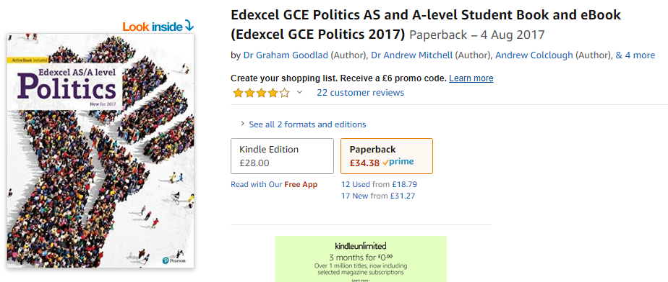

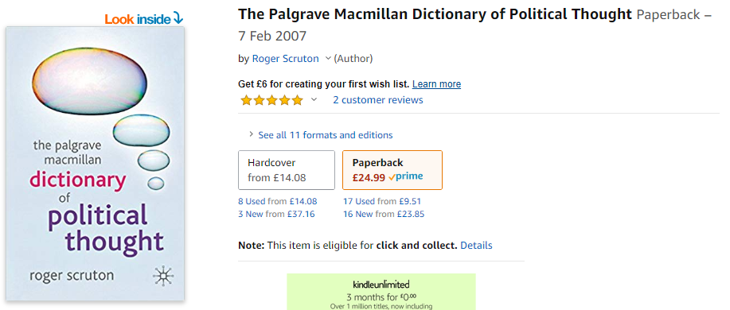

**Please also download and read the Edexcel Specification available here:** <https://qualifications.pearson.com/en/qualifications/edexcel-a-levels/politics-2017.html>

**An excellent source of information for political research relevant to your course is available here:** <https://www.tutor2u.net/politics>

**Please read the following:**

**A Beginner’s Guide to the Politics of the UK**

**Introduction**

This is an attempt to produce an unbiased beginner’s guide to the politics of the United Kingdom. An education in the UK today does little to inform or educate you about politics today, and then you are expected to go out there and make an informed choice on how to vote. This guide is aimed to be an aide to those who are wondering how they should vote or starting to take part in debate. It is not a technical or academic guide and will not meet the requirement of anyone studying Politics at A Level or university, although it may be a good starting point for those new to the subject.

I have not studied politics in an academic setting myself. However, I have encountered it in my studies of history, philosophy and current affairs, inspiring me to look further. Through my participation in debate and my extra research, I have gleaned a good working knowledge of modern politics in Britain. Here I set out that which I have learned, in the hope that you should find it helpful.

In this guide, I discuss the following:

* Political Systems
* The Origins of Democracy
* Development of Democracy in the UK
* The Democratic Ideal, Constitutions and the Separation of Powers
* The UK Constitution
* Parliamentary Democracy in the UK
* The Political Spectrum in the UK
* Political Parties in the UK
* The Current Political Climate in the UK

It is certainly possible to skip sections, but I recommend reading it all in order at least once. However, if you get bored with the first few sections, the stuff you really need to know can be found in the last four sections. All the information that follows is certainly out there, albeit often in biased forms. This guide is intended to be as unbiased as possible.

I try to keep this guide up to date, but politics is a very volatile area, with major incidents and u-turns occurring practically overnight. Although much of what follows often seems very complex, I have simplified it as much as possible. There are some areas (particularly the areas dealing with legal procedures and political structures) where I have made statements which are technically wrong. This is because the truth is so complex it would take a short book to explain it properly. The version which follows is more than sufficient for the majority. In addition to this, there are some areas where I have not gone into much detail. The Welsh Assembly is one such area: it does not directly apply to the majority of those in the UK and thus I have skimmed past it. If you are interested in this or similar areas, the information is out there.

**Political Systems**

Politics is the activities associated with the governance of a country or area. A country can be governed in many different ways: these are the different political systems. The various political systems are known by names derived from classical Greek. The two important stems are –*archy* (from *αρχή* - arche - meaning rule, government, motive or cause ) and –*cracy* (from *κράτος* - kratos - meaning power or strength). Prefixes are applied to these stems to arrive at terms for the different systems of government.

A list of the different political systems and their basic definition follows:

* Anarchy: *rule by none*
* Aristocracy: *literally rule by the best, in effect rule by an upper class*
* Autocracy: *rule by oneself, in effect rule by one person*
* Corporatocracy: *rule by corporations*
* Democracy: *rule by the people*
* Geriocracy: *rule by elders*
* Kleptocracy: *rule by thieves*
* Kritarchy: *rule by judges based on law*
* Krytocracy: *rule by judges based*
* Meritocracy: *rule by the most able*
* Monarchy: *rule by a hereditary autocrat*
* Ochlocracy: *rule by a mob*
* **Oligarchy: *rule by a few***
* Plutocracy: *rule by the wealthiest*
* Technocracy: *rule by those will greatest technical and scientific knowledge*
* Theocracy: *rule by god (via a religious order like a church)*
* Timocracy: *rule by those with honour/property – often a class system*

Some governments will be ruled by a mixture of the above. There are various other terms for systems of government. However, these all fall into at least one of the above categories and can often have extra connotations:

* Dictatorship: *an autocracy or oligarchy, often based on military strength*
* Feudalism: *a timocracy, with a series of castes or tiers in the society based on honour*
* Republic: *Latin for ‘rule by the people’, used to denote a government without a monarch and some form of democracy.*
* Despotism: *the rule by an autocrat where all others are regarded as slaves*

Currently, one of the most prevalent forms of government is *democracy*. This is not necessarily the best form of government. Some say it is the most moral form of government, as everyone has an equal say in the run of their country. However, others say that autocracies are the most efficient or that meritocracies are the most productive. These are only opinions; never assume that democracy being the best form of government is some sort of factual absolute.

Democracy is the most common form of government in the western world, as well as being our own. Therefore the rest of this guide focuses almost exclusively on democracy, its origins and its role in the UK.

**The Origins of Democracy**

Although there are traces of democracy throughout many ancient civilisations and societies, the first major, well-documented rise of democracy was in ancient Greece. Sparta had some of the trappings of democracy, but was actually an oligarchy. Instead it was her rival, Athens, to which democracy is most often traced today.

Athens, a city-state of ancient Greece, was initially an aristocracy. However, after a series of class struggles, an Athenian called Solon introduced some major reforms in 594 BCE. Over time, further reforms were added by Cleisthenes, Ephialtes, and Pericles. The result of these was a direct (otherwise known as ‘pure’) democracy. This was rule by referenda.

The main body of the Athenian democracy was the έκκλεσία (ekklesia), meaning *assembly*. The assembly was the main administrative, judicial and legislative body. All Athenian citizens could sit on this assembly and vote on any matter put before it. Any proposal which achieved 50% of the vote was passed. The assembly convened 4 times a month. Any adult Athenian male citizen could attend. This excluded slaves, children, women and resident foreigners, approximately 90% of the population. No more than 6000 (about 1/5 of those eligible to vote) could sit on the assembly at any one time and for some votes, a minimum of 5000 were required. At some times in Athens history, people were paid to attend. Speakers would speak in favour or against proposals before the vote was performed.

All the proposals put to the Assembly were made by the βουλέ (boule), meaning *council*. Each year, the 10 tribes selected a prytany for themselves. The pritany was formed by 50 male adult citizens of the tribe, who had not served on the council more than once before, selected randomly by the drawing of lots. The ten prytanies then formed the Council. Each prytany supervised the council for one month (there being 10 months in a Greek year) and each day a member of the currently senior prytany was selected by lot to be President of the Council meeting and any Assembly if one were to be called. Not only did the Council put proposals forward for the Assembly, it also greeted foreign delegates and administered the bureaucracy. The Council met every day. As no-one would be able to work whilst serving on the Council, members were paid a living wage.

Almost all other city officials were selected by the random drawing of lots. Like the council members, these were paid a wage by the city. However, the people selected first had to nominate themselves. There were over 500 different administrative jobs, from ensuring that the city drains were kept clean to checking the measurements of traders. A person would serve for one year. After this period he would step down and be investigated. If it was discovered that he had not fulfilled his duties or abused his status, he was open to prosecution. A person could only hold any job once. The only elected officials were the generals and treasurers. It was recognised that for these jobs, skill and experience were vitally important. A person, so long as he was elected each time, could hold these jobs for many years.

Athenian democracy, as one of the major examples of direct democracy, has received much criticism. Because Athenian democracy was the direct rule by the people, it was highly volatile and dependent upon the mood of the people – which was often vindictive. In fact, something of an oligarchy formed. The Assembly was informed on topics and news by professional speakers. These were normally from the upper classes as they could afford to not have a job and an education in public speaking. These oligarchs were not like modern-day politicians but were closer to our media-moguls. They often seized the will of the people, using it against their enemies and manipulating events through their powerful speeches.

As everyone knows, the public mood swings drastically and suddenly. Often it was whipped up into a frenzy. This led to some terrible errors in judgement. For example, an audit was carried out of the Athenian treasury. Money was discovered to be missing. In such cases, the guilty treasurer would normally confess and return the money, after which he would receive a slap on the wrist. However, in this case none of the city’s 10 treasurers would confess to the crime. An angry Assembly immediately voted to have all the treasurers executed. Just before the last treasurer was to be executed, a mistake was discovered to have been made in the audit and the surviving treasurer was set free.

Athens saw many cases like the above, and often made similar mistakes in areas of legislation and foreign policy. Furthermore, many measures which oppressed minority groups in Athens were passed, as they did not have the support in the Assembly to prevent them. This was called ‘tyranny of the majority against the right of the minority’. An example of this is when the Assembly voted to seize the goods (and divide them amongst the other citizens) of a small ethnic minority of citizens and take away their citizenship.

Much is to be learned about our democracy from the study of the different ancient democracies, particularly that of Athens. Many of the mechanisms in our democracy are designed to avoid or counteract the negative things seen in Athens.

**Development of Democracy in the UK**

Democracy as we now know it was developed in the UK. A feudal monarchic system was in place when, in 1215, King John tried to raise taxes. The Lords threatened him with rebellion, forcing him to sign the Magna Carta. By doing this, the king agreed that he couldn’t raise taxes without first getting the permission of a council of Lords. The Magna Carter also said that the King had to obey the law and gave all people certain rights, most notably introducing *Habeas Corpus* - forbidding unlawful imprisonment. Various additions were made to the charter in the following centuries.

The council of Lords gradually grew into a parliament of Lords which the King always consulted. In 1265, the first elected parliament was created. Each county elected a representative to sit on the parliament – in addition to its other members - to advise the king. The elected representatives were called burgesses. However, only those who owned enough land could vote. Therefore, only the landowners – the gentry and others from the aristocracy – could vote. These were all, of course, men. By 1341 Parliament had been separated into two Houses: one including the nobility and higher clergy (the House of Lords, or the Upper House), the other including the knights and burgesses (the House of Commons, or the Lower House), and no law could be made, nor any tax levied, without the consent of both Houses as well as of the Sovereign.

In the early 17th Century King Charles I attempted to over-rule Parliament, dissolved it and ruled alone for 11 years. When civil war broke out in Scotland he desperately required funds to pay the army – funds he could not raise without the consent of a Parliament. Therefore in 1640 he was forced to recall Parliament. However, this Parliament was more hostile towards him than its predecessor, which he had dissolved. It made it illegal for the King to not call a Parliament at least once every three years. Things came to a head in January 1642 when King Charles attempted to have 5 members of the House of Commons arrested on charges of treason. Seven years of civil war between the Royalists and the Parliamentarians followed. The English Civil War ended when General Cromwell of the Parliamentarians finally defeated the Royalists and captured King Charles. He was executed, and both the Monarchy and House of Lords were abolished. After Cromwell's death, the Restoration of 1660 restored the Monarchy and the House of Lords. In 1688 a constitutional Monarchy was introduced by the English Bill of Rights, adding to and reinforcing the Magna Carter.

Following the Treaty of Union in 1707, Acts of Union were passed in both the Parliament of England and the Parliament of Scotland, which created a new Kingdom of Great Britain. The Acts dissolved both parliaments, replacing them with a new Parliament of the Kingdom of Great Britain based in the former home of the English parliament. All the traditions, procedures, and standing orders of the English parliament were retained, which is why we have only examined the English Parliament. If you want to learn more about the Scottish Parliament, you will have to do your own research.

During the 18th century, the balance of power shifted away from the monarch in favour of parliament. Towards the end of the 18th century the monarch still had considerable influence over Parliament, which was dominated by the English aristocracy, but had ceased to exert direct power: for example, the last occasion Royal Assent (the monarch has to agree to every act passed by Parliament or it will not come into effect) was withheld, was in 1708 by Queen Anne. The United Kingdom of Great Britain and Ireland was created in 1801 by the merger of the Kingdom of Great Britain and the Kingdom of Ireland under the Act of Union. Once again, it was the British laws, institutions and practices that remained rather than those of Ireland, so if you wish to know about the Parliament of Ireland, you will have to do your own research.

The principle of ministerial responsibility to the lower House did not develop until the 19th century — the House of Lords was superior to the House of Commons both in theory and in practice. Members of the House of Commons were elected in an antiquated electoral system, under which constituencies of vastly different sizes existed. Thus, the borough of Old Sarum, with seven voters, could elect two members, as could the borough of Dunwich, which had completely disappeared into the sea due to land erosion. In many cases, members of the Upper House also controlled tiny constituencies, known as rotten boroughs, and could ensure the election of their relatives or supporters. Many seats in the House of Commons were "owned" by the Lords. After the reforms of the 19th century, beginning with the Reform Act of 1832, the electoral system in the lower House was much more regularised. No longer dependent on the upper House for their seats, members of the House of Commons began to grow more assertive, but the property requirement (although greatly decreased) to vote remained.

The supremacy of the British House of Commons was established in the early 20th century. In 1909, the Commons passed the so-called "People's Budget", which made numerous changes to the taxation system in a manner detrimental to wealthy landowners. The House of Lords, which consisted mostly of powerful landowners, rejected the Budget. On the basis of the Budget's popularity and the Lords' consequent unpopularity, the Liberal Party narrowly won two general elections in 1910. Using the result as a mandate, the Liberal Prime Minister, Herbert Henry Asquith, introduced the Parliament bill, which sought to restrict the powers of the House of Lords. The Parliament Act 1911, as it became, prevented the Lords from blocking a money bill (a bill dealing with taxation), and allowed them to delay any other bill for a maximum of three sessions (reduced to two sessions in 1949), after which it could become law over their objections. In 1918, all men over 21 and women over 30 (with some property restrictions) were given the vote and in 1928 universal suffrage for all those over the age of 21 was introduced

Further reforms to the House of Lords have been made during the 20th century. In 1958, the Life Peerages Act authorised the regular creation of life peerage dignities. By the 1960s, the regular creation of hereditary peerage dignities had ceased; thereafter, almost all new peers were life peers only. More recently, the House of Lords Act 1999 removed the automatic right of hereditary peers to sit in the Upper House (although it made an exception for 92 of them on a temporary basis). The House of Lords is now a chamber that is subordinate to the House of Commons.

Currently, all British subjects over the age of 18 are eligible to vote in general and public elections.

**The Democratic Ideal, Constitutions and the Separation of Powers**

For the reasons seen whilst looking at ancient Athens, direct democracy is not considered a good form of government in the modern world. The modern aim is to achieve a balance between the power of the government and the power of the people. Giving the government too much power can lead to oppressive dictatorships (such as Nazi Germany) whilst giving the people too much direct power (very frequent elections, referendums etc) can lead to inefficiency and instability.

The current trend is for representative democracy. Periodically elected officials give the population of a country control over the government, but the government is able to moderate the wild impulses of the populace. The job of those elected is to represent the views of their constituents in a parliament, assembly, congress or senate.

A constitution, when applied to a country, is a political system where the rules of principles of the governing body are clearly laid out. Constitutions establish the structure, procedures, duties and powers of a government and often set out the fundamental rights of its citizens. All but three (the UK, Israel and New Zealand) of the states recognised by the UN (over 190) have codified constitutions: a single document setting out the constitution in its entirety.

Codified constitutions are most often born of revolution and social upheaval. Following such struggles, the victors often seek to impose a certain system and set of rules on the country to ensure that the country does not stray away from their vision of how it should be run and to prevent the government from infringing the basic rights of its citizens. Examples of such constitutions are the American and Irish constitutions. In such cultures the constitution is often viewed as the very core of the nation: superior to all other laws – laws which are contradictory to the constitution are automatically struck down. Many countries require special procedures to be followed (such as referendums) before their constitution can be altered (*amended*) in any way. Almost all modern constitutions which outline a democratic system of government are based on the uncodified constitution of the UK, where modern democracy evolved. Codified constitutions have the benefit of being coherent and more easily understood as they are single documents rather than a layering of statutes, case law and conventions.

The *separation of powers* is an important doctrine used to avoid any one organisation, group or individual gaining too much power. This principle however is not fully observed in most modern democracies out of necessity – instead checks and balances are often put in place to prevent abuses of power. The three powers are the *legislature*, the *executive* and the *judiciary*. The first of these is the group which makes the laws of the country; the second is responsible for the daily management of the country, enforcement of the laws and commands the military whilst the third interprets and applies the laws.

**The UK Constitution**

The UK does not have a codified constitution – the current form of representative democracy evolved in the UK over centuries in a mostly peaceful process. Never did someone set out to officially write down all the principles by which the country is run. However, do not make the mistake that so many do of thinking that the UK has no constitution or that this constitution is unwritten: the UK does have a mostly written constitution, even if it is infinitely more complex than those of most other nations. The UK constitution is comprised of every single Act of Parliament, common law, international treaties, conventions and the Royal Prerogative.

Acts of Parliament are laws which have been passed by Parliament. Parliament is formed of three bodies: the House of Commons, the House of Lords and the Sovereign (also known as the monarch or crown). In certain cases, the House of Lords can be bypassed (although this is rare) and the monarch has not withheld their consent for centuries. Some laws are regarded more highly than others. It is argued that the following Acts form the basis of the UK constitution:

* Magna Carta (1215)
* Habeas Corpus Act 1679
* Bill of Rights 1689 - for England and Wales
* Claim of Right 1689 - for Scotland
* Act of Settlement 1701
* Act of Union 1707 - union of the Kingdom of England & the Kingdom of Scotland to form the Kingdom of Great Britain
* Act of Union 1800 - union of Great Britain & Ireland to form the United Kingdom of Great Britain and Ireland
* Reform Act 1832
* Reform Act 1867
* Reform Act 1884
* Parliament Acts (of 1911 and 1949)
* Representation of the People Act 1918
* Government of Ireland Act 1920
* Irish Free State (Agreement) Act 1922, Irish Free State Constitution Act 1922, and Irish Free State (Consequential Provisions) Act 1922
* Royal and Parliamentary Titles Act 1927
* Representation of the People Act 1928
* Statute of Westminster 1931
* Representation of the People Act 1949
* Life Peerages Act 1958
* Representation of the People Act 1969
* European Communities Act 1972
* Northern Ireland Constitution Act 1973
* Human Rights Act 1998
* Scotland Act 1998
* Government of Wales Act 1998
* Northern Ireland Act 1998
* House of Lords Act 1999
* Freedom of Information Act 2000
* Constitutional Reform Act 2005
* Government of Wales Act 2006

Court judgements collectively form what is known as *common* or *case law*. Common law is made by judges. When a case is heard, relevant previous cases will be examined for *precedents* on how the law or laws are to be interpreted and applied. These precedents are binding on all courts of the same or less authority unless they are changed either by the passing of a new Act of Parliament or as a result of a contradictory precedent being made by a higher court. If no precedent applies because the circumstances of the case have not occurred previously, the judge makes a decision, setting a new precedent, which is binding on all courts of equal or less authority in that jurisdiction. Currently the court with greatest authority is the Appellate Committee of the House of Lords but as of 2009 will be the Supreme Court of the United Kingdom.

International treaties do not automatically enter into the UK constitution, but many are incorporated into it. EU treaties and law in particular have great effect on the UK constitution.

Conventions are unwritten procedures or rules that are followed as a result of tradition. They are not enforceable and breaking one of the conventions is not illegal. Some conventions go back for centuries, but others are much more modern. Breaking these conventions do often lead to other difficulties, including criticism from the public. No monarch, for example, has withheld Royal Assent (which would veto any law the Houses wished to pass) since 1708. It is also convention that the Prime Minister does not campaign in by-elections. Mr Blair broke this convention, although Gordon Brown currently seems to be observing it. New conventions also emerge. Only the monarch can make peace and declare war. In the 20th century, this was always after being advised to do so by the Prime Minister. In 2003, Mr Blair put it to a vote in Parliament as to whether he should advise the Queen to declare war on Iraq. If this is done again in the future, it too may become a convention.

The Royal Prerogative is the collective name for the powers of the monarch. These powers are many, and most are exercised by his/her Prime Minister and Cabinet on behalf of the Sovereign or by the Sovereign upon the advice of Prime Minister or Cabinet. These powers can be taken away by Parliament if the Sovereign agrees but no new powers can be created – although they can be modified or ‘reinterpreted’. The powers include:

* The appointment and dismissal of ministers;
* The dissolution of parliament and the calling of elections;
* The granting of clemency and pardon;
* The award of dignities and honours;
* The declaration of war;
* The accreditation of diplomats;
* The negotiation of treaties;
* The declaration of an emergency;
* The grant of Charters of Incorporation;
* The minting of coinage;
* The appointment of bishops and archbishops in the Church of England;
* The expulsion of a foreign national from the United Kingdom;
* The publication of all statutes, legislative instruments and Orders-in-Council; existing and new;
* The power to order a subject not to leave the realm;
* The issue and revocation of passports;
* The exercise of jurisdiction over numerous Royal foundations of all kinds;
* The appointment of Royal Commissions and Officers for any purposes;
* The creation of new universities;

It is the Crown which mounts all criminal prosecutions. From this the monarch gains effective immunity from prosecution, although this has diminished in recent times.

Many constitutions outline the basic rights of the citizens of the state. Until very recently, British citizens had no guaranteed rights as it was assumed that they had the right to do anything not explicitly prohibited. However, these rights were not legally protected and thus any Act passed by Parliament could take away these assumed rights. This changed in 1998 when the Human Rights Act was passed as a result of European treaties and legislation. The constitution outlined above is highly controversial. Some say that it has a wonderful flexibility whilst others argue that it has a dangerous looseness. Over the past 300 years, the case has been made repeatedly for a codified constitution to be made.

**Parliamentary Democracy in the UK**

Just as the UK constitution evolved, so too the various powers discussed earlier, previously wielded solely by the Monarchy, have evolved. However, they are still only weakly separated, so the UK is often referred to as having a ‘fusion of powers’.

Thee main political body of the UK is the House of Commons. Each of the 646 constituencies of the UK elects a representative (a Member of Parliament) to sit in the House of Commons and represent their views. The election of MPs occurs at least every five years in General Elections, which are called by the Prime Minister. Every British citizen over the age of 18 is eligible to vote provided that they are not currently imprisoned for a criminal offence, insane or a member of the House of Lords. Any British citizen eligible to vote may strand for election, so long as they can pay a small fee which covers costs and discourages hoaxes. Most of those who stand are a member of a political party whose ideology they share. Each political party publishes an election manifesto prior to the General Election, outlining its ideology and making promises on what it would do should it win the election. Each party elects its own leader who becomes Prime Minister should they win the election. When a PM steps down, the party elects a new PM without another General Election being called. The party endorses its candidates and provides them with campaign funding. The UK operates on a ‘first past the post system’ so the candidate which receives the plurality (the largest share) of the vote is the one who wins. The leader of the most likely to command a majority in Parliament is asked by the monarch to be their Prime Minister and form a government. This is usually the leader of the party which has the most MPs. There are four *Great Offices of* State. These are the Prime Minister, the Chancellor of the Exchequer, the Foreign Secretary and the Home Secretary, in order of rank. The Prime Minister appoints members of his party to each office. The Chancellor of the Exchequer oversees the treasury and develops the government’s taxation policies, the Home Secretary oversees all affairs within the country (such as policing) and the Foreign Secretary oversees all foreign affairs. The position of Secretary of State for Justice was recently created, and many feel it is becoming the fifth Great Office. The Prime Minister appoints a Cabinet to advise him and the monarch. Those holding the four Great Offices of State are those first appointed to the Cabinet. The Prime Minister also appoints various ministers to oversee the various areas of government, such as education, health and sport.

Those MPs of the government not appointed to such positions sit on the back benches in the House of Commons. Ministers can have their position taken away if they vote against the party line but the ‘back benchers’ cannot really be punished, so it is these who most often mount rebellions on divisive issues. MPs not of the largest party sit on the benches opposite the largest party. The second largest party forms an official opposition and will appoint shadow officials to each government office (for example the Shadow Home Secretary) observe and criticise their counterparts.

There are few major parties in the UK. This is because the ‘first past the post’ system is used. If a party receives 10% of the vote in each constituency, they will not win an election in any constituency and thus will not be represented in Parliament despite having 10% of the country’s support. The advantage of this is system is that each constituency has its own MP: constituents can contact their own MP and if they fail to represent their views in Parliament, the constituents can vote for someone else at the next General Election. In this system, the people vote for their MP who is fully responsible to them rather than his party or the party’s leader (although that will obviously influence their choice). Under proportional representation, the link between MPs and their constituencies are lost but the House of Commons would be a more accurate representation of the people. Proponents of electoral reform often favour a compromise between the two: an ‘additional member’ system.

Local Elections are also held. In these, local councils are elected to oversee local affairs. With the massive improvements in communications in the last century, the powers of local councils have gradually diminished as centralisation increased and the government took more and more control over local affairs. The result is a massive central bureaucracy which is often accused of being ‘out of touch’ and being a hindrance rather than a help. Many feel that local councils should have greater influence over where money is spent in its area. To avoid tax rises, the government has recently been cutting back on the money it gives each local council, forcing local councils to either raise council tax or cut spending on things such as refuse collection.

The government is the executive body of the UK. Although the monarch nominally has command of the military and has the power to declare war, mount criminal prosecutions and so on, these functions are effectively managed by the government in power at the time.

The legislature of the UK is known as Parliament. Parliament is comprised of three entities: the Monarchy, the House of Commons and the House of Lords. No person can occupy a role in more than one of these entities and both the Monarch and the Lords do not vote in elections. Of the three, the House of Commons holds the most real power. Although the monarch is known as the Sovereign and theoretically has extensive powers, Parliament has Sovereignty, meaning that it has ultimate power over all political bodies in the UK. The Monarch is head of the Parliament and as such summons it at the beginning of its term and dissolves it at the end.

Two types of Lord sit in the House of Lords: the Lords Spiritual and the Lords Temporal. The Lords Spiritual are the senior Bishops of the Church of England and The Lords Temporal are members of the Peerage. The House of Lords is currently undergoing reform, but the Lords Temporal are currently either Hereditary or Life Peers. No new Hereditary Peers can be appointed. The superior House is the House of Commons. Members are elected in the manner explained previously.

Either House can propose a Bill (a new law). For the Bill to become an Act of Parliament and enter into law, it must be passed by the House of Commons, the House of Lords and receive Royal Assent. Both Houses can amend a Bill and send it back to the other House to be passed. Although a Bill must be passed by the House of Commons, the House of Lords is not permitted to vote on any Bill dealing with taxation (known as a money Bill) and by convention do not vote against any Bill outlined in the election manifesto of the government. As a result of the Parliament Act, any virtually Bill which has the support of the House of Commons can eventually bypass the House of Lords, so the most the House of Lords can do is delay it. Once the Bill has been passed, it must receive Royal Assent. The Monarch can withhold Royal Assent, vetoing the Bill, but has not done so for 300 years.

Because the government – the executive body – dominates the House of Commons and thus Parliament, it can effectively pass almost any law its members agree with (making back-bencher rebellions one of the things most feared by a government). This is against the doctrine of the separation of powers. However, the judiciary is much more independent and grows more so every year. By convention, the judiciary does not comment on the legislature. When it does, it should only comment on the practicality, necessity and so on of legislation rather than politics. Similarly, military leaders rarely make political statements and when they do they only reflect the military.

As a result of devolution, many regions (including Northern Ireland, Wales, Scotland and Greater London) have their own parliaments or assemblies. These are superior to local councils but inferior to the UK Parliament. Sometimes these bodies are formed of MPs from that region, sometimes they are independently elected. Depending on their powers, they can have legislative, executive and judicial powers. However, due to the variety and complexity of these, they will not be explained here.

**The Political Arena in the UK**

Politics is a matter of sliding scales. On most issue, you can take an *extreme* stance at one end of the scale or the opposite extreme stance at the other. As you become less extreme and approach the area of the scale where most people stand, you become more and more *moderate*. If you stand at this point of the scale, you are *centrist.* You must consider context when the word centrist is used, as different countries have different political climates. For example, a person considered to be left-wing in the USA may well be considered centrist or even right-wing in the UK.

The two most important scales are left-right wing and the libertarian-authoritarian scales. They are often combined to make a graph with the former as the x axis and the latter as the y axis. The first is arguably the most important. It is called the left-right wing scale, so it is often the x-axis on a graph for simplicity. This scale is about economic and social policy. The left tends towards extreme socialism whilst the right tends towards capitalism. Traditionally, economic and social policy have been combined, but Mrs Thatcher famously (and some would say catastrophically) managed to separate the two. Extreme capitalism is based upon the principle of a completely free market – there is no safety net for those who fail and industry and commerce is very loosely regulated, allowing people to deceive you. In this society, anything in the world of business goes – there are no laws or regulations prohibiting false marketing, faulty manufacturing etc. This society is the most productive as a whole, with a few very rich people, the majority being decently well-off and some people in truly terrible poverty. In extreme socialism, everyone earns the same, no matter how intelligent, important or hard-working they are. Commerce is regulated to such an extent that the state actually runs all the businesses and there are no private companies or competition. This removes the emphasis from initiative and working hard etc. This means that as a whole, the economy becomes less productive. There are no very rich people and no very poor people. However, people are worse off than most are in the capitalist system because (with no motivation to do anything) the country is less productive.

Let us view the process of accruing wealth as the process of climbing a ladder. At the top is wealth beyond your wildest dreams. At the bottom is wretched poverty, starvation and so on. Where you start on this ladder will always to some extent depend on your background. If you had a wealthy background, you are going to start higher up. As you climb the ladder, you become wealthier, but climbing the ladder takes a lot of effort and you are competing with everyone else – the ladder is very crowded. You can fall too. You might be able to grab hold of the ladder again lower down or you might fall all the way to the bottom – and the higher you are, the harder you fall. Your motivation to climb is to gain a better lifestyle for you and your family. In a country with an extreme right-wing economic policy, anything goes. You can push people off, tread on their toes – and they can do the same to you. In a more left-wing country, there are more rules and regulations. This may make it safer to climb the ladder, but it can make it more difficult to climb, with all those people in the way you have to be polite too. The amount of control the state exercises over commerce is its economic policy. More recently, social policy has been introduced. With the development of certain technologies, this has become all the more important. Social policy introduces too important things: a minimum starting point and a safety net. The minimum starting point is dictated by the quality of free or subsidised education available. It means that no-one in theory can start lower than a certain point. People can still start higher than this due to private education and greater starting-out money (ie, initial capital) but it does level the playing field a little. The safety net introduces a point below which it is impossible to fall. This safety net is made from free or subsidised public transport, health-care, shelter, leisure facilities and basic amenities as well as benefits such unemployment benefit. Another component of the safety-net is the minimum wage and strong trade-unions. This raises the base living standard of the people at the bottom of society. However, as it becomes higher and higher, more and more people become satisfied with just sitting on the safety net and living on what the state provides. This results in fewer and fewer people climbing the ladder and producing wealth, not only for themselves, but also for the country. If too many are content with sitting on the net, eventually the net becomes unsustainable and snaps. All the people sitting on it fall, and most of those who no longer have the knowledge of how to climb the ladder, especially if this has been going on for generations. Everything goes wrong: recessions occur, people starve and die of exposure.

A left-wing government wants to tax people heavily and with that money provide its services such as transport, healthcare and so on evenly among the population. However what is not even is the proportion of tax, as the rich get taxed more than the poor do, for the same amount of service. Under a right-wing government there is less tax, and services are all owned privately so you pay nothing until you need to use the service, at which point you pay the amount that the service requires. Like for health care, the idea is that you don't get taxed much so you are richer, and with that money you can afford an operation if you ever need one. This way everything is more consistent, nobody gets charged more than anyone else. However, anyone who cannot afford the service is in trouble.

Capitalist societies are the most productive. The average person is better off and there are some very, very rich people. There are also those who are in horrible poverty, literally dying. As you become more moderate, then centrist and finally move into the left-wing, society becomes less productive as a whole and the average living standard decreases. However, no-one is in the terrible conditions seen in the extreme capitalist system. Where you put the safety net is a matter of balance: putting it too low can really hurt people but putting it too high brings the average living conditions down, damages the economy and can lead to stagnation. Where you stand on this scale is a matter of what you think is best for you (if you are selfish), the people (if you are selfless) or for the country (if you are patriotic).

The y-axis is between libertarianism and authoritarianism. Very extreme libertarianism can be a form of anarchism (no-one in control) but pure libertarianism is about the liberty of the individual from interference by the state. Human rights are held in high regard and it is felt that you should be able to do whatsoever you like so long as it does not hurt anyone else. You should be free to consume drugs, commit suicide etc. More moderate liberals often oppose some of these on the basis that suicide hurts the family, drugs hurt any children you might have, etc. As you try to control more and more of these things, you are led towards the authoritarian state. In an extremely authoritarian state, it will control everything you do and think. This may not necessarily be to oppress you, but may be in order to ‘help you’. Authoritarian states have a surveillance culture, secret police and often have laws against ‘thought crimes’.

Many people ask why someone would want an authoritarian state. They assume that this necessarily means secret police and an Orwellian society. This is not always so. A good example is a person’s attitude towards drugs.. The libertarian says that this only affects the person involved, so it should be legal to take drugs. The more authoritarian view (about centre) points out that if the person is pregnant, it could result in a deformed or handicapped child and may cause mental problems for any parent trying to bring up children. Perhaps for the good of the children we should stop him/her from taking drugs. The authoritarian would say that this harms the person, so the state should act in the best interests and use whatever means necessary to prevent them from taking the drug. There are similar examples dealing with euthanasia, child-care and many other issues where a ‘welfare’ or ‘nanny’ state could play a role. Once again, this is a sliding scale, with no concrete answer to the question ‘what is best?’ However, as on the left-right wing scale there is a centre-ground where most modern politics resides.

The two scales outlined above operate completely independent of each other. Taking a certain stance on one does not mean you are bound to take a stance on another. Although, it would seem more natural for right wing governments to be libertarian and left-wing governments to be the opposite, this is by no means the rule. The Nazis were both extremely authoritarian and centrist in the left-right wing scale and the Conservative Party (right wing) used to be quite authoritarian.

The two scales outlined above are not the only scales on which parties have their views, but they are the two main ones. Other issues with sliding scales include:

* The EU: how much of a role should we play in the EU? How much control should we hand over to those not under the authority of the UK Parliament?
* Interventionism: should we directly intervene in other countries to protect our own interests? Or on moral grounds?
* Isolationism / internationalism: to what extent should we involve ourselves in the world? And international politics?
* Immigration: should we adopt open borders? Have a points system like Australia? Start kicking people out?
* Environmental policy: to what extent should we protect the environment? To what cost? Should we still do it if everyone else refuses to?
* Protectionism: should we protect our internal agriculture and industry by putting tariffs on imports? Should we allow free international trade to lower prices when it will increase unemployment when businesses go under because they are being undercut by foreign competition?
* Abortion: is it right or wrong? Should we prevent people from having abortions? Force them to? Or let them make their own decision?
* Nuclear Power: is it a necessary evil? Is it worth the risk?

There are many other issues with similar scales – constitutional reform, the monarchy, GM crops, electoral reform to name but a few. These scales are also largely independent of one another, although some are more closely tied than others. It is extremely unlikely that you will find a party which matches your personal ideology exactly. The idea is to choose a party which you agree with, trust and feel can run the country in a competent manner. Compromise is going to be a necessity.

**Political Parties in the UK**

Much confusion arises from the fact that what parties have traditionally stood for or what they want you to believe about them are often different from what they do now stand for. So I will try to explain both, firstly what the parties stand for in theory and secondly what they stand for in practice.  
  
**In theory**  
  
**Labour** - Economically socialist, they want to raise taxes and use the money to make society more "fair" by giving more welfare and benefits to the poor. By introducing minimum wage laws, by creating the NHS system which means everyone gets "free" health-care, no matter how wealthy they are (of course it's not actually free since we pay taxes - but it means you never get a massive bill in one go.) They nationalise companies in economic trouble to prevent them from collapsing and causing unemployment. In theory on a social level they are fairly liberal. They will not be legalising drugs any time soon but they will not start outlawing homosexuality either. They have always tried to distance themselves from the USSR and the view of socialism as coming hand-in-hand with secret police. The main thing Labour stands for is socialism.

The traditional Labour voter is working class or an idealistic student.  
  
**Conservatives** - Economically right-wing they are pro-capitalism. Also known as the ‘Tories’, they think that if somebody works hard and becomes rich, that is deserved and hence it is wrong to tax them heavily and give their money away to the poor, who have every opportunity to do well but do not because they are too lazy. They are often accused of keeping the rich rich, and the poor poor. They stand for privatisation rather than nationalisation, which results in lower taxes, less government control and again this is seen to be great if you are rich, but terrible if you are poor. Socially the Conservatives are traditionally authoritarian. They stand for a tough attitude on crime and drugs. Traditionally they have also been what we would now see as racist and homophobic (though they were not considered that at the time). This has led to the term ‘right wing’ wrongly being associated with these ideas so parties like the Nazis or BNP are labelled ‘right wing’ when actually they are economically centrist or even left-wing. They were named the ‘Conservative Party’ as they liked to maintain the status quo and were not considered progressive when they were formed. The driving identity of the Conservatives is capitalism.

The traditional Conservative voter is from the aristocracy or professional/middle classes – businessmen, lawyers and doctors, managers etc.

**Liberal democrats** - Economically centrist, they favour of high taxation but would spend more of the money on the NHS, education etc and less on benefits compared to Labour. However unlike the other two parties their main emphasis is more on social aspects than economics. Socially they just happen to be liberal. They would not legalise drugs or euthanasia, but might adopt a softer approach. However they would most certainly oppose ID cards or 42 day detention without trial on the grounds of it breaching our civil liberties. The core ideology of the Liberal Democrats is libertarianism.

The traditional Lib Dem voter is a student from the middle classes.  
  
**The Current Political Climate in the UK**

**Labour** - Economically they have moved away from the left to become centrist which is very much invading the territory of the Lib Dems. This was done because quite frankly, most of the general public is right-wing and Labour kept losing the elections. Now they have become "New Labour" they have also become a lot more popular.

There are still some lefties around in the Labour Party, and they are still pretty left-wing on some issues, like benefits. Many incorrectly feel that labour is now moving into right wing territory. This is not the case: Labour successfully introduced a wide-ranging benefits system decades ago. We are currently one of the most socialist countries in Europe, a good indicator of world politics. The fact that they are introducing few left-wing policies does not mean they have moved into the right wing. They also seem to have become very authoritarian under Gordon Brown at least. In just a year in office he has made cannabis class B rather than C (against the advice of experts), he has introduced 42 day detention without trial. New Labour are also quite pro-ID cards, and just generally are getting more and more authoritarian, as this is what many of their core voters support.

The Labour Party have a small majority  
  
**Conservatives** - Still economically right-wing, but less so than traditionally - which decreases the difference between them and labour when it comes to economics. The Tories desperately want to reduce the benefit system but are scared to do so. Only 60% of the population currently votes. The majority of those who do not vote would traditionally be Labour supporters. However, they have what they want and don’t bother to vote Labour. The Tories fear that if they reduce the benefit system they will trigger a backlash and wake up the core labour-supporters who would oust them at the next election. Socially it is difficult to say: with Labour being more authoritarian than ever, the Conservatives have begun to seem quite liberal and criticise a lot of Labour’s social policies. Whether that is just because they hate Labour and want to oppose what they do, or whether it is because they really are quite liberal these days remains to be seen.

The Conservative Party are the official opposition.

**Liberal Democrats** - Still about the same as in theory because they have never had a chance of winning they don't seem to really change their policies. They stick to the middle ground economically and remain moderately liberal socially.

The Liberal Democrats hold most of the seats not held by the Conservatives or Labour. If they side with the Conservative Party in a vote on legislation, the numbers are enough that they can threaten Labour supremacy should there be even a minor rebellion.

As you can see above, both Labour and the Conservatives are converging on the centre-ground. This is because this is where the swing-vote is. They are betting on managing to keep their core voters whilst persuading the lower-middle classes to vote for them. The Lib Dems are caught in the middle and have nowhere to retreat to. Surprisingly, they are managing to hold their own. However, some of the extremes from both parties are getting annoyed by the migration to the centre and are now looking elsewhere. Neither the Labour nor the Conservative Party is going to retreat from the centre ground until they start haemorrhaging more voters from their extremes than they are gaining from the centre. At this point it will retreat towards its more traditional position in a hope of keeping the voters it has gained from the centre and attracting the deserters back to its ranks.

In the meantime, a number of more extreme fringe parties have developed to serve the needs of those who feel betrayed. There are also new parties appearing with a one-issue only purpose. These do not so much as hope to achieve power as to raise awareness for their cause and pressure the government into adopting some of their policies. Not to be forgotten are the various regional parties which often play a major role for the various devolved assemblies and parliaments. Other parties only play a role in local elections. The best known of these minor parties are:

* Respect is the only minor party to currently have an MP, is left-wing and anti-war.
* The United Kingdom Independence Party has no parliamentary seats but support has greatly increased since the last General Election. It is Euro-sceptic and favours tough immigration policies.
* The British National Party has a racist reputation but, like UKIP, has increasing support from certain groups. It is actually centre-left in economic policy.
* The Green Party has seats in the Greater London Assembly and it focuses on environmental issues.
* The Socialist Workers Party is a splinter from Labour and has since tended to more extreme socialism.
* The Liberal Party is a regional splinter of the Liberal Democrats
* The Scottish National Party has formed a minority government in the Scottish Parliament and advocates an independent Scotland.
* Plaid Cymru has seats in the Welsh Assembly.

If you want to learn more about politics after reading this, you should visit the websites of all the major parties – just be aware of the natural bias these will have. You could also look up more information on the internet about not only the individual parties but also the systems involved. Remember though that whilst Wikipedia may be your friend, it is a friend who can stick a knife in your back is if you are too trusting.

If you have any suggestion, corrections or feedback for this guide, please contact me with them.