

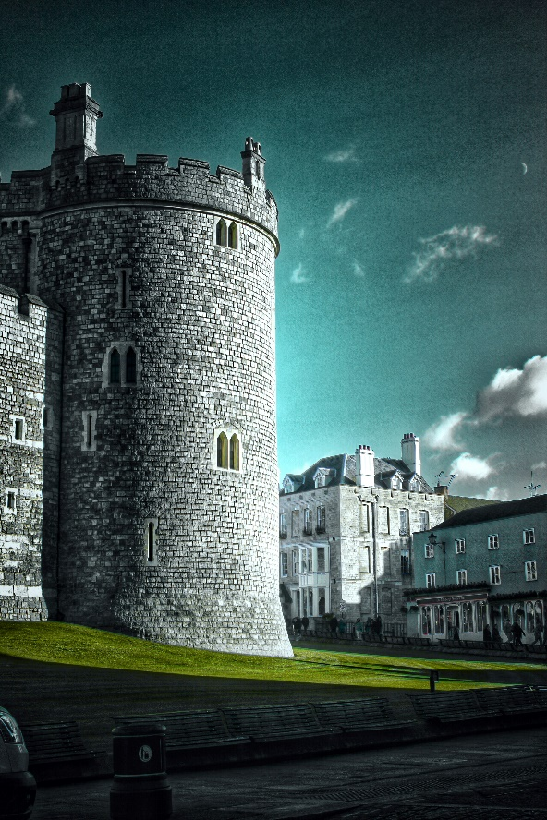

**PHOTOGRAPHY**

**Transition Booklet**

**Name: ___________________**

**Contents**

|  |  |  |  |
| --- | --- | --- | --- |
| **Course Expectations** | Pg 2 | **Contextual Understanding** | Pg 11 |
| **Course Breakdown** | Pg 3 | **Photography Artist research** | Pg 12 |
| **Summer Project** | Pg 4 | **Example of Page Layouts** | Pg 14 |
| **Assessment Objectives** | Pg 6 | **Annotating pages** | Pg 16 |
| **Mark Scheme** | Pg 8 | **Sketchbook examples** | Pg 18 |
| **Self-Assessment sheet** | Pg 10 | **Useful Links** | Pg 20 |

**Course Expectations**

The Photography AS and A Level are demanding courses designed to challenge your skills, ideas and creativity. In order for you to achieve to the best of your ability you must agree to the following:

* **Attendance affects attainment** - Attend all lessons, arrive on time and bring all the necessary equipment and resources. Do not book appointments during lesson hours.
* **Correct equipment** - While we can provide you with most of the resources you need, we don’t have an endless supply of white pens or glue sticks so you will be expected to purchase your own.
* **Punctuality** - Take responsibility for arriving on time to lessons after break or after a free period.
* **No mobile phones** - Mobile phones are not to be used or visible in class unless otherwise stated by the classroom teacher.
* **Effort** - Work to the best of your ability in class and focus on the lesson. Outside issues should be left outside the Art rooms and not affect your learning.
* **Respect others** - Listen respectfully to the views of other students and consider how your own views are developing.
* **Complete all homework on time** - this includes printing out resources.
* **Deadlines** - Need to be met with all set work completed to the best of your ability.
* **Keep your finger on the pulse** - Keep up to date with developments, exhibitions and articles about historical and contemporary photography and photography techniques (see Useful Links section of this guide)
* **Research** - Complete all necessary research and analysis as directed. Too much is better than too little.
* **Working Independently** - Attempt all work. If you are unsure of what to do, of course you may ask questions, but there are times when your teacher will want you to work independently without question. You must respect this.
* **Silent Study time** - Make the most of your free & silent study periods. If we have the space in the Art rooms, we are happy for you to utilise it.
* **Specialist equipment** – Photography equipment (cameras, etc) is not cheap and needs to be carefully looked after at all times. While in your care it is your responsibility and therefore you are responsible for any lose or damages.

**Learner Agreement**

As a dedicated member of the Photography course, I promise to meet the expectations above. I understand that not doing so, will result in school sanctions, potential parent meetings, and most importantly, it will have a negative impact on my attainment.

**Signed ______________________________________________**

**Print name ______________________________________________**

**Course Breakdown**

The breakdown for the 2 year A level course is as follows:

**YEAR 12**

The first year of the course is run like a foundation year. Most of the year you will be completing a variety of small or mini projects (1 or 2 weeks each) culminating in an extended (longer or sustained) project at the end of the year. Each mini project is designed to teach different photographic skills while developing your wider knowledge and understanding of how to respond to a project brief, encorporating a variety of the Assessment Objectives necessary. The extended project will be more independent, structured and timed to mirror the Externally Set Component in year 13, giving you experience required to meet component 2.

Below are a variety of the topics/projects/techniques we may be looking at:

|  |  |  |
| --- | --- | --- |
| **How do we see?** | **knowing your camera** | **Line** |
| **Cropping** | **Exposure** | **ISO** |
| **Depth of Field** | **Text and Image** | **Capturing Motion** |
| **Lighting** | **Photomontage** | **Digital Manipulation** |

**YEAR 13**

Year 13 consists of two units or **components** and 200 marks in total:

**Component 1: PERSONAL INVESTIGATION**

* No time limit
* 120 marks (60% of the Alevel grade)

A major in-depth critical, practical and theoretical investigative project developing

outcome/s based on a theme, supported by a 1000 words (minimum) essay.

**Component 2: EXTERNALLY SET ASSIGNMENT**

* Preparatory time + 15 hours supervised time
* 80 marks (40% of the Alevel grade)

An extended project based on a theme provided by the examination board (EDUQAS), culminating in a 15 hour exam (3 days of supervised sessions) in which you are expected to create a finished outcome/series of finished outcomes.

**Year 11 > 12 Summer Work:**

Over the summer period, you will be expected to begin developing skills for the photography course, with a focus on original thought and imagination. To do this you will be completing this small project below.

**Project Brief**

*30 Day Photo Challenge*

*To take a series of 30 photographs over a 30-day period, which will be later presented to the rest of the class*

**SPECIFICS:**

Your project must consist of 30 different photos that have been taken over the summer holidays on 30 different days (ie one photo a day).

In terms of what to take photos of, you have 3 options:

* **A Theme** – pick a theme and run with it over 30 days (ie landscapes)
* **A Diary** – document your holidays in 30 days of pictures
* **A Challenge List** – check out sites like Pinterest for 30 Day Challenge Lists

So think carefully about what it is you want to do/show and pick one from the list above. Think creatively, be imaginative and consider composition (what’s in frame/shot)

You will be expected to present your work to the rest of your class in your first full week of Year 12. So you need to transfer all 30 photographs into a PowerPoint document along with the date and time each photo was taken (this is to make sure you don’t cheat. Your camera/phone should record this information when you take each photo).

**DEADLINE – First lesson back in September**

**Examples:**

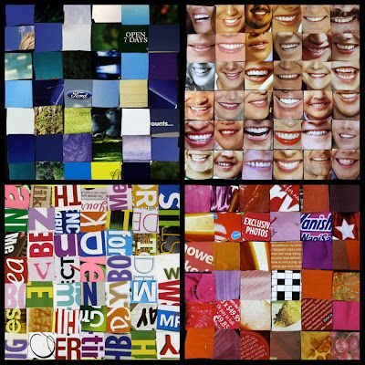**[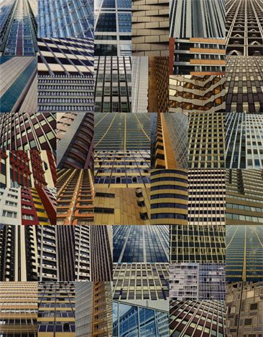](http://www.sharonelphick.com/towers.html)[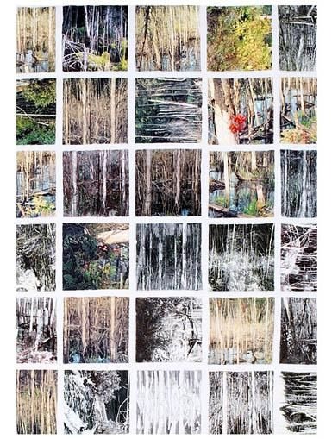](http://www.quiltart.eu/sandrameech.html)A THEME**

**[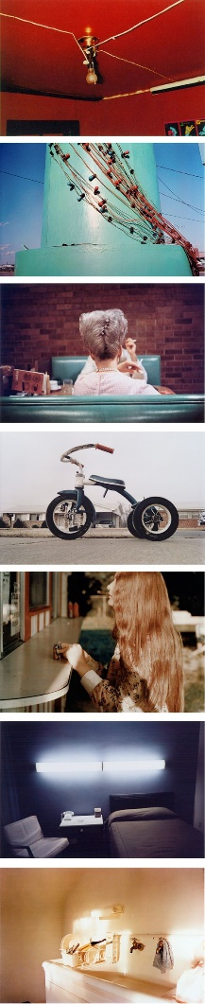](http://anatomyoftheself.wordpress.com/2009/07/19/william-eggleston/)[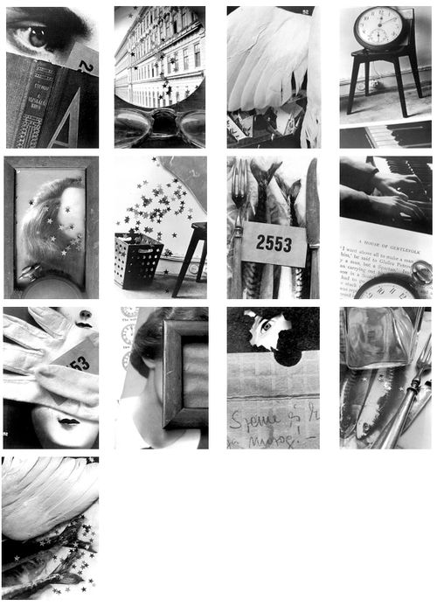](http://tallisphoto.tumblr.com/search/surrealism)A DIARY**

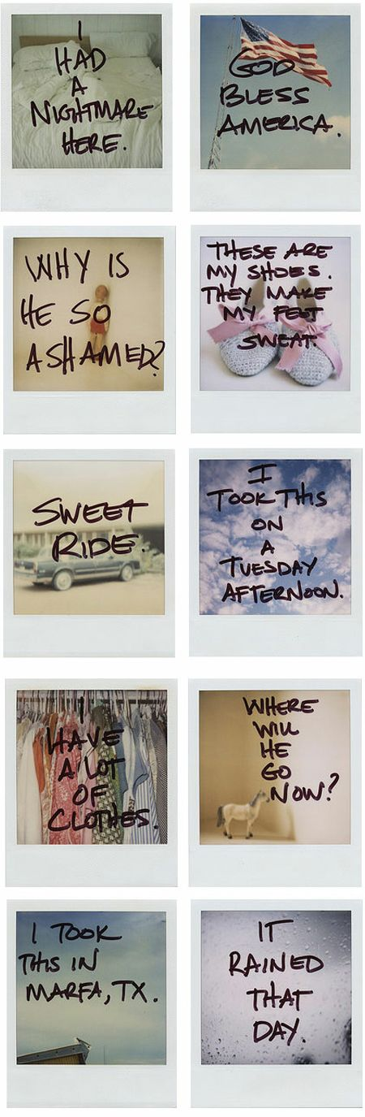

**[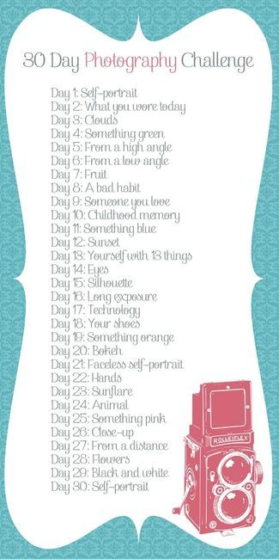](http://imgfave.com/view/1397083)**

**[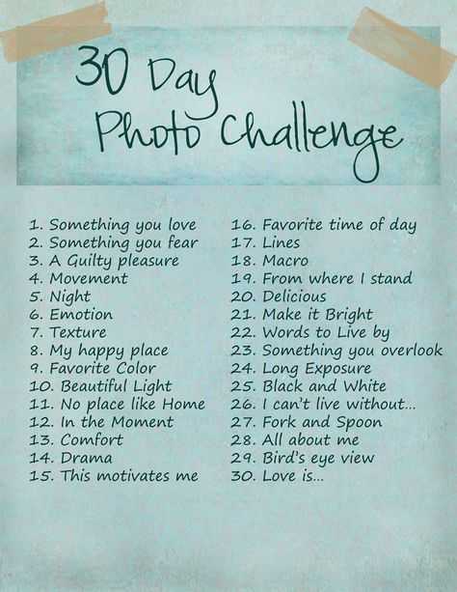](http://jackiegoudy.com/its-happening-30-day-photo-challenge)A CHALLENGE LIST**

**[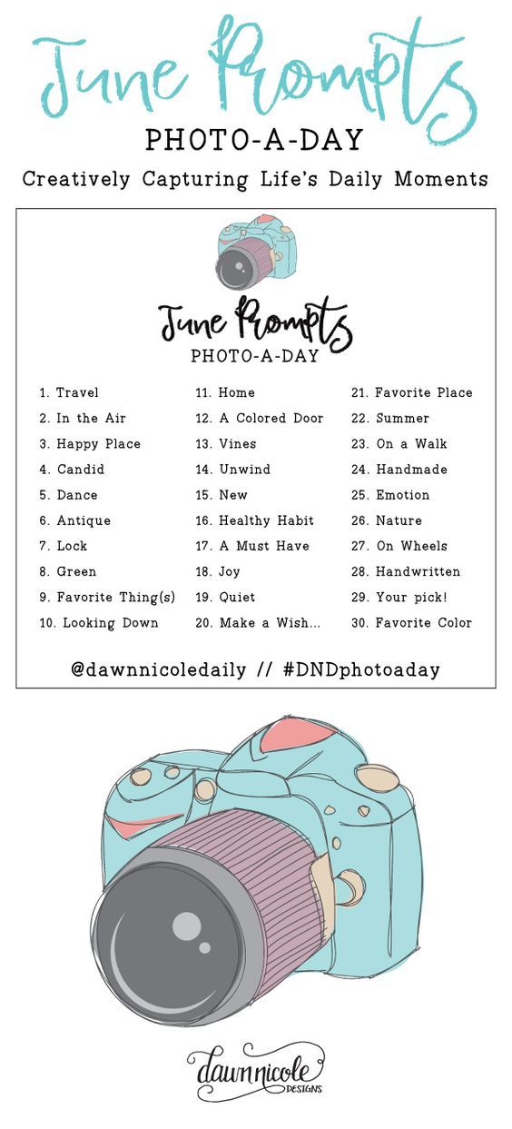](http://full-focus.co.uk/walimex-pro-650-1300-mm-f8-16-if-tele-lens-minolta-md/)**

**Assessment Objectives**

There are 4 **Assessment Objectives (AO)**, which are the same for both components (portfolio & exam).

The table below shows the weighting and marks available for each assessment objective, for each component and for the qualification as a whole.

|  |  |  |  |  |
| --- | --- | --- | --- | --- |
|  | **AO1**  **Marks (%)** | **AO2**  **Marks (%)** | **AO3**  **Marks (%)** | **AO4**  **Marks (%)** |
| Comp 1: Personal Investigation (60%) | 30 (15%) | 30 (15%) | 30 (15%) | 30 (15%) |
| Comp 2: Ext Set Assignment (40%) | 20 (10%) | 20 (10%) | 20 (10%) | 20 (10%) |
| Total Weighting | 50 (25%) | 50 (25%) | 50 (25%) | 50 (25%) |

Below each of the 4 Assessment Objectives descriptors have been broken down and bullet pointed into simple terminology (what you need to do):

**AO1** - Contextual Understanding **(25% weighting)**

**Develop ideas through sustained and focused investigations informed by contextual and other sources, demonstrating analytical and critical understanding.**

IN MORE SUBJECT SPECIFIC DETAIL…

* Development of ideas that are informed by contextual study of past and present photographic and other sources such as film, fine art, installation art, graphic design, production design and published media and the place of photography within these.
* Awareness of the variety of photographic and motion picture genre and, where appropriate, relating personal work to a particular genre.
* Analytical skill and critical and contextual understanding in appraising, comparing and contrasting the work of relevant photographers and other contextual sources and in formative and summative evaluation of personal photographic outcomes.

**AO2** – Creative Making **(25% weighting)**

**Explore and select appropriate resources, media, materials, techniques and processes, reviewing and refining ideas as work develops.**

IN MORE SUBJECT SPECIFIC DETAIL…

* Selection of, and experimentation with, appropriate photographic media and processes, other media and combinations of media, with controlled use of lighting, shutter speed, aperture, lenses, filters and digital software. Technical details may be included, but should be selective and concise. Concern with technical processes should not assume greater importance than the progression of creative ideas.
* Exploration of stimulating resources and studio-based and environmental sources to initiate and develop innovative ideas, with due regard to viewpoint, composition, tone, colour, texture, scale and other visual elements. Each significant step in the creative process should be documented. The full potential of photography should be explored through experimentation with traditional and digital media, where appropriate, combining photographic and other techniques to originate new ways of working.
* Discrimination in reviewing ideas as work develops. Careful control exercised in refining detail, such as in editing, image manipulation and print resolution, to produce outcomes of quality.

**AO3** – Reflective Recording **(25% weighting)**

**Record ideas, observations and insights relevant to intentions, reflecting critically on work and progress.**

IN MORE SUBJECT SPECIFIC DETAIL…

* Gathering, selecting, organising and communicating relevant information in undertaking research into visual and tactile sources of reference. Due attention should be given to the selection of only the most significant images and the analysis and annotation of these, rather than including multiple thumbnail/contact prints with no evaluative comments.
* Recording, through photography and by other means, such as sketches, storyboards and written notes, ideas, observations and insights that are relevant to personal intentions.
* Critical reflection on work and progress in order to review what has been learned, deepen understanding and clarify purpose and meaning.

**AO4** – Personal Presentation **(25% weighting)**

**Present a personal and meaningful response that realises intentions and, where appropriate, makes connections between visual and other elements.**

IN MORE SUBJECT SPECIFIC DETAIL…

* Presentation of creative responses that are essentially personal and effectively realise stated intentions, such as a photographic poster to support a strongly held opinion or images of architectural structures projected onto a three-dimensional construction.
* Explicit connections made, where appropriate, between the different elements of the submission, including contextual, practical and written responses, presenting work in an order which can be easily followed.
* Consideration of different presentational formats, such as animated sequences and use of mixed media, selecting the most appropriate of these for the submission, giving due regard to the purpose of the work and how it might engage the interest of an audience or potential clients. If the print size or cost of a preferred format is a constraint, then this could be drawn, described and/or presented as a scale model.

**Mark Scheme**

There are 5 marking bands – each containing 6 marks for component 1 and 4 marks for component 2. The descriptors in the Mark Scheme (you can find over the following 2 pages) are used to place your work/performance into a band for each AO. Your mark within each band depends on how well you have met the criteria described.

**QUICK TASKS**

* **Try highlighting the descriptive words on the Mark Scheme (overleaf) in order to improve your understanding of how to reach the higher bands.**
* **As your projects develop ask yourself where you feel your work sits within the Mark Scheme.**



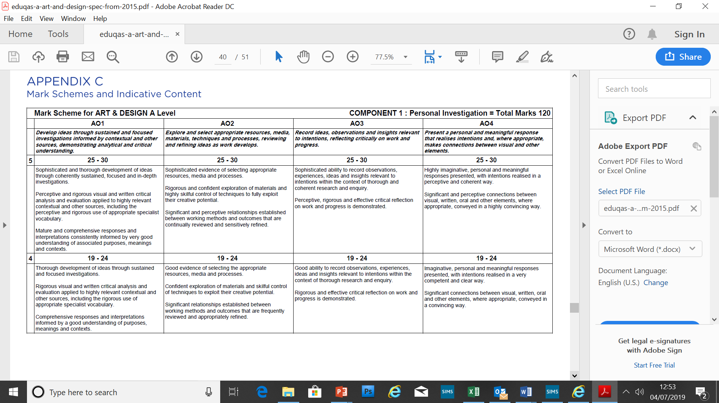

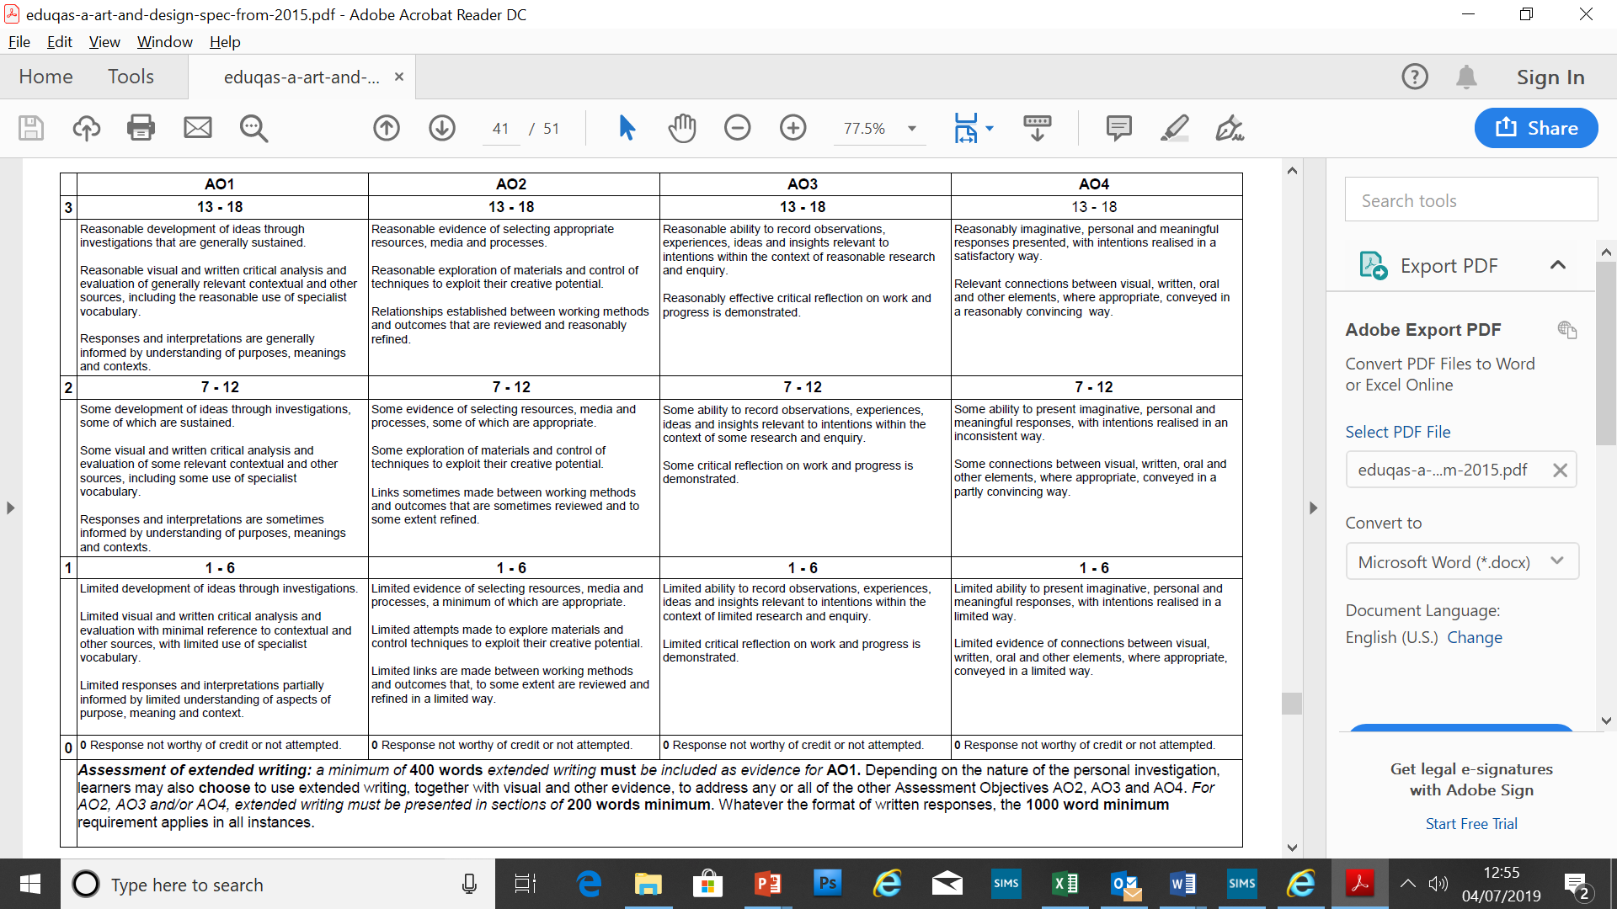

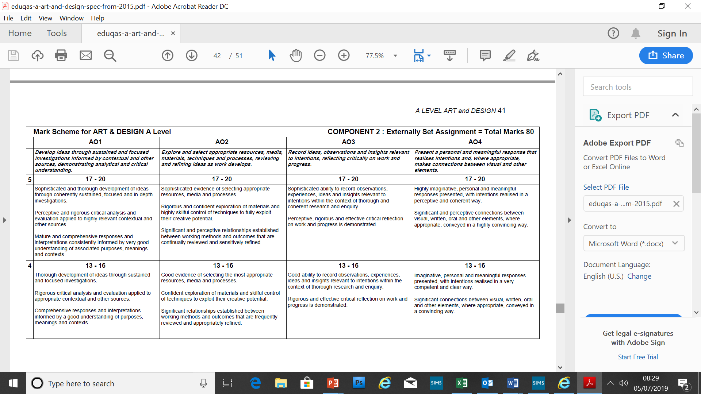

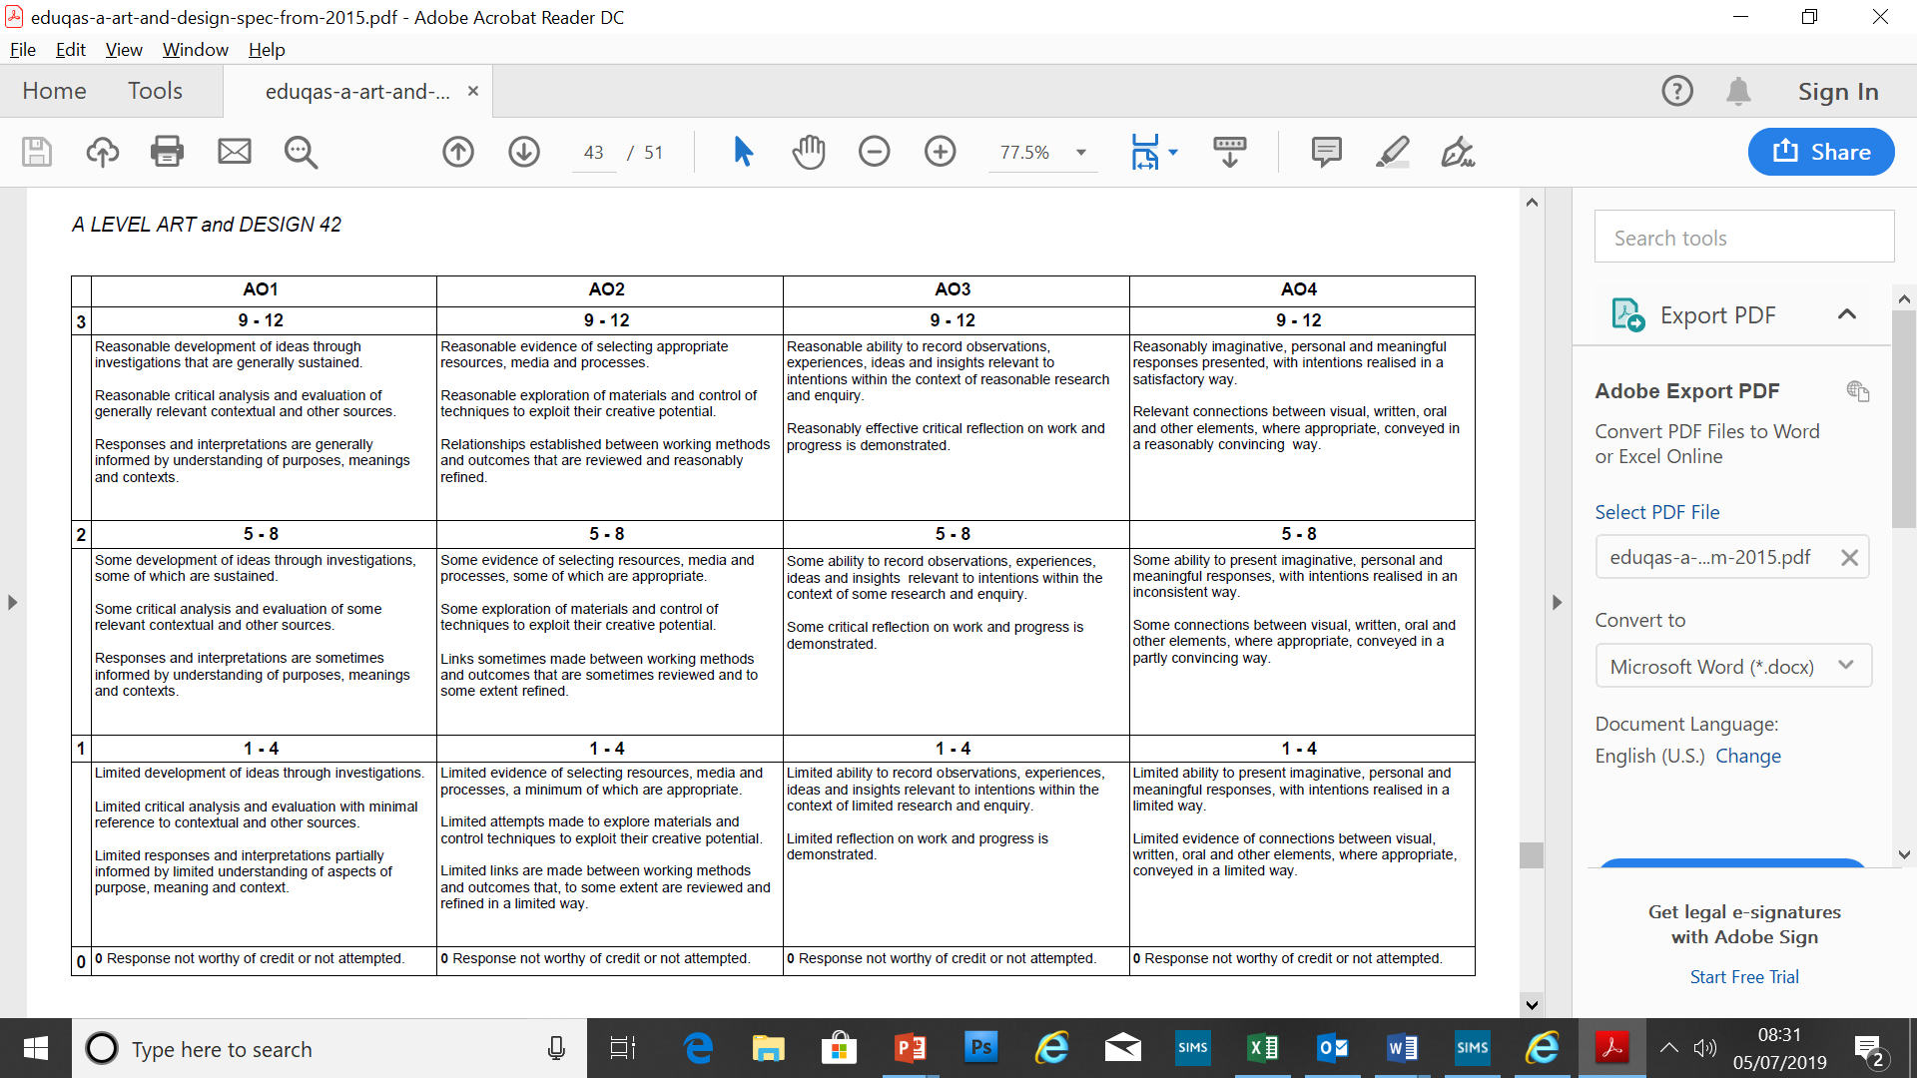

**Self-assessment sheet**

If you’re still not sure what to do, then you can’t go too far wrong just sticking to bullet points in the table below (If it helps tick them off as you go through your book. Proving good examples of each will open you to as many marks as possible)

|  |  |  |  |
| --- | --- | --- | --- |
| AO1 | **AO2** | AO3 | **AO4** |
| Contextual Understanding | **Creative Making** | Reflective Recording | **Personal Presentation** |
| **Develop ideas through sustained and focused investigations informed by contextual and other sources, demonstrating analytical and critical understanding.** | **Explore and select appropriate resources, media, materials, techniques and processes, reviewing and refining ideas as work develops.** | **Record ideas, observations and insights relevant to intentions, reflecting critically on work and progress.** | **Present a personal and meaningful response that realises intentions and, where appropriate, makes connections between visual and other elements.** |
| Study the work of your chosen photographers/artists. Give your own opinions and explain why they inspire you. | Experiment with your photo techniques and use a variety of media to develop your ideas. Annotate your work to explain what you are doing. | Take a range of photographs using your topic as a focus. Print a selection of images (including large scale), annotate why you have chosen these and how you could develop them further. | Develop your best idea(s)/image(s) working towards a final outcome. Link all of your work and explain how you have come this conclusion- tell a story! |
| * Photographer/Artist brilliant research 1 * Photographer/Artist brilliant research 2 * Artist research linking strongly to your development * Annotation on every page * Images by relevant Photographers/artists on pages to link with your work * References to other artists' work throughout development of final piece | * Contact sheets of initial ideas * Response to research * Experiment with shutter speed * Lighting * Photoshop manipulations * Photomontage * Presentation * Cropping experiments * Lenses and filters * Depth of Field / Aperture * Colour and Black & White. | * Brainstorm and ideas page * Annotated set of Photos 1 * Annotated development ideas * Photo developments * Careful selection of prints from contact sheets * All photos and ideas annotated | * Statement of intent for final piece development * Annotate primary research page. What ideas/sources have you chosen to develop and why? * Clear annotation on every page of development work * Regular references to your chosen artist/photographer * Working out composition page * Final piece mock-up (composition) * At least 10 pages of clear development from statement of intent * Evaluation of final outcome. |

**CONTEXTUAL UNDERSTANDING (AO1)**

**HOW & WHAT TO RESEARCH**

You need to research **photographers**, **artists**, **styles** and **genres** relevant to your topic or theme. Obviously you can do this through the use of the **internet**, **books** or visit of significance (such as **galleries**). It should consist of both **primary** and **secondary** sources.

**So where do I look on the internet?**

*What should I be typing into my google search engine?*

For initial ideas and what other student’s/budding photographers have created, check out Pinterest. For more in depth search (ie specific photographers research) you must first find out the name of a relevant photographer.

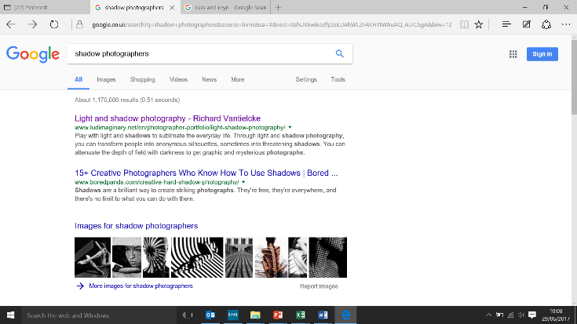You could start by typing your theme/topic into a search engine followed by the word “photographers” ie **SHADOW PHOTOGRAPHERS**.

The search engine should hopefully give you some ideas.

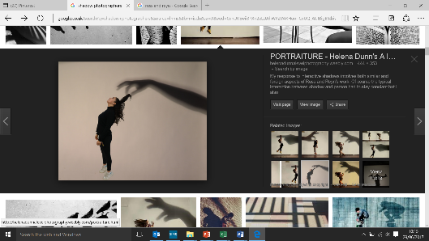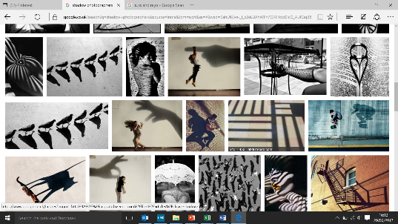If you want to be more specific in your search click on **Images** and scroll through having a look for something you like and it will hopefully give you an idea of the photographer who took it.

On closer inspection of this work I can see it is by Russ & Reyn.

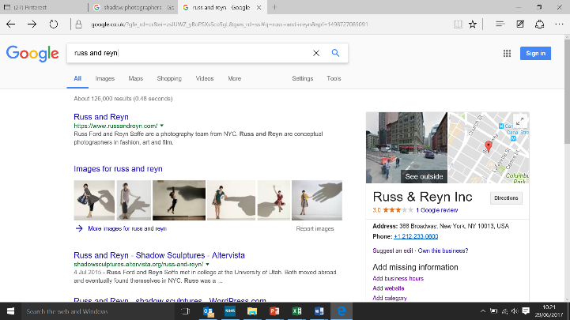A further search of **RUSS AND REYN**’s work gives me various examples of their photography and a variety of links to information about them and their work.

The next page discusses what to include in your research into photographers.

**PHOTOGRAPHY ARTIST RESEARCH (AO1)**

**Who is your chosen photographer?**

Provide a very brief description of them and their work.

**Key Themes**

Are there any key themes in their work? E.g. use of colour/ composition/ imagery/ subject

**THE PHOTOGRAPH**

What to include when looking at specific photographs by your chosen photographer…

* What is the title of the photograph you are looking at?
* When was it taken?
* What genre is it? (E.g. portrait/ landscape etc.)

Analysis of the techniques: Those aiming for higher grades need to look into the technical aspects of the work they are studying. Find out about the photographer's work on related websites and in books.

**Analysis of the photograph (s)**

**Content** - what can you see? Why is it there? Where is your eye drawn? Is the shot set up or is it more photojournalism? Is it trying to convey a message?

**Formal elements** - what has been used? Is there any experimentation with focus/ ISO etc.? Has the image been manipulated? How is the image framed? What size is the image? How does it make impact?

**Process** - how is the photograph presented? Is it digital or darkroom? How is it printed? What size is it printed (if it is interesting e.g. very large or very small)

**Mood** - is it aggressive/ tension/ angry/ happy/ laid back/ imposing/ theatrical etc.

**Your opinion**

* What appeals to you about the image artist?
* How does it make you feel?
* What would you like to apply to your own photography?

**HOW TO PRESENT YOUR RESEARCH…**

Ensure that all cut edges are done on a **guillotine** and **cut straight**, use **Pritt Stick**, **double sided tape** or **mount spray** to stick down your work so that it doesn’t crinkle.

Consider various layouts before sticking it down to ensure it makes an impact. Keep titles simple perhaps use a print from a computer.

* **Have a title** - the artist’s name, make it really clear that it is not your own work
* **Present the biography**
* Select **at least 3** images of their work, have a good quality print of them, and include the title etc. right next to the image
* Present **your analysis and opinion**

**RESPONDING THROUGH YOUR PHOTOGRAPHS**

Make sure that you present your response to the Photographers work. This should be a double page of annotated images including a contact sheet. Draw as many parallels between your work and your chosen photographer’s as possible.

**The next 2 pages give you an idea of potential ways to layout all this research**

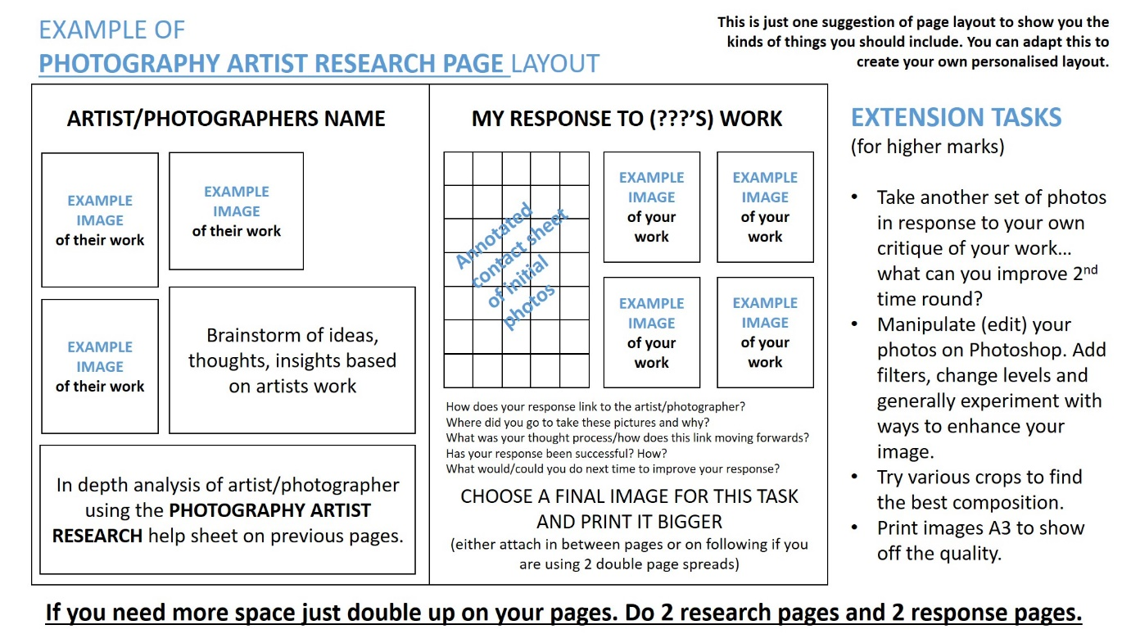

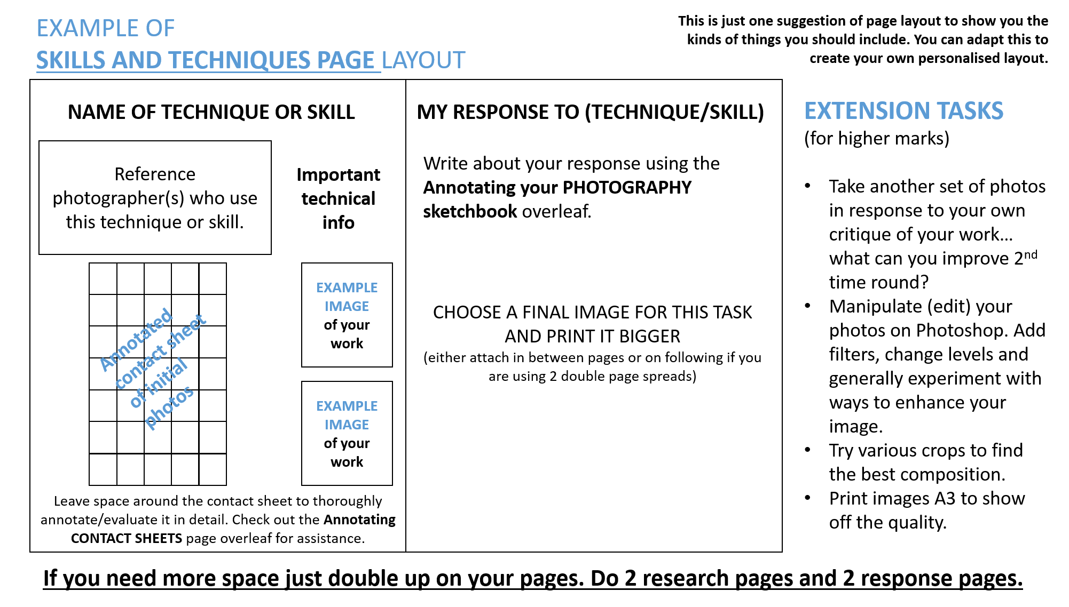

**Annotating your PHOTOGRAPHY sketchbook**

Every page in your book needs to be annotated in detail. If you are struggling with what to write, try some of these starting points. You could also consider how to adapt these structures into your own words.

1. This image works well because...
2. The composition of this image is strong because…
3. I am satisfied with this image because…
4. I think I could improve this image because…
5. Next time I would improve my technique by…
6. I have cropped the composition of this section because…
7. The media/skill/technique used works well here because…
8. Here I have experimented with…………………. I discovered that…
9. The combination of …………… and …………… work well because…
10. I was inspired by the work of …………… and their use of…
11. I looked at the last piece of work and decided to…
12. Here I experimented with using …………… I think…
13. This work is similar to the work of …………… because…
14. Here you can see I have been influenced by the work of…
15. I took this photo …(where)… and I like the…
16. I am studying …………… so I thought it was appropriate to take photos of…
17. I think I can develop photo/idea further by…

**SOME KEY TERMS**

Reflex

Aperture or F-Stop Lens

Card reader/writer Resolution

Composition Depth of Field (DOF) Tripod

Digital zoom Negative

DSLR (Digital Single Lens Reflex) Crop

DPI (dots per Inch- printing) Background

Exposure Foreground

File format Double Exposure

Flash Sync Filter

Inkjet Low/High Key

ISO Panning

JPEG Saturation

LCD SD Card

Macro Lens Light

Noise/Noise reduction Shutter priority

Optical resolution Shutter speed

Optical zoom Thumbnails / Contact sheet

Overexposure Time lapse

Pixel Viewfinder

Subject Red eye

**Annotating CONTACT SHEETS**

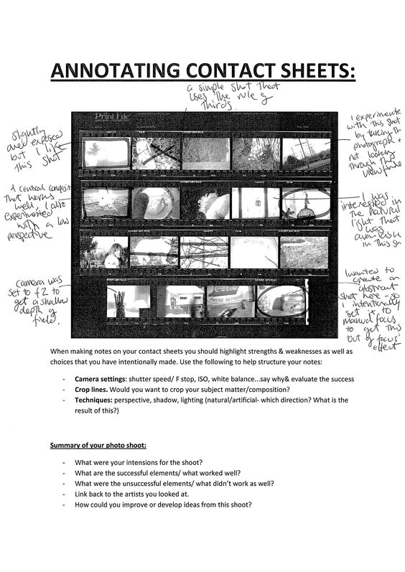

­

When adding notes on your contact sheets you should highlight strengths and weaknesses as well as choices that you have intentionally made. Use the following structure to help with your annotation:

* Camera settings: shutter speed / F stop, ISO, white balance… Why did you choose these settings and was the image successful?
* Crop lines. Would you want to crop your subject matter/composition?
* Techniques: perspective, shadow, lighting (natural/artificial – which direction? What is the result of this?)

Summary of your photo shoot:

* What were your intentions for the shoot?
* What are the successful elements / what worked well?
* What are the unsuccessful elements/ what didn’t work as well?
* Link back to the artists/photographers you looked at.
* How could you improve or develop ideas from this shoot?

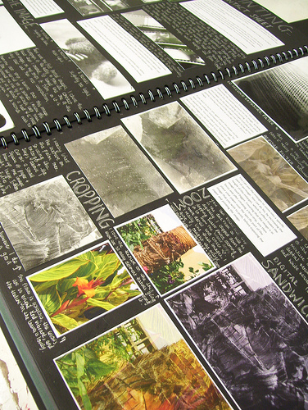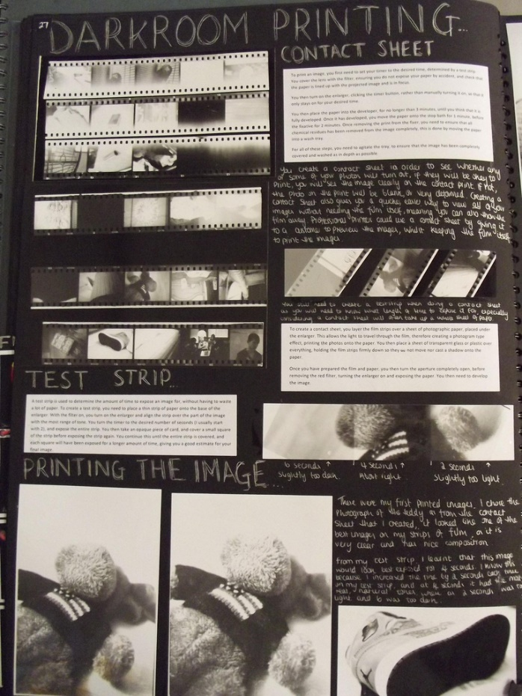**Sketchbook examples**

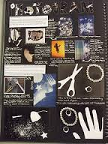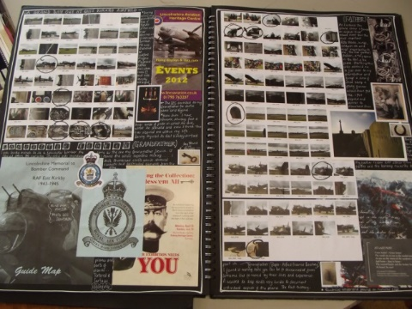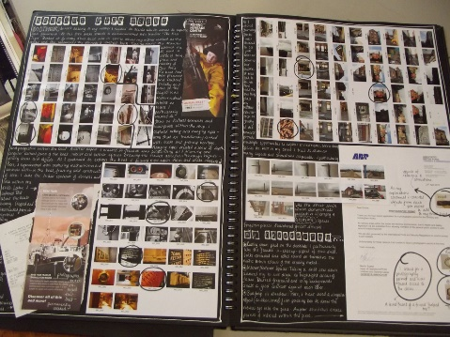

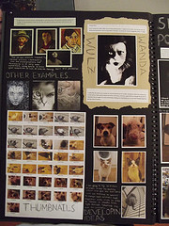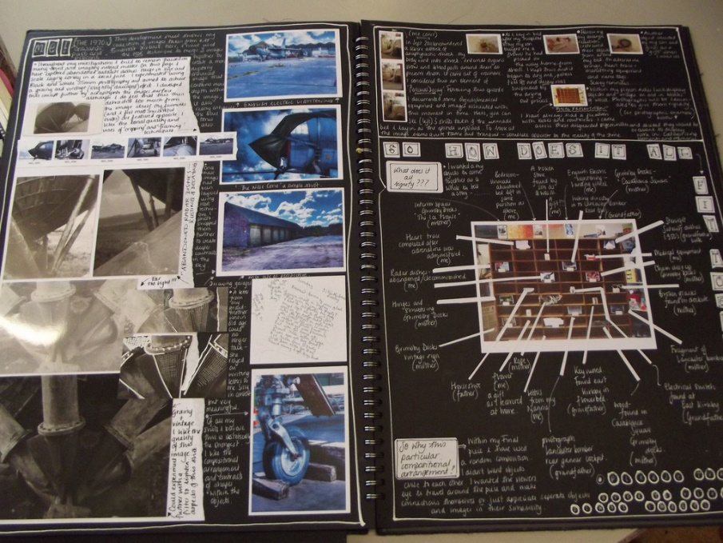

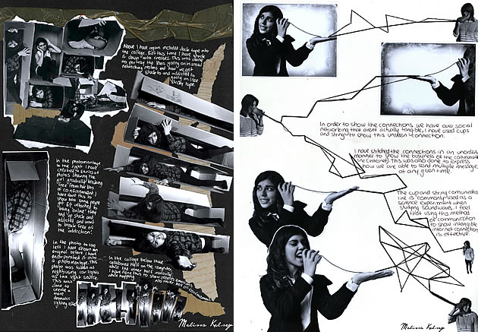

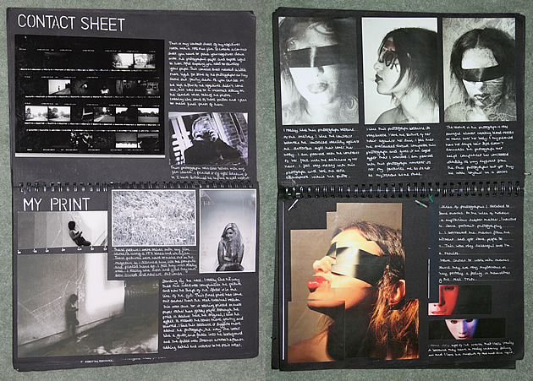

**Useful links**

<https://www.youtube.com/watch?v=rKkmIl_ydxE> – GCE A2 exemplar sketchbook – A*

<https://www.youtube.com/watch?v=WJ5kojvyv8s> – GCE AS exemplar sketchbook – A

<https://www.youtube.com/watch?v=wFYPYJKCk1w> – GCE AS exemplar sketchbook – A

<http://www.studentartguide.com/> - exemplar sketchbooks

<https://www.youtube.com/user/webArtAcademy> - Web Art Academy – multiple tutorials

<https://www.youtube.com/user/tate> - Tate Gallery - multiple videos about art / artists

<https://www.youtube.com/user/MoMAvideos> - Museum of Modern Art, New York

<https://www.youtube.com/user/nationalgalleryuk> - National Gallery, London

<http://www.saatchigallery.com/> - Saatchi Gallery – contemporary art gallery, London

<http://www.tate.org.uk/> - Tate Galleries – London, Liverpool, St Ives

<https://www.royalacademy.org.uk/> - Royal Academy of Art – London

<http://whitecube.com/> - White Cube galleries – London / Hong Kong

<http://www.camdenartscentre.org/> - Camden Arts Centre – exhibitions / workshops

<http://www.whitechapelgallery.org/> - Whitechapel Gallery – exhibitions / workshops

<http://www.npg.org.uk/> - National Portrait Gallery – London

<http://www.nationalgallery.org.uk/> - National Gallery – London

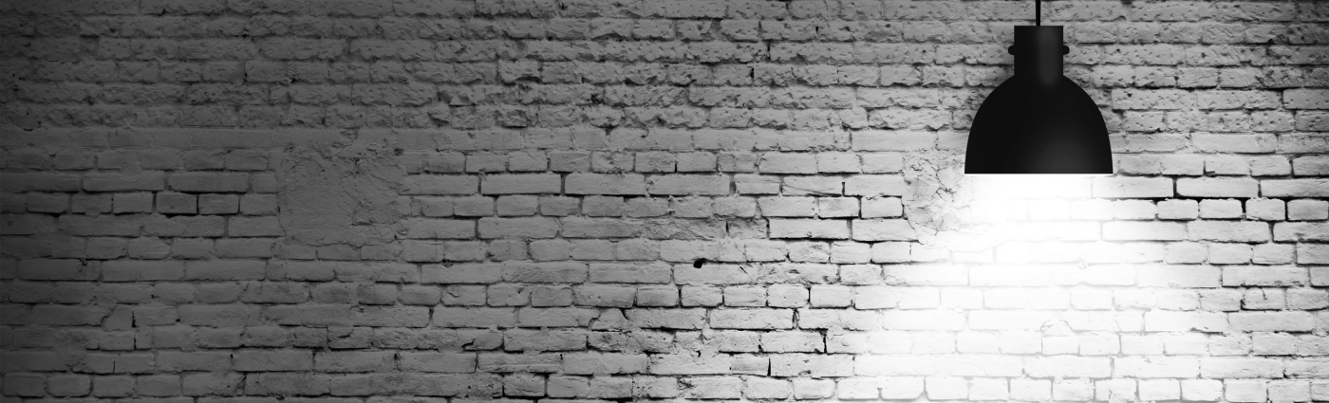<http://thephotographersgallery.org.uk/> - Photographers Gallery – London

THINK

CREATIVELY