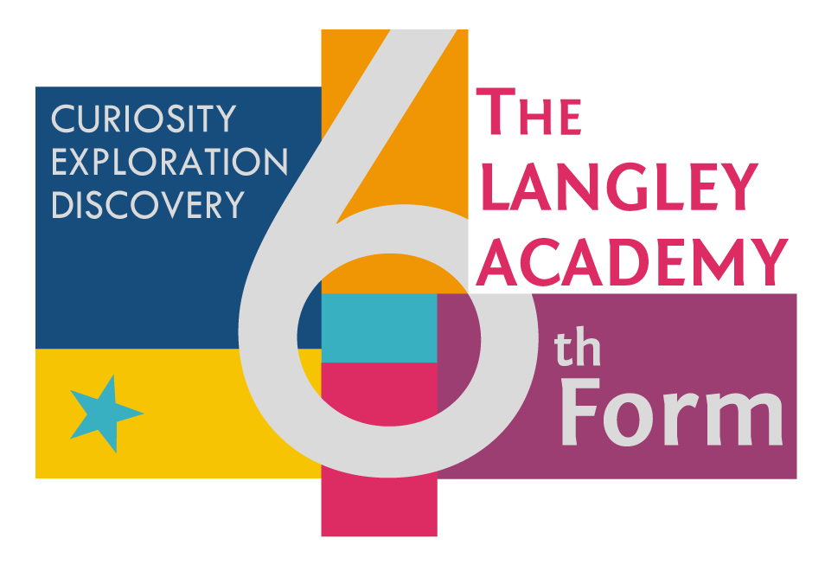

**Subject Transition Booklet**

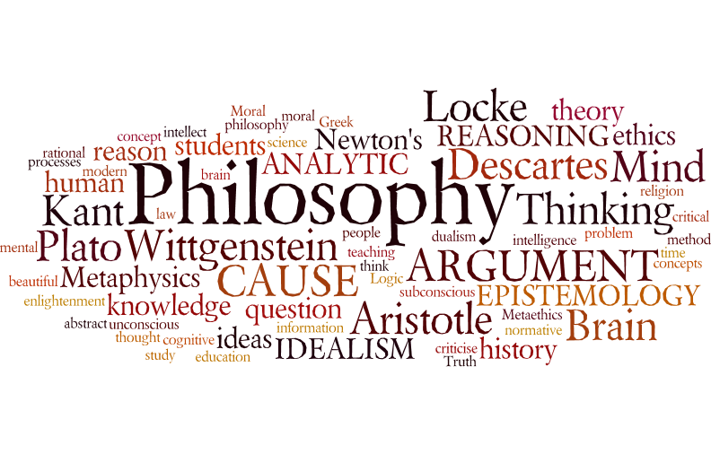

**Subject:** Philosophy

**Teachers:** Mr. Raymond

Student Name:

**Overview of the Programme**

*The A-Level philosophy course has 4 components – 2 of which are completed in Year 12, while the other 2 are completed in Year 13. The four components in the course are the following;*

***Epistemology:*** *The study of knowledge, specifically if we can be certain that the external world which we perceive exists and whether we perceive it directly or indirectly.*

***Moral Philosophy:*** *The study of various ethical theories, as well as examining what the source of our morality is. We then apply these theories to specific moral issues and finally examine whether an objective moral standard exists or not.*

***Metaphysics of God:*** *A study of the possible existence of an all loving, all powerful, all knowing God, through a variety of different arguments; such as teleological, cosmological and ontological arguments. We also study the meaning of religious language and the problem of evil.*

***Metaphysics of Mind:*** *A study of whether the mind and body can exist independent of one another. We explore a variety of different standpoints and theories with regards to this topic in this final component.*

*A-Level Philosophy is assessed through 2 examinations at the end of Year 13. The examination is through AQA. There is* ***no coursework component*** *and the paper are structured as follows;*

*Paper 1: Epistemology & Moral Philosophy*

*Paper 2: Metaphysics of God & Metaphysics of Mind*

**Textbook(s) for the course**

* ‘Philosophy for AS and A-Level: Epistemology and Moral Philosophy’ by Michael Lacewing

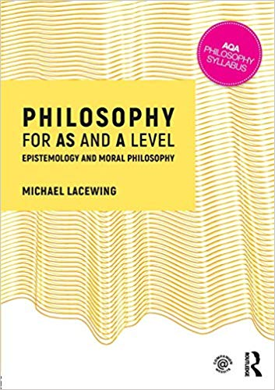

* ‘Philosophy for A-Level: Metaphysics of God and Metaphysics of Mind’ by Michael Lacewing

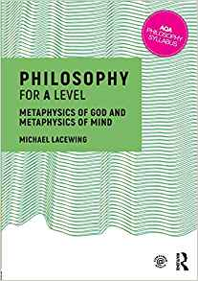

**Suggested reading list**

|  |  |
| --- | --- |
| **Title** | **Author** |
| Meditations for First Philosophy | Descartes, Rene |
| The Problem of Knowledge | Ayer, A.J. |
| The Elements of Moral Philosophy | Rachaels, J. |
| The Philosophy of Religion: A Critical Introduction | Clack, B. |
| Philosophy: Key Themes | Baggini, J. |

**Introductory Quiz**

***Philosophy 101*** *– See how may you can answer correctly! (circle the correct answer)*

1. ***Which philosopher is best known for his statement cogito ergo sum?***
2. *Plato (b) Jean Paul Sartre (c) Rene Descartes (d) Socrates*
3. ***According to Plato, what is knowledge?***
4. *That which can be proven (b) There is no such thing as knowledge*
5. *Opinion (d) A justified true belief*
6. ***Thomas Aquinas’s cosmological arguments argue for…***
7. *The existence of knowledge (b) Nihilism (c) The existence of other intelligent life (d) The existence of God*
8. ***Philosophy comes from the Greek philosophia, meaning what?***
9. *Lover of questions (b) Lover of philosophy (c) Love of wisdom*
10. *Love of soapboxes*
11. ***Which branch of philosophy is primarily concerned with the question of being?***
12. *Existentialism (b) Marxism (c) Humanism (d) Platonism*
13. ***Who is widely known as the first existentialist, despite never having used the word existentialism?***
14. *Soren Kierkegaard (b) Hannah Arendt (c) Alan Watts (d) Jean Paul Sartre*
15. ***Transcendental idealism argues that…***
16. *Our experience is based on our perceptions (b) Knowledge has foundations (c) There is an afterlife (d) God is the ideal human*
17. ***What does tabula rasa mean?***
18. *New knowledge (b) Rise tomorrow (c) Red tablet (d) Clean slate*
19. ***Who wrote The Last Messiah?***
20. *Frederich Nietzsche (b) Socrates (c) Peter Wessel Zapffe (d) Alan Watts*
21. ***Descartes’s meditation that led him to conclude that perhaps even mathematical laws are not true is referred to as…***
22. *The Cartesian argument (b) The law denial argument (c) The foundation argument (d) The evil demon argument*
23. ***Existential nihilism insists what?***
24. *The human condition has no meaning (b) Humans are naturally co-dependent (c) Knowledge is limited (d) Death is not the end*
25. ***The allegory of the cave argues what?***
26. *Our perceptions may not be accurate (b) Perceptions are sources of absolute knowledge (c) There is value in ignorance (d) We are born with infinite knowledge*
27. ***Metaphysics is the study of…***
28. *Politics (b) Existence (c) Ethics (d) Knowledge*
29. ***Epistemology is the theory of…***
30. *Poetics (b) Cosmology (c) Knowledge (d) Metaphysics*
31. ***Plato was a student to which philosopher?***
32. *Xenophon (b) Thomas Aquinas (c) Aristotle (d) Socrates*
33. ***Jean-Jacques Rousseau is known for what?***
34. *His publication The Social Contract (b) Rejection of philosophy as a discipline (d) Contributions to existentialism*
35. ***What is the philosophical study of value called?***
36. *Ontology (b) Axiology (c) Valuation (d) Ethics*
37. ***Which branch of philosophy deals with the question of beauty?***
38. *Poetics (b) Decorum (c) Dramatics (d) Aesthetics*

**Subject Specific Task**

***Plato’s allegory of the Cave & Theory of Forms***

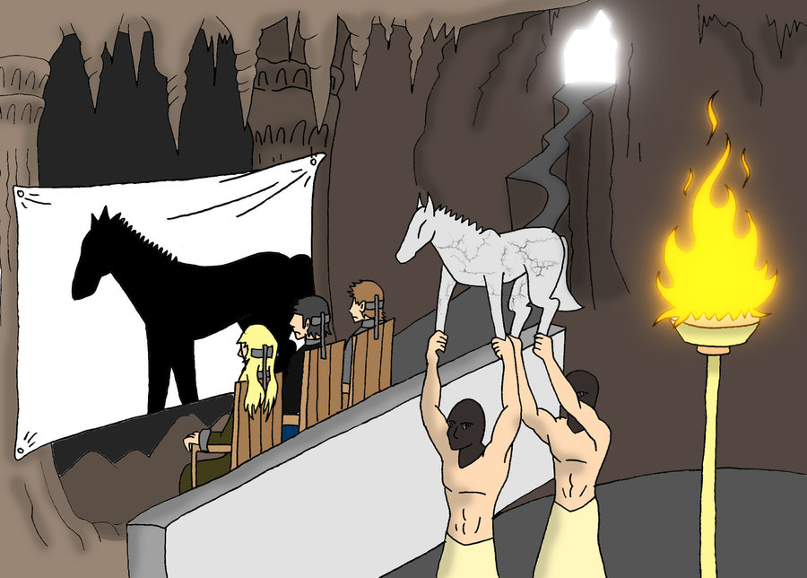

Plato’s allegory of the cave summary

**Key terms**

**Allegory** A story with a hidden or moral meaning

**Analogy** When we compare an object or thing to something else/ suggest likeness to it e.g. ‘Miss O’Halloran is like a small child’

* **List as many analogies you can find in Plato’s cave**
* **What do you think the hidden message (allegory) is in Plato’s cave**

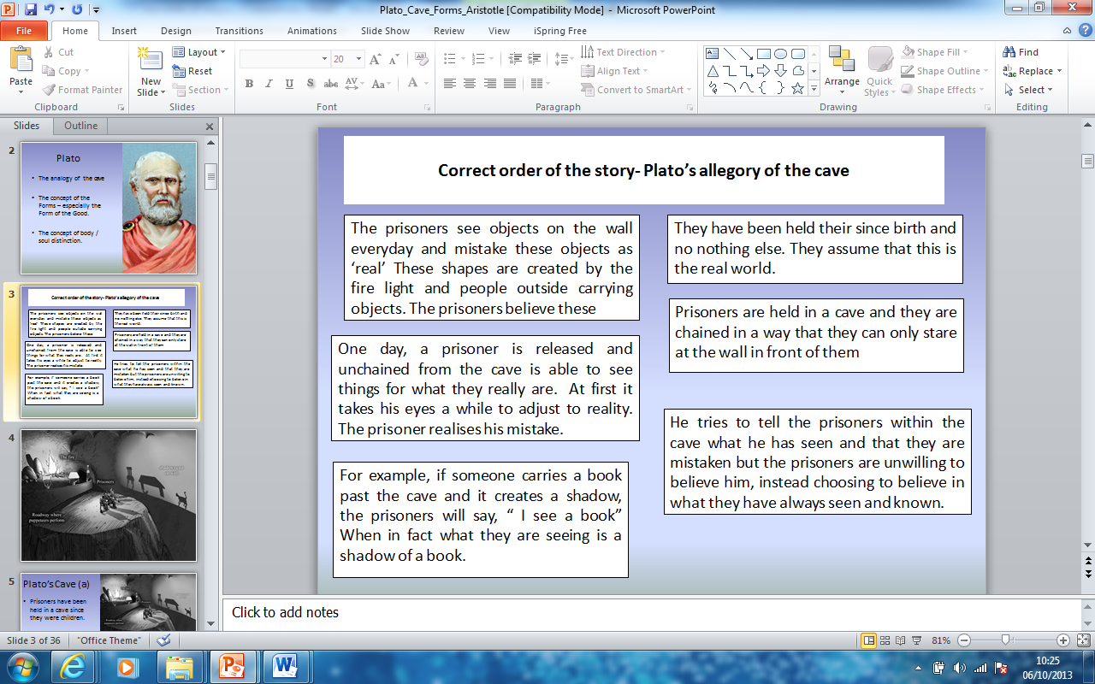**Sequence the story in the correct order**

Cave

[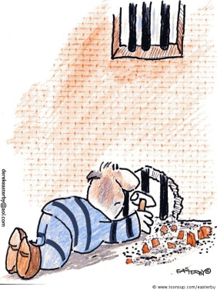](http://www.google.co.uk/url?sa=i&rct=j&q=&esrc=s&frm=1&source=images&cd=&cad=rja&docid=iaYgKjvVaGr7MM&tbnid=m_pl2Bq8dcCQXM:&ved=0CAUQjRw&url=http://www.toonsup.com/cartoons/prison_escape&ei=4jJRUtCsG6mQ0AWz3ID4Dg&psig=AFQjCNEehWCb8CRrGEFgIDdQkpPVyi8y4A&ust=1381139528780705)[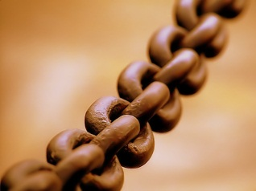](http://www.google.co.uk/url?sa=i&rct=j&q=&esrc=s&frm=1&source=images&cd=&cad=rja&docid=u1HqbbCgbvuOZM&tbnid=OyC8SVa-Y5WzQM:&ved=0CAUQjRw&url=http://en.wikipedia.org/wiki/Chain&ei=fDNRUob9AcOm0AW7tIGYBA&psig=AFQjCNEaiarFmcTDWoRKE1lVaHRmtz7fLw&ust=1381139649780265)[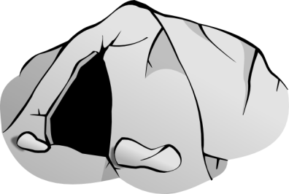](http://www.google.co.uk/url?sa=i&source=images&cd=&cad=rja&docid=3HLdX6t304141M&tbnid=R2j1ZvOsEcpRaM:&ved=&url=http://vector-magz.com/clip-art-2/cave-clip-art-item-1/&ei=BzJRUrStMoSn0QWJ8IDYBg&psig=AFQjCNFKmMwFMgg6FSdBfLNhlD3iwCmISw&ust=1381139335874087)**Analogies found in the cave - Match**

Escaped prisoner

Sun

[](http://www.google.co.uk/url?sa=i&rct=j&q=&esrc=s&frm=1&source=images&cd=&cad=rja&docid=MlNkNI6WnKZFVM&tbnid=X0vdk3LvshBDJM:&ved=0CAUQjRw&url=http://www.demotix.com/news/510223/emirates-land-and-people&ei=qzRRUq2dLMSU0QXc2oCoDg&psig=AFQjCNFMZQ1uF5kdIoVgHphrfNboPhF97A&ust=1381139977617538)[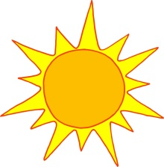](http://www.google.co.uk/url?sa=i&rct=j&q=&esrc=s&frm=1&source=images&cd=&cad=rja&docid=Pa0t6WjvyXuw0M&tbnid=zJ_Caf5LGenoVM:&ved=0CAUQjRw&url=http://www.bostonbakesforbreastcancer.org/summer-sun-radiation-and-chemo/&ei=qjBRUvr3MrGS0QX3woCADA&bvm=bv.53537100,d.d2k&psig=AFQjCNESMdfXyE3n3TuzoMh-73BJQYgOsg&ust=1381138983446188)

Chains

[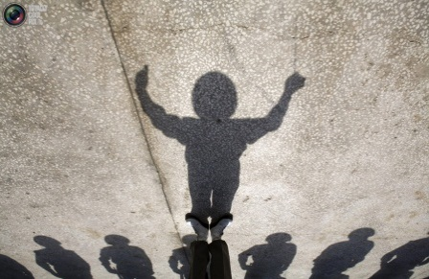](http://www.google.co.uk/url?sa=i&rct=j&q=&esrc=s&frm=1&source=images&cd=&cad=rja&docid=C5P0VYh-DIF6OM&tbnid=GnY-xMDX_h0beM:&ved=0CAUQjRw&url=http://totallycoolpix.com/2011/03/shadows/&ei=3DBRUpi_IsTL0QWim4Fo&bvm=bv.53537100,d.d2k&psig=AFQjCNF6nOhbC9uysYf1XS7ho4hHhAG0AA&ust=1381139028326709)

[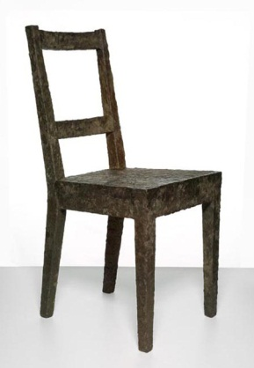](http://www.google.co.uk/url?sa=i&rct=j&q=&esrc=s&frm=1&source=images&cd=&cad=rja&docid=IIzhXWyqbjbCTM&tbnid=AfdoRjQkwIqcHM:&ved=0CAUQjRw&url=http://www.dezeen.com/2009/07/22/timeless-objects-by-boym-partners/&ei=sDVRUqLTLcau0wWv34CAAw&psig=AFQjCNHSGNPxX4cBTH8TL4FSpUZceHIoNA&ust=1381140266322115)

[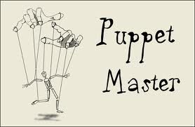](http://www.google.co.uk/url?sa=i&rct=j&q=&esrc=s&frm=1&source=images&cd=&cad=rja&docid=lZ2EfpVSsE41_M&tbnid=gwV_l6M9iMvWZM:&ved=0CAUQjRw&url=http://politicsandfinance.blogspot.com/2011/11/will-ows-new-york-city-take-movement-to.html&ei=YjVRUt2OGamV0AXHyoCwCA&psig=AFQjCNH5l-woHinidC876Ex4VpS5G84W0A&ust=1381140132789800)

World outside cave

[](http://www.google.co.uk/url?sa=i&rct=j&q=&esrc=s&frm=1&source=images&cd=&cad=rja&docid=l8Y1SY0dWdF3QM&tbnid=rSybf6sQqcM1gM:&ved=0CAUQjRw&url=http://www.clker.com/clipart-4522.html&ei=BzRRUsWxMcXK0wX_2oCYBA&psig=AFQjCNHgctB6rCQJsLpaH_jyoPDyXnUKyw&ust=1381139828145363)

Shadows

[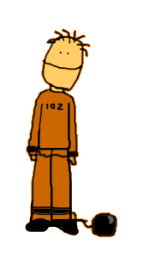](http://www.google.co.uk/url?sa=i&rct=j&q=&esrc=s&frm=1&source=images&cd=&cad=rja&docid=5mM0uVibIWSqJM&tbnid=-OYqQvavCOIt6M:&ved=0CAUQjRw&url=http://www.jewishcomment.com/cgibin/news.cgi?id%3D12%26command%3Dshownews%26newsid%3D154&ei=yDpRUpC0AZKa0AXai4DICg&bvm=bv.53537100,d.d2k&psig=AFQjCNFd6yzxo8h3d0ptkP1lLoyw3p7cEw&ust=1381141571227263)

Puppet master

The objects held up

Fire

Prisoner

The people casting shadows that keep the prisoners trapped in the cave of ignorance could be interpreted as the people who are not truly enlightened but want power and control (Politicians/ Media) That stop people from questioning and searching for truth.

This represents our perception of what is ‘real’ We think what we see in this world is true but it is a mere imitation of reality

The objects we cannot see when chained facing the wall or stuck in our narrow minded view of the world are the ‘real’ objects. What we see are imitations (shadows) If we turned around and saw the real shapes (forms)

These people are philosophers (those who have escaped being chained) by their thinking and have true knowledge EPISTEMOLOGY They can see things as they truly are.

This is most of us. We are fooled by what we think is real, we do not question things and we are trapped and limited.

This is the light for the prisoners, this is the only source of light they know and believe to be true. It can represent the dim / unenlightened world that we live in. Once the prisoner breaks free he is able to see clearly the force and power of the sun which ‘enlightens’ everything, so perhaps this represents darkness

This is the highest form of good. It is the biggest source of energy and provides warmth, produces seasons and controls most things in the world of the forms.

This is the world of the ‘real’ forms- A true picture of reality which we can find out if we open our minds up and question everything (think philosophically)

These things stop us and limit us from seeing reality, they hold us back and restrict us. This could also represent the thoughts or ideas we have (or lack of them) that stop us from knowing the truth. It could also represent our senses which limit us to this world and what we know.

These things stop us and limit us from seeing reality, they hold us back and restrict us. This could also represent the thoughts or ideas we have (or lack of them) that stop us from knowing the truth

***Epistemology is:***

[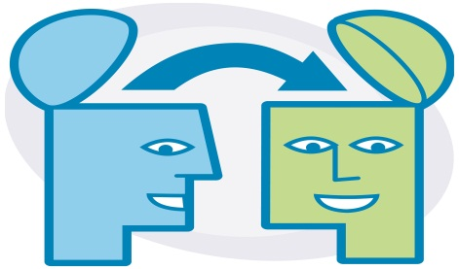](http://www.google.co.uk/url?sa=i&source=images&cd=&cad=rja&docid=pH35OFT7mtmSZM&tbnid=rGbWzlWJ0iv8CM:&ved=0CAgQjRwwAA&url=http://www.imperial-consultants.co.uk/ktfs&ei=lj9RUoqgOOiV0QWxyYHYBg&psig=AFQjCNEWXHLtXKWVOuml511QUe4_yJ5BaA&ust=1381142806966087)[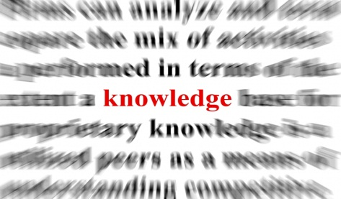](http://www.google.co.uk/url?sa=i&source=images&cd=&cad=rja&docid=_fnu1mO6Rxk2jM&tbnid=MhkPelL9EHh-5M:&ved=0CAgQjRwwAA&url=http://www.socialable.co.uk/the-missing-ingredients-for-success/knowledge-is-power-2/&ei=Vz9RUundBsSP0AWM0ICgDw&psig=AFQjCNF6F2S8Lvpjom0_dxbMlEP3Rh63aQ&ust=1381142743162143)

[](http://www.google.co.uk/url?sa=i&rct=j&q=&esrc=s&frm=1&source=images&cd=&cad=rja&docid=IIzhXWyqbjbCTM&tbnid=AfdoRjQkwIqcHM:&ved=0CAUQjRw&url=http://www.dezeen.com/2009/07/22/timeless-objects-by-boym-partners/&ei=sDVRUqLTLcau0wWv34CAAw&psig=AFQjCNHSGNPxX4cBTH8TL4FSpUZceHIoNA&ust=1381140266322115)

***The forms:***

[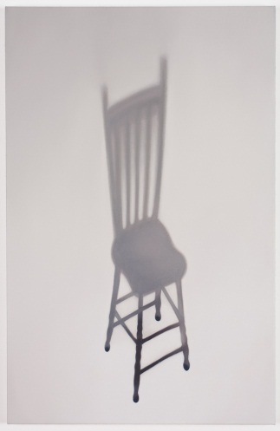](http://www.google.co.uk/url?sa=i&rct=j&q=&esrc=s&frm=1&source=images&cd=&cad=rja&docid=HTrpQCDdepmvPM&tbnid=qhAGxJEWYCdc5M:&ved=0CAUQjRw&url=http://gwenessa.com/artwork/shadows/chairshadow2/&ei=aEBRUr-9NIPJ0AWs9oD4Dg&psig=AFQjCNEA_PRqfd5X_Ds08gOYu-gsl_x25A&ust=1381142985462480)

***The particulars:***

[](http://www.google.co.uk/url?sa=i&source=images&cd=&cad=rja&docid=veHcpN0PkVIsGM&tbnid=ujtKG1oaAR-qJM:&ved=0CAgQjRwwAA&url=http://www.ankn.uaf.edu/curriculum/Articles/History/TomHopkins/Anderson/App.html&ei=WUFRUrfcJsSv0QWdvIH4CQ&psig=AFQjCNHyp335QlW6vUS87ZpKIMjvTmp-_w&ust=1381143257730931)

**Key notes on the forms**

|  |  |
| --- | --- |
| Our world (Material) | World of the forms |
|  | Outside of time and space |
| Relative |  |
|  | unchanging |
| Impermanent |  |
| Superficial |  |
| Subject to opinion |  |
|  | Beyond the senses |
| Can be measured |  |
|  | Perfect |

For Plato, our world is the complete opposite to the world of the forms which is the perfect world

|  |  |
| --- | --- |
| **Knowledge** | **Intelligible world** |
| **Opinion** | **Visible world** |

**Draw a DOG in this box and label it with all the features that make it a dog**

[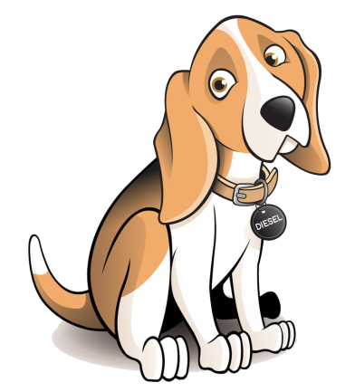](http://www.google.co.uk/url?sa=i&rct=j&q=&esrc=s&frm=1&source=images&cd=&cad=rja&docid=_5uwvrUcnuhl0M&tbnid=9KvX3lxksGrOeM:&ved=0CAUQjRw&url=http://cartoon-animals.disneyandcartoons.com/cartoon-dogs&ei=GktRUvytBsKQ1AWyx4CQCg&bvm=bv.53537100,d.d2k&psig=AFQjCNGoQjgFS_VFiR96IQXzhlu07IhysA&ust=1381145728674939)**The form of the dog- How do we know or recognize what a ‘dog’ is if we have never seen the real form of a dog in the world we live in?**

Plato would say we know this because…..

How do we know beauty?

Who is more beautiful? Pick one out of the two

[](http://www.google.co.uk/url?sa=i&rct=j&q=&esrc=s&frm=1&source=images&cd=&cad=rja&docid=sBgfiYuhpKqBmM&tbnid=WPi21jKfpq97HM:&ved=0CAUQjRw&url=http://lissarankin.com/was-angelina-jolie-medically-hexed&ei=Q1BRUv2MN7TI0AXVwYHoBA&bvm=bv.53537100,d.d2k&psig=AFQjCNFrZhp-H3pvSv61mq_vG9QrOn2_iQ&ust=1381147061082938)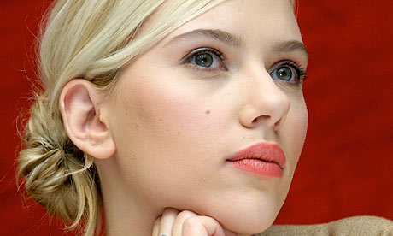

[](http://www.google.co.uk/url?sa=i&rct=j&q=&esrc=s&frm=1&source=images&cd=&cad=rja&docid=PloWMbaNgoEdZM&tbnid=7as3XeAxW8VgAM:&ved=0CAUQjRw&url=http://en.wikipedia.org/wiki/Heather_Trott&ei=mFBRUseAMKGI0AX2wIDACA&bvm=bv.53537100,d.d2k&psig=AFQjCNFttW6FNciX484aGeJ_eUdaASHNjA&ust=1381147139057334)[](http://www.google.co.uk/url?sa=i&source=images&cd=&cad=rja&docid=R6jV4Ohp28ag5M&tbnid=2PRKFEAf9sclOM:&ved=0CAgQjRwwAA&url=http://www.digitalspy.co.uk/celebrities/linda-henry/?page%3D2&ei=wFBRUveIK8SW0AXH_oGQBQ&psig=AFQjCNGeqTfm-Xpt_KCDAdDHlBuRfX_fqQ&ust=1381147200765955)

[](http://www.google.co.uk/url?sa=i&source=images&cd=&cad=rja&docid=4W6WHch-uM8GwM&tbnid=6ArOzyvyIWQtUM:&ved=0CAgQjRwwAA&url=http://top-tennisplayerss.blogspot.com/2011/07/maria-sharapova-tennis.html&ei=IVFRUpXzM8up0AXTi4D4DA&psig=AFQjCNHUb7umlp8wnFTNOJVfxzlWe9GOXw&ust=1381147297895549)[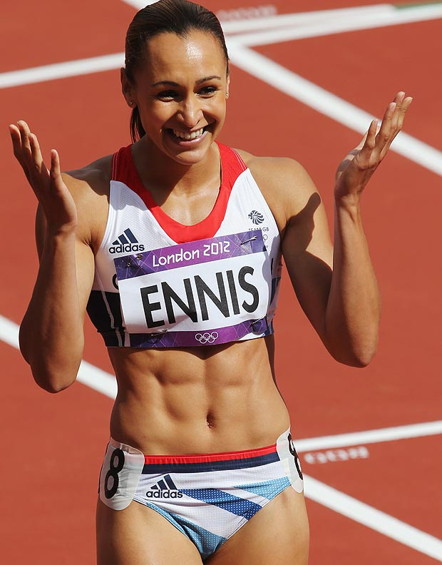](http://www.google.co.uk/url?sa=i&rct=j&q=&esrc=s&frm=1&source=images&cd=&cad=rja&docid=gkvO4HsGbANarM&tbnid=aU3xvnChsmRbNM:&ved=0CAUQjRw&url=http://www.thesun.co.uk/sol/homepage/sport/olympics/4470878/Jessica-Ennis-of-Team-GB-closing-on-Olympic-gold-in-womens-heptathlon.html&ei=YFFRUurvJcXT0QXGy4CgDQ&psig=AFQjCNFKirspx9hNZnOIlHgg6o6xQ_ogXQ&ust=1381147351051101)

Plato on the Body & Soul (circle correct word)

* 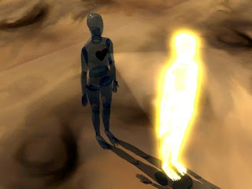The body and soul are ***separate/ together***
* The **soul/ body** existed before in the world of forms
* The **soul/body** is closer to the forms
* The **soul/body** lives on after we die
* The **soul/ body** needs and wants things so stops us from finding out truth/ philosophy
* If you are worried about **bodily/ soul** desires (sex/food/comfort) you are a lower creature
* Only Philosophers can separate the soul and body and should not get distracted by body needs
* Plato is **positive/negative** about the body
* Only Philosophers can see forms as they are not ignorant and sense driven

**Plato’s ideas about the body/ soul and knowing the forms**

**(Using the pictures and examples of chairs below- Explain how Plato would suggest we know what a chair is/ who can know what a chair is/ link to the soul and body)**

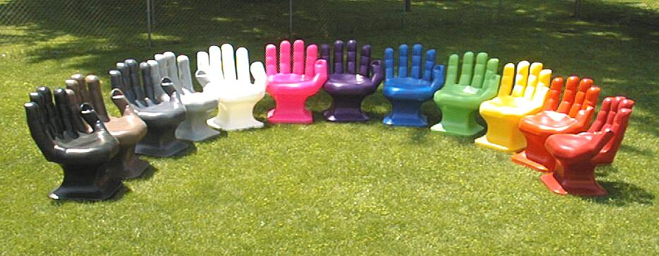

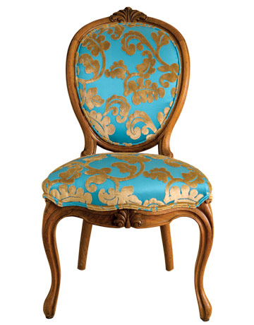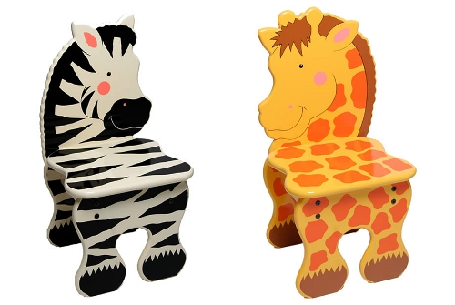

**Criticising Plato Praising Plato**

Plato gives a good argument for why there is imperfection in the world around us

We base our understanding on the world on what we sense- Why is this wrong? It is evidence of existence- No proof of another world

Plato suggests that only Philosophers can ‘know’ the real truth- Elitist- Should these people rule/ lead because they are intelligent?

Strong argument for how and why we recognise the ‘essence in things’ like a dog even though there is not one type of dog-

Everyone sees beauty differently, so how can we all see something different and it come from the ‘perfect’ form of beauty?

Where is the form world? No proof of this actually existing

No evidence to prove the world inside the cave is unreal and the world outside the cave is real.

We recognise beauty/ Justice/ Goodness because it has been taught to us by family and friends, not because we have had a previous experience of the real form before we were born

**Check your understanding today: Reflection questions**

* Can you explain the Allegory of the Cave in your own words?
* Do you know the difference between the material world and the world of the Forms?
* Could you explain ***why*** Plato says the world we live in is not the real world?
* Can you give a definition of a Form?
* Do you understand Plato’s Theory of the Forms?

**Exam style questions on Plato**

**Explain Plato’s allegory of the cave**

**“Plato is wrong to say that people live in a shadow world” Discuss**

**Explain Plato’s theory of the forms**

**“Plato’s theory of the forms is useless” Discuss**

[](http://www.google.co.uk/url?sa=i&source=images&cd=&cad=rja&docid=veHcpN0PkVIsGM&tbnid=ujtKG1oaAR-qJM:&ved=0CAgQjRwwAA&url=http://www.ankn.uaf.edu/curriculum/Articles/History/TomHopkins/Anderson/App.html&ei=WUFRUrfcJsSv0QWdvIH4CQ&psig=AFQjCNHyp335QlW6vUS87ZpKIMjvTmp-_w&ust=1381143257730931)

[](http://www.google.co.uk/url?sa=i&source=images&cd=&cad=rja&docid=veHcpN0PkVIsGM&tbnid=ujtKG1oaAR-qJM:&ved=0CAgQjRwwAA&url=http://www.ankn.uaf.edu/curriculum/Articles/History/TomHopkins/Anderson/App.html&ei=WUFRUrfcJsSv0QWdvIH4CQ&psig=AFQjCNHyp335QlW6vUS87ZpKIMjvTmp-_w&ust=1381143257730931)

[](http://www.google.co.uk/url?sa=i&source=images&cd=&cad=rja&docid=veHcpN0PkVIsGM&tbnid=ujtKG1oaAR-qJM:&ved=0CAgQjRwwAA&url=http://www.ankn.uaf.edu/curriculum/Articles/History/TomHopkins/Anderson/App.html&ei=WUFRUrfcJsSv0QWdvIH4CQ&psig=AFQjCNHyp335QlW6vUS87ZpKIMjvTmp-_w&ust=1381143257730931)

[](http://www.google.co.uk/url?sa=i&source=images&cd=&cad=rja&docid=veHcpN0PkVIsGM&tbnid=ujtKG1oaAR-qJM:&ved=0CAgQjRwwAA&url=http://www.ankn.uaf.edu/curriculum/Articles/History/TomHopkins/Anderson/App.html&ei=WUFRUrfcJsSv0QWdvIH4CQ&psig=AFQjCNHyp335QlW6vUS87ZpKIMjvTmp-_w&ust=1381143257730931)

[](http://www.google.co.uk/url?sa=i&source=images&cd=&cad=rja&docid=veHcpN0PkVIsGM&tbnid=ujtKG1oaAR-qJM:&ved=0CAgQjRwwAA&url=http://www.ankn.uaf.edu/curriculum/Articles/History/TomHopkins/Anderson/App.html&ei=WUFRUrfcJsSv0QWdvIH4CQ&psig=AFQjCNHyp335QlW6vUS87ZpKIMjvTmp-_w&ust=1381143257730931)

[](http://www.google.co.uk/url?sa=i&source=images&cd=&cad=rja&docid=veHcpN0PkVIsGM&tbnid=ujtKG1oaAR-qJM:&ved=0CAgQjRwwAA&url=http://www.ankn.uaf.edu/curriculum/Articles/History/TomHopkins/Anderson/App.html&ei=WUFRUrfcJsSv0QWdvIH4CQ&psig=AFQjCNHyp335QlW6vUS87ZpKIMjvTmp-_w&ust=1381143257730931)

*Read the following extract from Descartes’ Meditations and write a response, up to 2 A4 pages in length. In your response, comment on Descartes’ core arguments (what is he trying to prove with this argument? How does he go about proving this?) and analyse the strengths and weaknesses of the argument as a whole. Finally, give your personal response to his argument.*

***“I have convinced myself that there is absolutely nothing in the world, no sky, no earth, no minds, no bodies. Does it now follow that I too do not exist? No: if I convinced myself of something then I certainly existed. But there is a deceiver of supreme power and cunning who is deliberately and constantly deceiving me. In that case I too undoubtedly exist, if he is deceiving me; and let him deceive me as much as he can, he will never bring it about that I am nothing so long as I think that I am something. So after considering everything very thoroughly, I must finally conclude that this proposition, I am, I exist, is necessarily true whenever it is put forward by me or conceived in my mind. (AT 7:25, CSM 2:16f)”***

**Wider-world relevance of subject**

*Students will need to find an example of the subject having an impact in real/daily life.*

**Post-18 link**

*University Courses:*

***University of Oxford:***

* *Philosophy and Theology*
* *Psychology, Philosophy and Linguistics*

***Newcastle:***

* *Philosphy BA*

***University of Chichester:***

* *Politics, Philosphy & Ethics BA hons.*

***Birkbeck University of London:***

* *Philosophy BA*

***Canterbury Christ Church University:***

* *Religion, Philosophy and Ethics BA hons.*

***New College of the Humanities:***

* *History with Philosophy BA hons.*

***University of Roehampton:***

* *Philosophy BA hons.*

***St. Mary’s University, Twickenham:***

* *Theology, Religion and Ethics with Foundation Year BA hons.*

***Royal Holloway University of London:***

* *Philosophy BA*

*Careers:*

* *Teacher*
* *Lecturer*
* *Politician*
* *Barrister*
* *Solicitor*
* *Paralegal*
* *Chaplain*
* *Psychotherapist*

*Transferable Skills:*

* *Public Speaking*
* *Creative thinking*
* *Good Writing Skills*
* *Problem Solving*
* *Debating*
* *Effective Argument*

