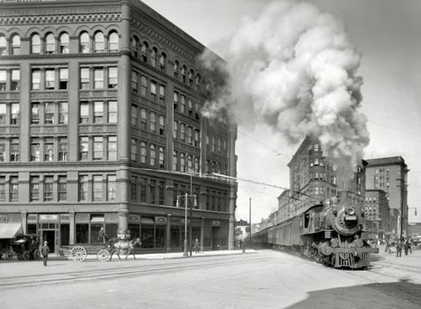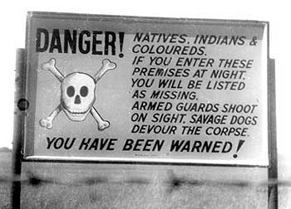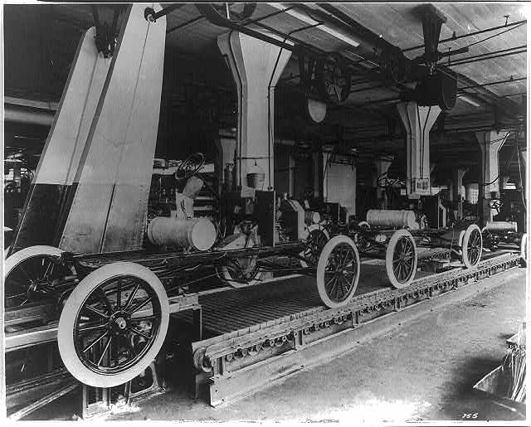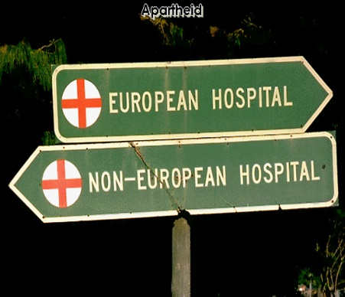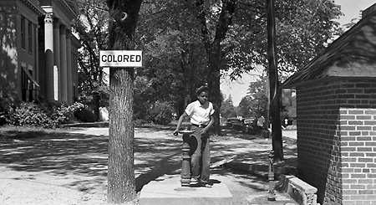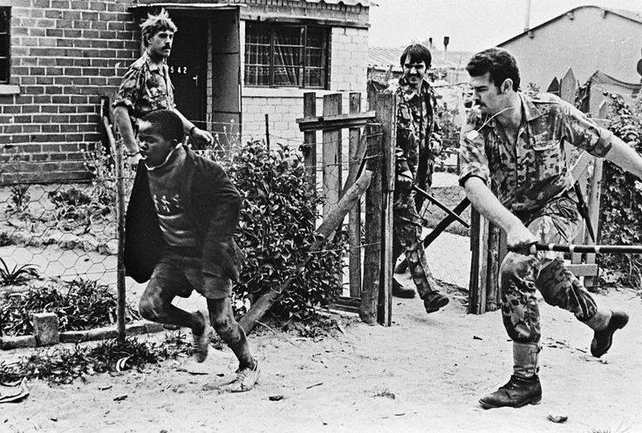

**Subject Transition Booklet**

**Subject:** History

**Teachers:** TKI and BCH

Student Name:

**Overview of the Programme**

* The exam board followed is Edexcel.
* There are 3 exams at the end of Year 13.
* There is a piece of coursework that places huge emphasis on literacy, research, independence and academic writing.

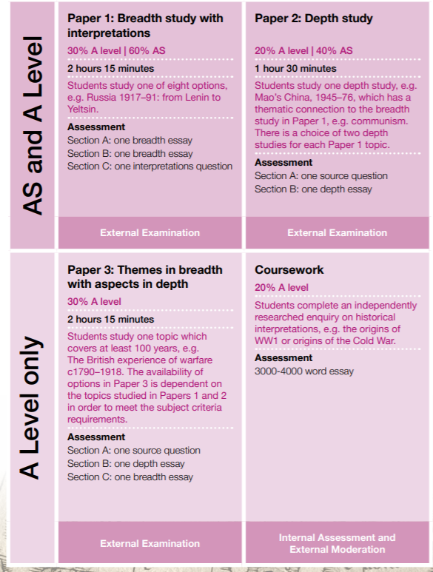

**Textbook(s) for the course**

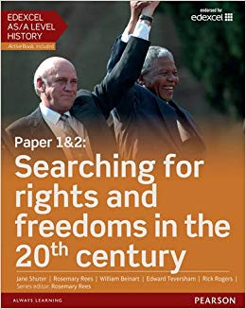This is the core textbook for Year 12. It will be used in almost every lesson and it is essential that as part of the course you buy a copy. It is available on Amazon and other online retailers. It is currently priced at £28.50. Should payment prove difficult please do raise it with us and we can offer support.

ISBN: 978-1-4479-8533-4

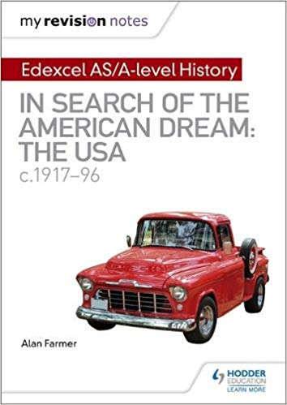

This is the revision guide for Unit 1. It is very high quality and offers students a mix of content, past paper questions and exam technique. It is available on Amazon and currently priced at £8.33

ISBN: 978-1-5104-1809-7

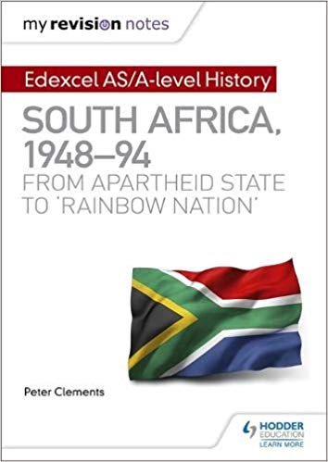This is the revision guide for Unit 2. It is exactly the same in terms of layout as the book for Unit 1. It is also available on Amazon and it currently priced at £8.99.

ISBN: 978-1510-41812-7

These books are also available as a bundle on Amazon.

**Suggested further reading**

As a History student it is extremely important that you deepen your knowledge by reading around the topics you are doing to expand your understanding or to consolidate knowledge. Throughout your A Level recommended reading will be encouraged and you will be guided towards certain resources. However, some good books relating to US History are below. Those with asterisks next to them are particularly highly recommended.

|  |  |
| --- | --- |
| Title | Author |
| *The Penguin History of the United States\** | Hugh Brogan |
| *Civil Rights in the USA 1945-1968\** | Vivienne Saunders |
| *The United States 1776-1992\** | Derrick Murphy, Kathryn Cooper and Mark Waldron |
| *American Civilisation* | David Mauk and John Oakland |
| *The Great Depression and the New Deal: A Very Short Introduction* | Eric Rauchway |
| *The Cold War: A Very Short Introduction* | Robert J McMahon |
| *Debating the Reagan Presidency* | John Ehrman and Michael W Flamm |
| *The Reagan Effect: Economics and Presidential Leadership* | John W Sloan |

**Additionally, students will be introduced to the academic journal database jstor.org and taught how to use it to supplement and expand their learning from lessons**

**Glossary:**

|  |  |
| --- | --- |
| **Constitution** |  |
| **Bill of Rights** |  |
| **Executive** |  |
| **Congress** |  |
| **Supreme Court** |  |
| **House of Representatives** |  |
| **Senate** |  |
| **Impeach** |  |
| **Intransigence** |  |
| **Convention** |  |
| **Great Migration** |  |
| **Executive Order** |  |
| **Social mobility** |  |
| **‘Iron Curtain’** |  |
| **USSR/ Soviet Union** |  |
| **Containment** |  |
| **Isolationist** |  |
| **Brinkmanship** |  |
| **Inflation** |  |
| **Baby Boom** |  |
| **States’ rights** |  |
| **State of the Union Address** |  |
| **Lynching** |  |
| **HUAC** |  |
| **McCarthyism** |  |
| **Appeasement** |  |
| **De jure/ De facto segregation** |  |
| **Ghettoisation** |  |

*.*

**Transition tasks:**

1. What are the founding principles of the American Constitution?
   1. BONUS: What are the strengths and weaknesses of it?
2. Research and create a diagram that explains the organisation of the Federal government of the USA. Add details of the responsibilities of each branch of the Executive.
3. Research one key event in American history before 1945: The American Civil War OR the Westward Expansion OR the American War of Independence. Following your research, create a fact sheets with the following key information: What? When? Why? Consequences?
4. Research the main American political parties. What were their main viewpoints?
5. Use the following website to create a timeline of American presidential elections from 1945 onwards: [www.270towin.com](http://www.270towin.com). Choose two and detail what the main issues were and why you think the outcome was particularly interesting.
6. Research and ensure that you understand the different between social, economic, political, religious and international history. Create a reference sheet for future use.
7. Research and ensure that you understand the differences between Capitalism and Communism. Create a reference sheet for future use.