Subject: Economics
Link Teacher/s: Mrs Gill and Mrs Jaswal
Welcome | Welcome to the Economics!  The current climate makes studying Economics all the more important. Over the course of the next 2 years you will learn about decisions governments, firms and people make with limited resources. You will consider the trickle affect of those decisions on different groups of people, but perhaps most importantly you will form your own judgements about economic decisions that should be made in a range of scenarios.
Course Summary / Expectations | Economics A [Edexcel]  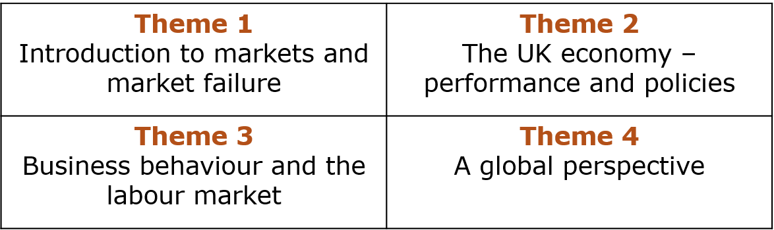  You will be covering 4 themes over the two-year course  Assessment information  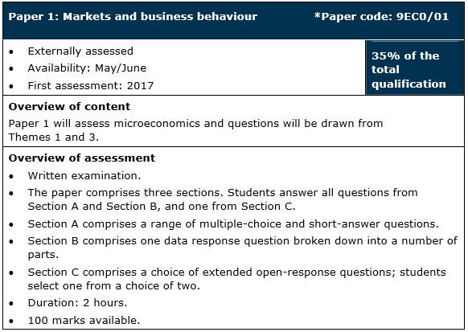  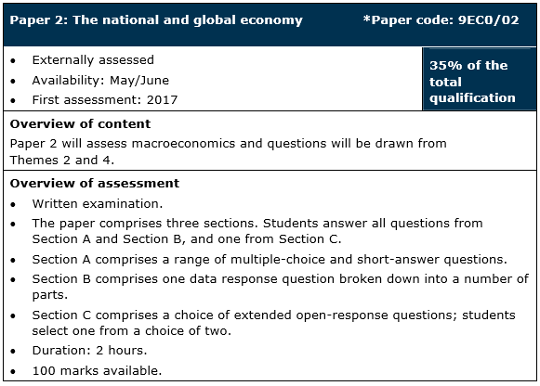  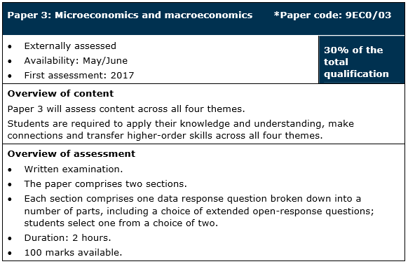  .
Tasks to Complete | - Download the Edexcel A Economics specification from https://qualifications.pearson.com/en/qualifications/edexcel-a-levels/economics-a-2015.html  - Read a news article daily from http://www.bbc.co.uk/news/business/economy  Create a PowerPoint presentation of your top 5 stories  - What did you find interesting?  - What further questions do you have about these issues?  Challenge: Look through the specification (Edexcel exam board), what links can you make between the articles and the topics you will be studying?  - Write a 600 word blog on one of the following questions:  - Does the public expect too much of UK politicians  - Will targets to bring greenhouse emissions in the UK to net zero by 2050 be a drag on economic growth  - “The gig economy is a great opportunity to increase women’s participation in the labour market by allowing more flexibility.” Discuss.  Or alternatively you can make up an economic related question of your choice and discuss
Useful Websites/ Resources | Websites:  Great for A level Economics theory:  - Tutor2u - http://www.tutor2u.net/economics  - Economics Help – http://www.economicshelp.org  - EconplusDal – http://www.econplusdal.com  - Economics Online - http://www.economicsonline.co.uk/  - Investopedia – http://www.investopedia.com  - YouTube – there are a wide range of YouTube revision videos available on all A Level Economics topics, popular channels include EconplusDal and Khan Academy  Great for economics in the news:  - BBC News (economy section) - http://www.bbc.co.uk/news/business/economy  - The Guardian (economics section) –  - https://www.theguardian.com/business/economics  - The Telegraph (economy section) –  - http://www.telegraph.co.uk/business/economy/  - The Independent (money section) –  - http://www.independent.co.uk/money  - This is money –  - http://www.thisismoney.co.uk  Great for economics data:  - Office for National Statistics - https://www.ons.gov.uk/  - Trading Economics – http://www.tradingeconomics.com  Books:  - The Economics Book by Niall Kishtainy  - Economics: The User's Guide: A Pelican Introduction by Ha-Joon Chang  - Cracking Economics by Tejvan Pettinger  - Freakonomics: A Rogue Economist Explores the Hidden Side of Everything by Levitt, Steven D., Dubner  - The Undercover Economist by Tim Harford  - The Euro by Joseph Stiglitz  - Capital in the Twenty First Century by Thomas Piketty  - Doughnut Economics by Kate Raworth  - GDP: A Brief but Affectionate History by Professor Diane Coyle
Key Terms/ Glossary | This period is a great opportunity for you to get started on building an economics keyterm glossary. I have listed some concepts/terms that you will need to familiarise yourself with however you may come across keyterms while you are reading around the subject that you do not know – include these in your glossary too!  - Demand  - Supply  - GDP  - Inflation  - Unemployment  - Trade balance  - Import  - Export  - Protectionist policies  - Globalisation  - Trade unions  - Macroeconomics  - Microeconomics

