Subject: Computer Science
Link Teacher/s: NAH and MBL
Welcome | Computer Science A-Level is a 2 year Linear course which comprises 2 exams and 1 practical programming project which is internally assessed and externally moderated.  Why choose an OCR A Level in Computer Science?  Computer Science is a practical subject where learners can apply the academic principles learned in the classroom to real world systems. It is an intensely creative subject that combines invention and excitement, and can look at the natural world through a digital prism.  A Level in Computer Science will value computational thinking, helping You to develop the skills to solve problems, design systems and understand the power and limits of human and machine intelligence.
Course Summary / Expectations | Learners must take three components (01, 02 and 03) to be awarded the OCR A Level in Computer Science.  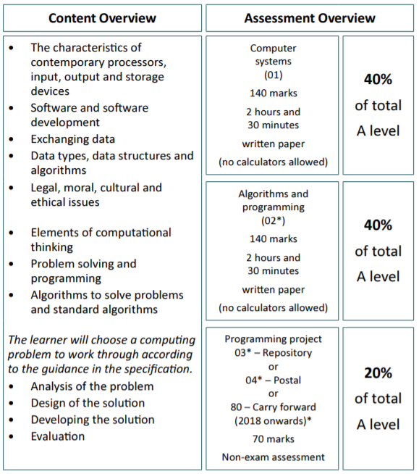
Tasks to Complete | All students must complete the transition work tasks and submit online to Mr. Blackford or Mr Ahmed using school email address.  Question 1  Programming constructs determine the way in which statements in a program are executed.  Three types of programming constructs are sequence, selection and iteration. Describe what each of these means.  Sequence  ______________________________________________________________________________________  ______________________________________________________________________________________  ______________________________________________________________________________________  ______________________________________________________________________________________  ______________________________________________________________________________________  Selection  ______________________________________________________________________________________  ______________________________________________________________________________________  ______________________________________________________________________________________  ______________________________________________________________________________________  ______________________________________________________________________________________  Iteration  ______________________________________________________________________________________  ______________________________________________________________________________________  ______________________________________________________________________________________  ______________________________________________________________________________________  ______________________________________________________________________________________  Question 2  Explain the term algorithm.  ______________________________________________________________________________________  ______________________________________________________________________________________  ______________________________________________________________________________________  ______________________________________________________________________________________  ______________________________________________________________________________________  What makes an algorithm efficient?  ______________________________________________________________________________________  ______________________________________________________________________________________  ______________________________________________________________________________________  ______________________________________________________________________________________  ______________________________________________________________________________________  Research what a “Bubble Sort” is and describe how a bubble sort works?  ______________________________________________________________________________________  ______________________________________________________________________________________  ______________________________________________________________________________________  ______________________________________________________________________________________  ______________________________________________________________________________________  ______________________________________________________________________________________  ______________________________________________________________________________________  ______________________________________________________________________________________  Now write a bubble sort program in Python to sort the list:  SortData = [34, 52, 11, 45, 22, 13, 10, 11, 76, 100, 23]  - Tick this box when completed.  Question 3  Wayne is writing an application for a touch screen mobile phone to identify types of ladybird.    The application will use a single interface, which has  - A facility to input the size of the ladybird in mm  - A facility to input the number of spots (0 to 30)  - A facility to input the colour of the spots (BLACK, WHITE, RED or OTHER)  - An output to show photographs and short descriptions of the types of ladybird fitting the criteria, which have been input.  In the outline below, draw a design for the interface of this application. You may annotate your design to explain how it works.    Question 4  Describe what is meant by the term IDE (Integrated Development Environment).  ______________________________________________________________________________________  ______________________________________________________________________________________  ______________________________________________________________________________________  ______________________________________________________________________________________  ______________________________________________________________________________________  Identify and describe three features commonly found in an IDE that will help programmers to fin any bugs in their code.  1.____________________________________________________________________________________  ______________________________________________________________________________________  ______________________________________________________________________________________  2.____________________________________________________________________________________  ______________________________________________________________________________________  ______________________________________________________________________________________  3.____________________________________________________________________________________  ______________________________________________________________________________________  ______________________________________________________________________________________  Question 5  1. Clock Speed  The purpose of this activity is to understand the effect of changing the clock speed of  a computer system. To complete this, you should know the function of a CPU in a  computer system and know something about the fetch-execute cycle.  1. What is a clock speed?  2. What happens within a CPU cycle?  3. If my CPU processes data at 1,800,000,000 clock cycles per second, is that fast?  4. ‘Fewer clock cycles with more work are better than more clock cycles with less  work.’ What advantages are there of setting your clock speed to be slower (under  clocking it)?  What advantages are there of setting your clock speed to be faster (over clocking it)?  5. What are the dangers of over clocking a system?  2. Hangman  Create a flow chart and Pseudo code for a simple hangman game. (No more than 5 letters  to guess)
Summer Reading | OCR A Level Computer Science  by George Rouse, Jason Pitt, Sean O'Byrne  ISBN-10: 1471839761  OCR AS and A Level Computer Science  by P M Heathcote , R S U Heathcote  ISBN-10: 1910523054  My Revision Notes OCR A level Computer Science (My Revision Notes: OCR A-Level)  by George Rouse, Sean O'Byrne, Jason Pitt  ISBN-10: 1471865835  Python Programming for the Absolute Beginner, Third Edition  by Mike Dawson  ISBN-10: 1435455002
Useful Websites/ Resources | www.craigndave.org  www.teach-ict.com  username: sl3 7ef  password:memory8  www.codeacademy.org
Key Terms/ Glossary | Computer articture  CPU  MEMORY  CACHE  CLOCK SPEED  CLOCK CYCLE  PYTHON

