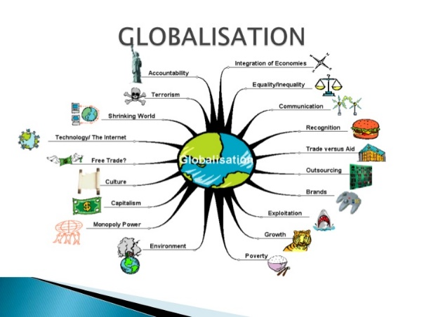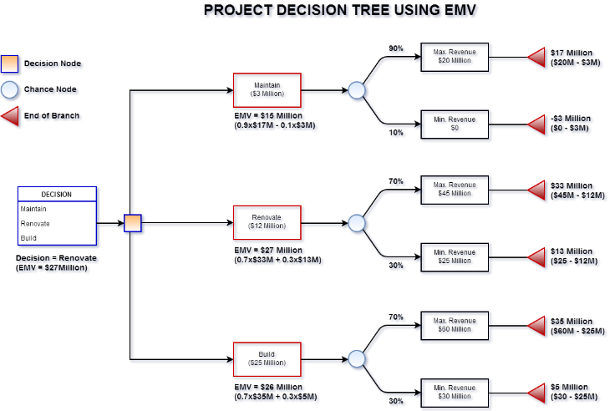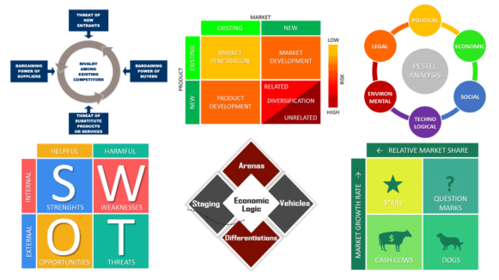

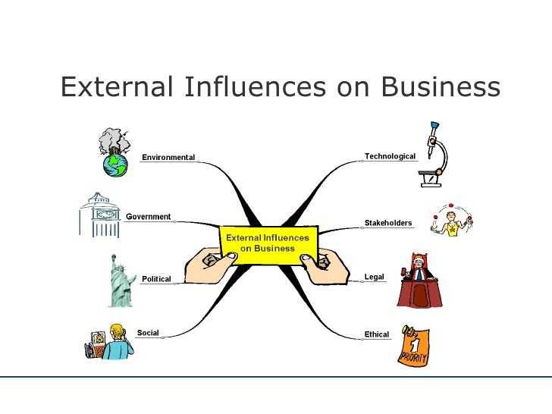

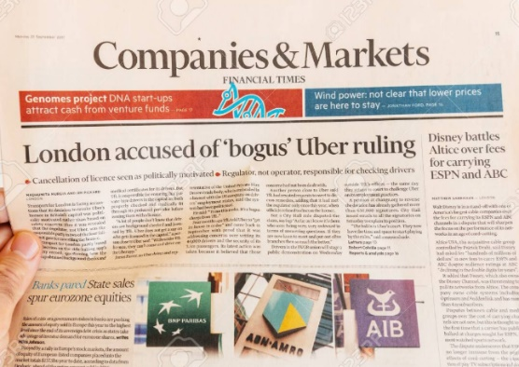

**Subject Transition Booklet**

**Subject: Business Studies- A level**

**Teachers: Mrs. Folaranmi, Mrs.Jaswal and Mr. Forth**

Student Name:

**Overview of the Programme**

*Please give details of the subject including topics covered, assessment methods, structure of the exam(s)/coursework, exam board etc….*

* The exam board which Business follows is Edexcel.
* There is no coursework requirement and you will only be assessed through exams.
* There are three exams you will sit at the end of year 13 which will determine your final grade for the course.
* The content will be taught over two Years-

AS- Theme 1 and Theme 2

A level- Theme 3 and Theme 4

* The Pearson Edexcel Level 3 Advanced GCE in Business is structured into four themes and consists of three externally examined papers.
* Details of these papers are below:

**Paper 1: Theme 1 and Theme 4**

**Paper 2: theme 2 and Theme 3**

**Paper 3: Theme 1, Theme 2, Theme 3 and Theme 4**

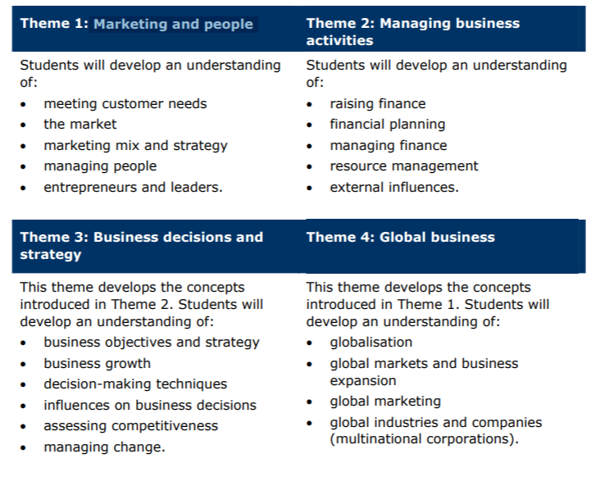

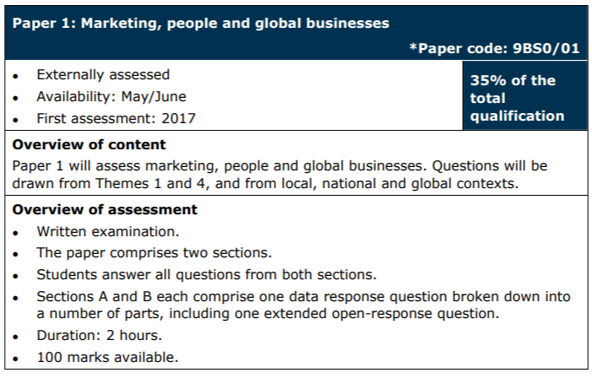

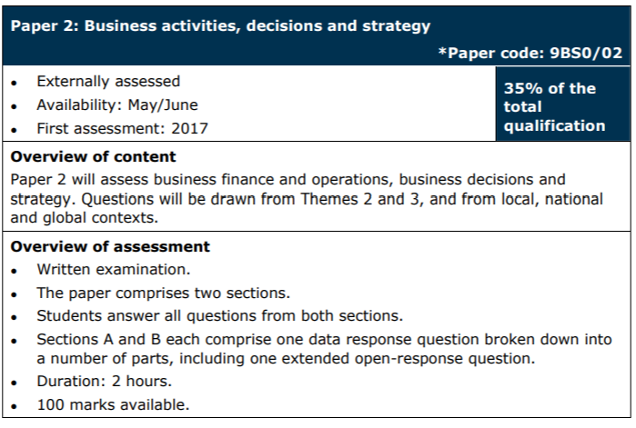

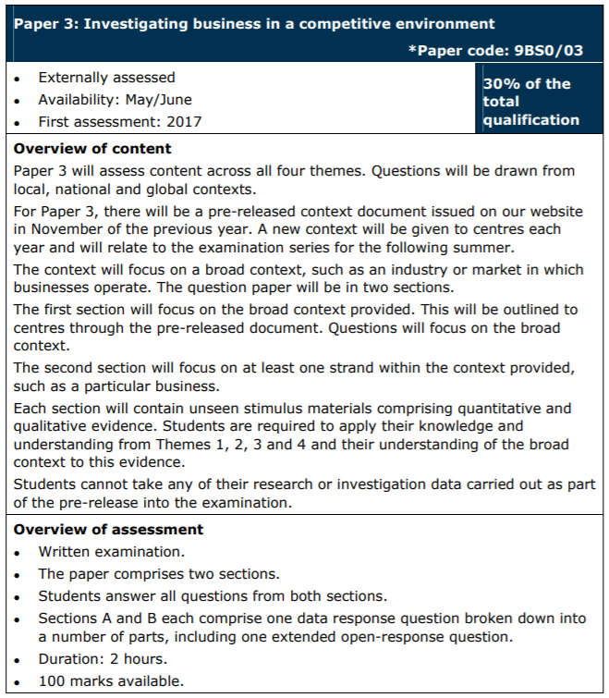

**Textbook(s) for the course**

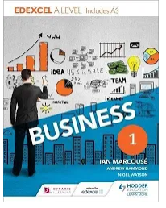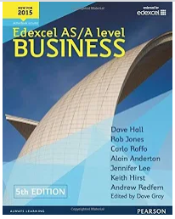

**Detailed specification could be accessed using the link below:**

<https://qualifications.pearson.com/content/dam/pdf/A%20Level/Business%20Studies/2015/specification-and-sample-assessment-materials/9781446914694_GCE2015_A_BUS_WEB.PDF>

**Suggested reading list**

|  |  |
| --- | --- |
| **Title** | **Author** |
| The Tipping Point: How Little Things Can Make a Big Difference | Malcolm Gladwell |
| The Google Story | David A. Vise |
| The Toyota Way: 14 Management Principles from the World's Greatest Manufacturer | Jeffrey Liker |
| Billions of Entrepreneurs: How China and India Are Reshaping Their Futures and Yours | Tarun Khanna |
| Business Stripped Bare: Adventures of a Global Entrepreneur | Sir Richard Branson |
| The Intelligent Investor | Benjamin Graham |
| No Logo | Naomi Klein |
| House of Cards: How Wall Street's Gamblers Broke Capitalism | William D Cohan |
| Financial Times | FT App |
| Websites | <http://www.tutor2u.net>  <http://www.bized.co.uk>  <http://www.businesscasestudies.co.uk>  [www.bbc.co.uk/news/business](http://www.bbc.co.uk/news/business) |

**Introductory Quiz**

1. **Write T or F by each idea**

|  |
| --- |
| **Marketing** |
| 1. Mass marketing always involves setting low prices 2. Niche marketing tends to involve low volume sales 3. Competition is often intense in mass markets 4. Set up costs are often high in mass markets 5. Monopoly markets can lead to high profit margins 6. Market share is always measured by % of market sales revenue held by one brand |
| **Market Research** |
| a primary research will guarantee the success of a new product launch  b secondary data may be biased  c a focus group is an example of qualitative research  d product orientated firms are very likely to fail |

|  |  |
| --- | --- |
| 1. **Match the term with the definition** | |
| 1. Competitive advantage 2. Product differentiation 3. Added value 4. Market mapping | 1. The increase in value that a business creates by undertaking the production process. 2. A study of various market conditions that is used to identify trends and corresponding variables between consumers and products 3. Making a product or service more attractive to a particular target market. 4. Offering consumers greater value, either by means of lower prices or by providing greater benefits and service that justifies higher prices. |

**Subject Specific Task**

**Complete the activity seen here and on PPT slide 5**

A screenshot of a cell phone

Description generated with very high confidence

**Answer Box**

**Once you have completed your answers and checked with your teacher, complete these two exam style questions, worth 3 marks.**

Evo magazine is a UK car magazine produced monthly, featuring all the latest news and reviews of supercars and the motoring industry. It is considering moving all of its content online and not producing a print version. Explain one benefit to EVO magazine of moving all its content online. (3)

**Answer Box**

Bulk Powders UK is a company who produces and sells a variety of protein shakes in the UK. Their website allows them to sell around the world to many countries. Recently they have purchased new robots which allows the protein to be packaged significantly faster, previously this was all done by hand. Explain one benefit of the move toward automation in the warehouse. (3)

**Answer Box**

**Part 2: Context, context, context**

*Examiners are often found stating ’the candidate failed to address the context of the question/business/industry’.*

In the short article below highlight where you see context being used.

*Beats by Dre have recently signed a deal with the NBA to become the league’s official supplier of headphones and wireless speakers. There will be a number of NBA team special headphones available for purchase in October 2018. The NBA commissioner Adam Silver stated ‘Beats revolutionized the music industry and has become one of the most innovative and culturally influential brands in the world’. The NBA is synonymous with global culture, including music such as hip hop and style such as Nike and LeBron James. The partnership is a multi-year deal that sees products on all global NBA superstars. Beats was bought by Apple back in 2014 for $3billion. The new adverts promoting the campaign can be seen on YouTube and with more marketing campaigns featuring at the forthcoming NBA draft and NBA All star game.*

References: <https://www.hotnewhiphop.com/beats-by-dre-announces-nba-partnership-includes-team-branded-headphones-news.59205.html>

|  |  |
| --- | --- |
| **Context seen** | **Why it represents context** |
|  |  |
|  |  |
|  |  |
|  |  |
|  |  |

**Final question**

The W group of hotels are considering installing the world’s largest solar panel farm in Oman, generating electricity for all of its hotels across the Middle East and moving its reliance away from traditional gas and nuclear forms of energy. The solar panel farm will be built on a site not far from Oman’s popular naturally occurring tourist attractions. It is likely the solar panel farm will require significant investment in developing new roads and electric convertors to make this a success. The local population are concerned about the proposal.

Write down the environmental damage this development could do to the region, you should aim for at least three points.

1)

2)

3)

**Q. State one potential benefit and one potential negative impact on the environment if the W hotel are allowed to build the proposed solar panel plant in Oman. For each point, explain the likely effect on the environment.**

**Answer Box**

**Mock Exam**

The exam seen here contains 30 marks and should take no more than 40 minutes to complete. The exam is not written specifically for one exam board, however, it does contain questions which should challenge your knowledge of business and reflection on some of the themes discussed in this booklet.

1. Define the term variable cost (2)
2. Fresh Water LTD sells bespoke luxury water to top end restaurants across Manchester and Glasgow. It currently has the following costs of manufacturing per litre bottle of water: £1.10 per bottle for glass, £0.65 purification costs of water per litre bottle and rent of £9,000 per month. Calculate the total cost for one month, assuming the company manufactures 4,300 litres of water. (4)
3. Explain one benefit to a business of using Market research before launching a new product. (3)
4. Explain one disadvantage to a business of using an overdraft as a source of finance. (3)
5. Frankie runs an old school record shop. In order to break even, she needs to sell 15 records a day, 7 days a week. Last week Frankie sold 80 records. Calculate Frankie’s margin of safety for last week. [1]

6a) Cold Stone provides beautiful driveway finishes for homes across the UK. They have a number of showrooms located around the UK but are interested in expanding abroad into Europe. The MD believes having a website is the best way forward. Explain one benefit to the company if it chooses to sell its services through the internet. (3)

6b) Cold Stone would like to improve awareness of its brand across Europe. Explain one method of marketing it may use which would generate interest in the brand. (3)

7a) Winter Is Coming (WIC) is an online fashion store aimed at Skiing and Snowboarding pursuits. It wishes to expand and open its first retail store in France. Assess one drawback of using retained profit as a source of finance for the proposed expansion. (8)

7b) Winter Is Coming (WIC) sources many of its products from China and ships them over via Air freight. The company is considering building its own large-scale manufacturing plant on farmland not far from the Alps in France. Assess one possible benefit and one possible drawback to the environment if WIC builds the proposed manufacturing plant. For each explain the likely effect on the environment. (12)

**Wider-world relevance of subject**

*Students will need to find an example of the subject having an impact in real/daily life.*

*It’s the subject requirement that you all register to Financial Times.*

*Please follow the instructions below to create your own account.*

***If you have not been given access TLA school emails yet, use your old school email id’s to get registered***

<https://www.ft.com/corp-signup/join?token=ac3405c3-87c0-4414-85e5-4b119b9ce99e>

Students can also find the link at [www.ft.com/schoolsarefree](http://www.ft.com/schoolsarefree) (It takes 5 working days to show)

**Business articles:**

<https://www.ft.com/content/02c37758-1e58-11e8-aaca-4574d7dabfb6>

Use the above link to pick an article of your choice and answer the questions attached to that article.

Or pick from the list below:   
  
**Recommended FT articles and tasks:**

* Risk/uncertainty, Positioning: UK’s first 5G service Market segmentation,
* E-commerce: Gucci turns to call centres Market segmentation,
* assessing innovation: Dublin’s first alcohol-free bar
* What is a business: Bonmarché to be acquired
* Managing change: Companies cannot ignore older workers
* Marketing: Luxury watchmakers unnerved
* Operational decisions: Fast Retailing
* Analysing the external environment: Serving Africa’s online consumers
* Understanding markets and customers: UK consumers hold off spending
* Understanding markets and customers: Diesel’s demise
* Competitive environment: Honda’s investors back UK closure
* Political and legal: Competition watchdog seeks new powers
* Marketing: Amazon restructures in India
* Political and legal: Hotel booking site clamp down
* Social and technological change: Rise of the stay-at-homes
* Different business forms: Levi Strauss launches IPO

**Post-18 link**

## What courses are available?

Universities and colleges in the UK are offering courses in the following subject areas:

* [Business studies](https://digital.ucas.com/search/results?SearchText=business+studies&filters=Destination_Undergraduate&ProviderText=&SubjectText=&AutoSuggestType=&SearchType=searchbarbutton)
* [Management studies](https://digital.ucas.com/search/results?SearchText=management+studies&filters=Destination_Undergraduate&ProviderText=&SubjectText=&AutoSuggestType=&SearchType=searchbarbutton)
* [Finance](https://digital.ucas.com/search/results?SearchText=finance&filters=Destination_Undergraduate&ProviderText=&SubjectText=&AutoSuggestType=&SearchType=searchbarbutton)
* [Accounting](https://digital.ucas.com/search/results?SearchText=accounting&filters=Destination_Undergraduate&ProviderText=&SubjectText=&AutoSuggestType=&SearchType=searchbarbutton)
* [Marketing](https://digital.ucas.com/search/results?SearchText=marketing&filters=Destination_Undergraduate&ProviderText=&SubjectText=&AutoSuggestType=&SearchType=searchbarbutton)
* [Human resource management](https://digital.ucas.com/search/results?SearchText=human+resource+management&filters=Destination_Undergraduate&ProviderText=&SubjectText=&AutoSuggestType=&SearchType=searchbarbutton)
* [Hospitality](https://digital.ucas.com/search/results?SearchText=Hospitality&filters=Destination_Undergraduate&ProviderText=&SubjectText=&AutoSuggestType=&SearchType=searchbarbutton), [leisure](https://digital.ucas.com/search/results?SearchText=leisure&filters=Destination_Undergraduate&ProviderText=&SubjectText=&AutoSuggestType=&SearchType=searchbarbutton), [tourism](https://digital.ucas.com/search/results?SearchText=tourism&filters=Destination_Undergraduate&ProviderText=&SubjectText=&AutoSuggestType=&SearchType=searchbarbutton), and [transport](https://digital.ucas.com/search/results?SearchText=transport&filters=Destination_Undergraduate&ProviderText=&SubjectText=&AutoSuggestType=&SearchType=searchbarbutton)

You can also decide on your specialist study topics to suit your interests and career aims. Some elements may be core, required study with an additional range of optional, specialist modules to choose from. Many courses also include work placements and the option to spend a year working in industry.

Some degrees are accredited by one or more of the national professional bodies that certify qualifications for careers in management and accounting. This can mean students are exempt from some of the exams required to become a chartered accountant or manager, for example.

Subject combinations and available course options include:

* single, joint, and multiple subject combinations
* full-time, part-time, and flexible study options as well as courses with a placement (sandwich courses)
* qualifications ranging from BA and BSc (Hons) degrees through to HND, HNC, and Foundation Certificates

## Apprenticeships

 Apprenticeships are available in the following areas:

Degree apprenticeships:

* Leadership and management, e.g. chartered manager
* Accountancy – e.g. professional accountant (coming)
* Banking and financial services – e.g. relationship manager

Higher apprenticeships:

* Accountancy – e.g. management accountant, actuarial technician
* Banking and investment – Level 4 – e.g. financial adviser, investment operations specialist
* Business and Professional Administration – e.g. office manager
* Hospitality management
* Insurance – e.g. insurance underwriter
* Management – e.g. contact centre operations manager, human resource management
* Legal services – e.g. conveyancing technician, chartered legal executive
* Retail management
* Supply chain management

[Find out more about apprenticeships](https://www.ucas.com/undergraduate/getting-started/apprenticeships-uk)