Subject: Biology
Link Teacher/s: Mr Muranda/ Miss Bevan
Welcome | Biology is the study of living things, but not just animals and plants. You’ll also learn about the molecules that make living things work, the cells that they’re made from, the systems within plants and animals, and the interconnections between organisms.  Biology is different from physics and chemistry, in that living things don’t always do what you expect them to do. You can’t test one organism and assume all the rest will be the same, so you’ll learn about the statistical analysis behind making claims.
Course Summary / Expectations | The course content is as follows:  AS and first year of A-level  1 Biological molecules.  2 Cells.  3 Organisms exchange substances with their environment.  4 Genetic information, variation and relationships between organisms.  A-level only  5 Energy transfers in and between organisms.  6 Organisms respond to changes in their internal and external environments.  7 Genetics, populations, evolution and ecosystems.  8 The control of gene expression.  Biology is assessed in the following way:  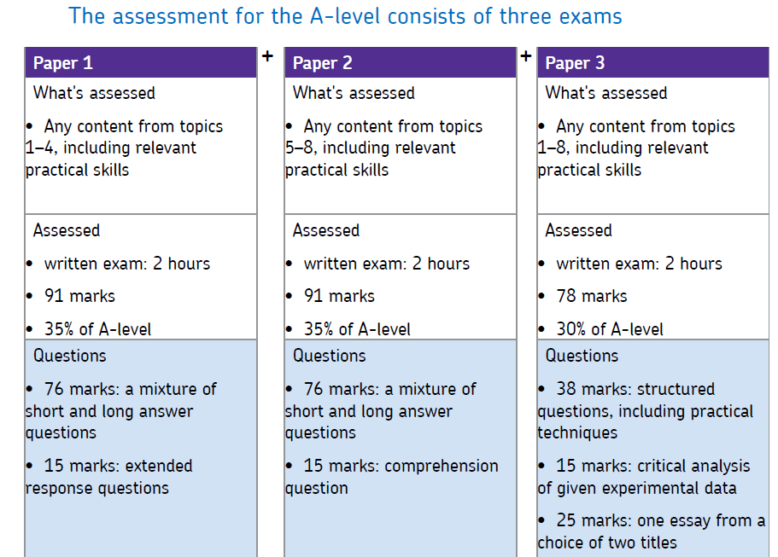  On top of this there are required practicals throughout, these practicals are assessed but encourage you to become a true scientist.
Tasks to Complete | This booklet is a transition guide and will help you with the jump from GCSE to A Levels, there is a jump but if you put in the effort now it will make it a lot easier moving forward: https://filestore.aqa.org.uk/resources/biology/AQA-7401-7402-TG.PDF
Summer Reading | 1. The AQA website is a great place to start:  The Biology webpages are aimed at teachers, but you may find them useful too. Information includes:  - The specification – this explains exactly what you need to learn for your exams.  - Practice exam papers  - Lists of command words and subject specific vocabulary – so you understand the words to use in exams  - Practical handbooks explain the practical work you need to know  - Maths skills support  2. Royal Society of Biology  “A single unified voice for biology”. They work with everyone from government policy makers to students, as well as universities and researchers studying biology. Their website includes a dedicated student section. Have a look at rsb.org.uk  3. The student room  Join the A-level Biology forums and share thoughts and ideas with other students if you’re stuck with your homework. Just be very careful not to share any details about your assessments, there are serious consequences if you’re caught cheating. Visit thestudentroom.co.uk  4. Magazines such a New Scientist
Useful Websites/ Resources | https://www.aqa.org.uk/subjects/science/as-and-a-level/biology-7401-7402  https://www.rsb.org.uk/  https://bmcbiol.biomedcentral.com/  https://www.sciencemuseum.org.uk/  https://www.nature.com/  https://www.newscientist.com/
Key Terms/ Glossary | As you go through the transition guide, start to create your own glossary of terms. A lot of these are mathematical terms which are vital throughout the A level Course.

