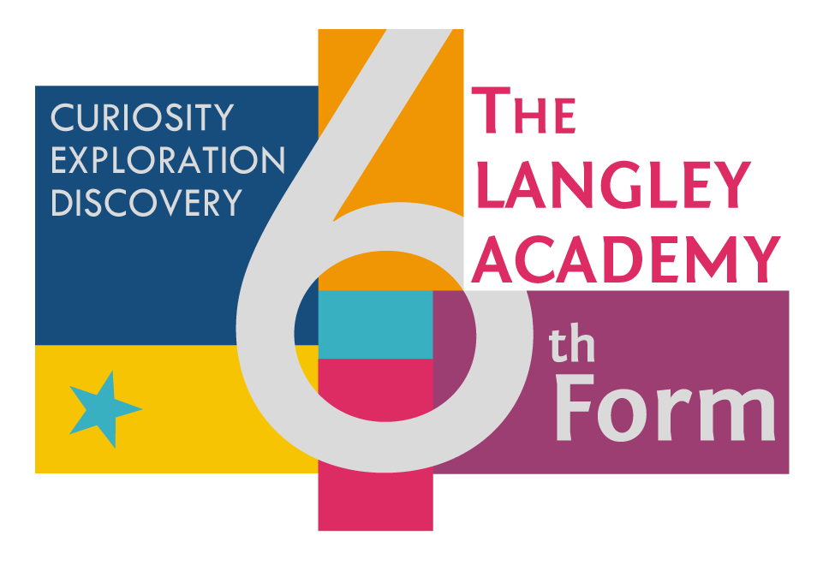

**

**Subject Transition Booklet**

**Subject: BTEC Business**

**Teachers:**

**Mrs G Folaranmi ( Head of Faculty -Business & Economics)**

**Mr A Forth ( Head of Sixth Form )**

**Mrs A Jaswal ( Head of year)**

**Mrs P Gill ( Second in charge) Business Faculty**

Student Name:

**Overview of the Programme**

Welcome to the BTEc programme of Study at the Langley Academy.

It promises to be an exciting time as you transition from Year 11 to our Sixth form.

The BTEc handbook that will be issued to you as soon as you resume will give you every single detail about this course.

We look forward to having you on board!

**A brief summary**

BTecs are an alternative to A-levels and have different degrees of equivalence.

This programme will be delivered like any other A-level programme.

You will be taught the content and assessment will take different formats including coursework, in class assessment and external examinations.

If you are like engaging with research and using information to interrogate different Business Scenarios with the intent of proffering solutions, then this is the course for you.

At TLA we offer the Extended Certificate which comprises of 4 Units and also the BTEc Diploma comprising 8 Units

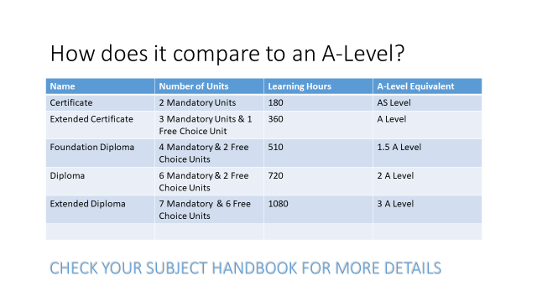

Historically we have enriched this programme by giving students the opportunity to fundraise, manage events and participate in school trips.

We are looking to integrate more of such activities into the curriculum this year once lockdown restrictions are lifted.

**HINTS !**

We want you to succeed on this programme and we will make every effort to support you every step of the way. We encourage you to use your time wisely, attend all lessons and ask for help if unsure about anything.

**Lets’ get started!**

In preparation for your BTEc course lets make sure you are equipped with some Key terms.

These Key terms are from Unit 14: Investigating customer service

Task 1

Create a glossary of key terms ( Do this on a word document ready to print and file in your exercise book)

|  |  |
| --- | --- |
| KEY TERM | DEFINITION |
| Informal |  |
| Formal |  |
| Credibility |  |
| Integrity |  |
| Non-tangible |  |
| Passive -aggressive |  |
| Stereotyping |  |
| Ombudsman |  |
| Ofcom |  |
| Strapline |  |
| BOGOF |  |
| Empathy |  |
| Liquidate |  |
| Primary research |  |
| Public domain |  |
| Quantitative |  |
| Qualitative |  |
| Customer-centric |  |
| Dividend |  |
| Bench mark |  |
| Memo |  |
| Egotistic |  |
| Altruistic |  |
| Attrition |  |
| Client retention |  |



**Excellent, now that you are done with creating your glossary of key terms, Let’s get cracking with the next task.**

**A good grasp of key terms makes for coherent, well-structured responses when completing coursework or external assessments.**

Your next task involves an exploration of different customer service roles, duties and methods for dealing with customers.

I would like you to explore some recruitment websites and look at the job descriptions for customer service personnel in 3 different industries e.g. manufacturing, construction, retail .

Once you have conducted your research, fill in the table below. An example has been done for you**.**

|  |  |  |
| --- | --- | --- |
| Types of Business | Role | Customer service duties |
| Beauty salon | Receptionist | Take bookings, respond to queries, manage diaries for stylists, greet clients, provide refreshments, take payments, order supplies |
|  |  |  |
|  |  |  |
|  |  |  |

**Once you have been issued with your links to Microsoft teams, I will expect you to upload your work in addition to printing/organising in your exercise book.

|  |  |
| --- | --- |
| Website links for task above | Search for : |
| <https://www.indeed.co.uk/> | Customer service roles |
| <https://www.monster.co.uk/> | Customer service roles |



**Watch this video :**

<https://www.youtube.com/watch?v=W6yXonvwRVs>

*On one side of A4 write a response to the following Statement*

*‘It is the responsibility of every employee to ensure that customers know that they are valued and listened to and that heir expectations are met or exceeded’*

***Guidance***

1. ***Agree or disagree with the statement***
2. ***Give reasons for your stance***
3. ***Support your stance with research evidence e.g. case studies of companies that have gone bust as a result of poor customer service***

***ENDGAME***

***Some businesses have survived and some have had to go into administration as a result of COVID 19.***

1. ***What does it mean for a business to go into administration?***
2. ***Give examples of businesses that have gone into administration this year and explain why.***
3. ***Are there other reasons aside from poor customer service or COVID 19 that might have caused some businesses to go bust? Explain with reasons and back up with facts and information from research you have done.***

***Method of presentation***

1. ***Video recording***
2. ***A4 Leaflet***

***Textbooks***

***We encourage you to buy these textbooks, you’ll always have a resource to refer to while you are being taught and when completing assignments or revising for the externally examined Units.***

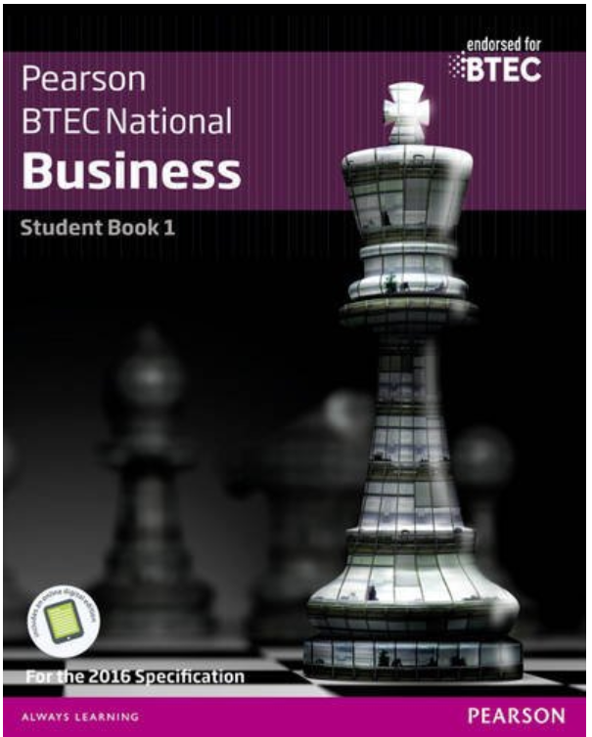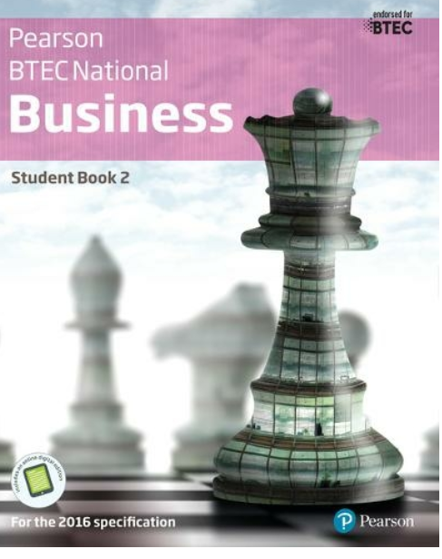

***Keep working hard and you’ll get achieve your desired outcomes.***

***Good luck from the TEAM.***