Subject: Btec Applied Sciences

|  |  |  |
| --- | --- | --- |
| **Welcome** | *Welcome to the course, overview from the teacher*  *BTEC Nationals are widely recognised by industry and higher education as the signature vocational qualification at Level 3. They provide progression to the workplace either directly or via study at a higher level.* | |
| **Course Summary / Expectations** | *Summary of course content, assessment methods etc.*  *In year 12*  *Pearson BTEC Level 3 National Certificate in Applied Science Mandatory units There are two mandatory units, one internal and one external. Learners must complete and achieve at Near Pass grade or above in the mandatory external unit and achieve a Pass or above in the mandatory internal unit.* | |
| **Tasks to Complete** | *Research / Written Tasks/ Glossary completion. This should be reviewed from last year and can be extended to account for y11 starting this work earlier*  *For the Unit 1:*  *Biology: you will need to recap eukaryotic cell structure, work through power points, from key words make a glossary, complete past paper questions*  *Physics: Calculations*  *Physics formulae and application*  *Chemistry: Balancing chemical equations*  *For the Unit 2:*  *Report writing*  *Graphing skills*  *Referencing skills* | |
| **Summer Reading** | *Texts, articles etc. Will need to be able to post on Teams/ access online*  *Power point on eukaryotic cells*  *Read .www.training.seer.cancer.gov/anatomy/cells_tissues_membranes/cells/structure.html*  *You tube Q 1 animal cell model answer applied science* | |
| **Useful Websites/ Resources** | *Websites, documentaries, YouTube clips etc.*  *You tube- btec applied science biology Thula kamaleswaran*  *https://www.youtube.com/watch?v=lWU6ma5405U*  [*https://qualifications.pearson.com/content/dam/pdf/BTEC-Nationals/Applied-Science/2016/specification-and-sample-assessments/9781446938195_BTECNat_AppSci_ExtDips_Spec.pdf*](https://qualifications.pearson.com/content/dam/pdf/BTEC-Nationals/Applied-Science/2016/specification-and-sample-assessments/9781446938195_BTECNat_AppSci_ExtDips_Spec.pdf)  [*https://www.youtube.com/results?search_query=btec+applied+science+level+2+unit+1+revision*](https://www.youtube.com/results?search_query=btec+applied+science+level+2+unit+1+revision)*+*  [*https://phet.colorado.edu/en/simulations/category/physics/motion*](https://phet.colorado.edu/en/simulations/category/physics/motion)  [*https://qualifications.pearson.com/content/dam/pdf/BTEC-Nationals/Applied-Science/2016/specification-and-sample-assessments/9781446938195_BTECNat_AppSci_ExtDips_Spec.pdf*](https://qualifications.pearson.com/content/dam/pdf/BTEC-Nationals/Applied-Science/2016/specification-and-sample-assessments/9781446938195_BTECNat_AppSci_ExtDips_Spec.pdf) | |
| **Key Terms/ Glossary** | | *As you go through the transition guide, start to create your own glossary of terms. A lot of these are mathematical terms which are vital throughout Btec Course.* |

**Btec transition work activities:**

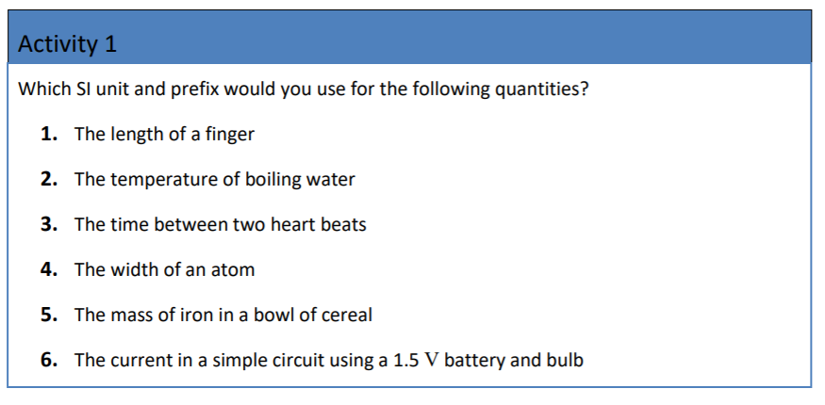

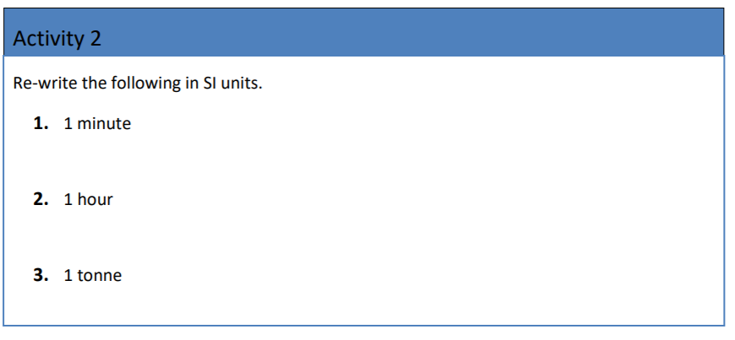

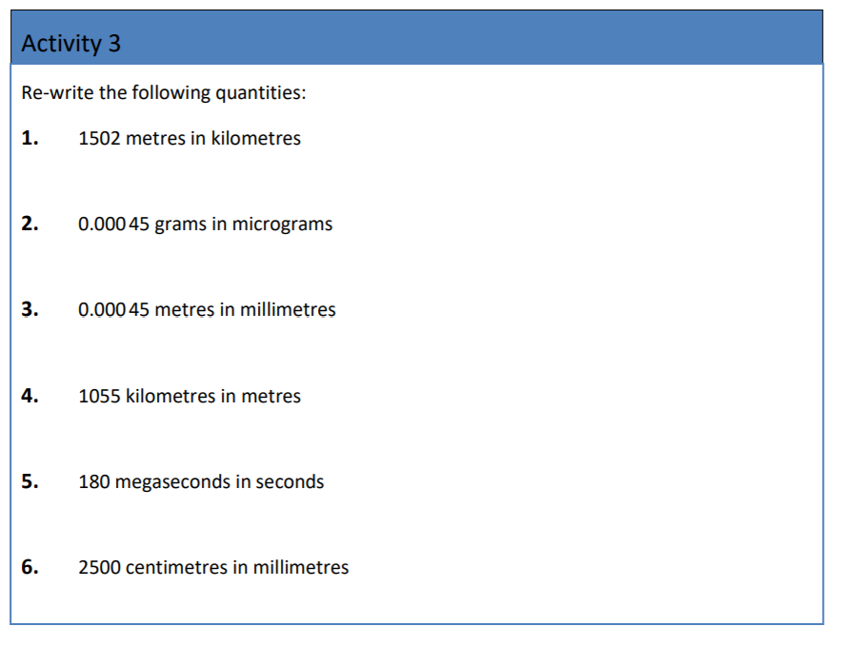

With research playing an important part of the course, a skill you need to develop is citing your sources of information that you have used in the course of your research. This is an invaluable skill to acquire especially if you plan on going onto higher education and a relevant degree course. The most used system of citing your sources is the Harvard style and is described on the next page.

