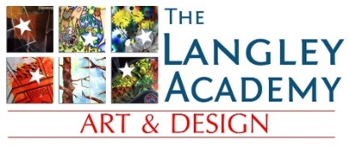**ART TRANSITION WORK**

**Year 11 > 12 Summer Work:**

**Architecture and Mark Making**

Over the summer period, you will be expected to begin developing drawing skills and exploring different artworks.

**What is architecture?**

***Architecture****is the****art****and science of designing buildings and other physical structures. A wider definition often includes the design of the total built environment from the macro level of town planning, urban design, and landscape****architecture****to the micro level of construction details and, sometimes, furniture.*

Architecture has been within landscape painting for centuries. It is your job to make it feel relevant and current by giving it a contemporary style. It is worth looking at sites such as Pinterest for ideas that students have already explored.

In preparation for your first project brief you are expected to complete the following tasks by the first week back in September:

1. A PowerPoint presentation on architecture which should include
   1. Research on at least 2 Artists that create images based on architecture.
   2. A variety of different architectural images (No more than 5 images per page)
   3. Analysis/Annotation of selected/favoured images
2. Visit a gallery online that exhibits architectural paintings and document by selecting a chosen few (these can be included on a slide or 2 in your PowerPoint). Make sure you note the artist’s names, dates and medium.

*(Depending on the lockdown situation over the summer this may be able to be done in person at a gallery- document with photographs)*

1. Take a variety of own photographs of architecture *(This can be done on your daily exercise that is currently permitted)* and create a minimum of 6 artworks. This should include:
   1. 2x 15minute piece
   2. 2x 30minute piece
   3. 2x hour long piece
2. Gather images of different buildings and architectural designs from newspapers and magazines.
   1. create 3 collages using the images. These collages could be of cityscapes, individual buildings or close up architectural elements.
   2. Add your own pen/paint over the top of the collages to add interest, details and make the piece cohesive.

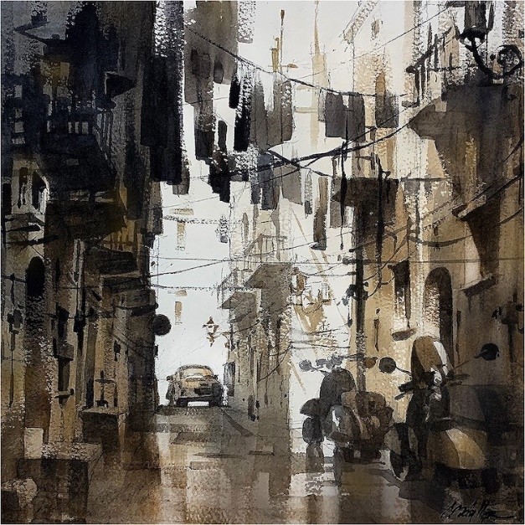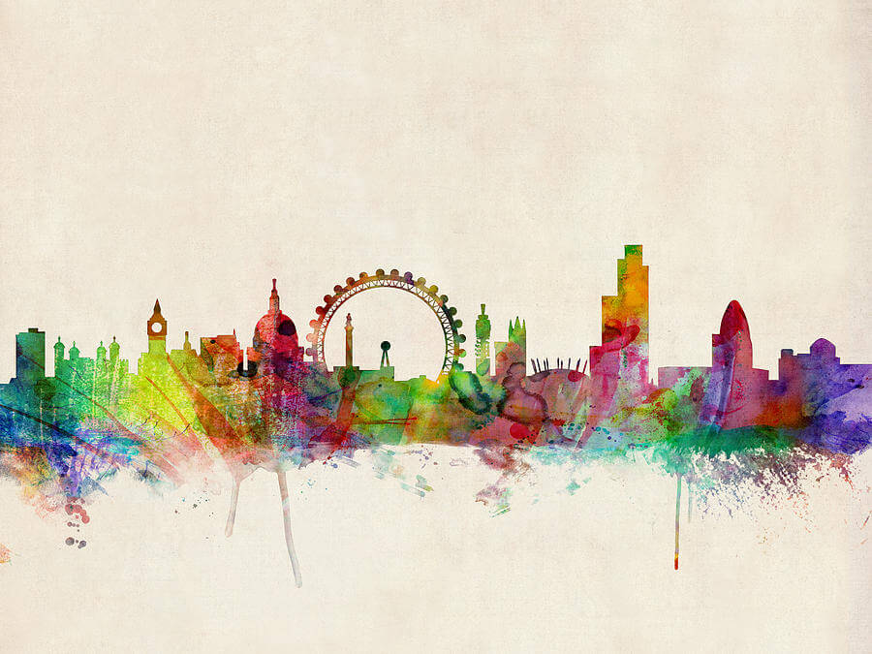You will be expected to present your work to the rest of your class in your first full week of Year 12.

