Subject: A Level PE
Link Teacher/s: AJO/JEV/NJE/SBE (maternity leave)
Welcome | Welcome to the course, overview from the teacher
Course Summary / Expectations | - 70% theory, 30% non-exam assessment  - Students assessed in only one activity as either player/performer or coach  Component 1:  Factors affecting participation in physical activity and sport  Written Paper (35%)  - Applied anatomy and physiology  - Skill acquisition  - Sport and society  Component 2:  Factors affecting optimal performance in physical activity and sport  Written Paper (35%)  - Exercise physiology and biomechanics  - Sports psychology  - Sport and society and technology in sport  Each component is a 2 hour written paper worth 105 marks each.  Combination of multiple choice, short answer and extended writing questions  Component 3:  Non-exam assessment: Practical performance in physical activity and sport worth 90 marks. Internal assessment, external moderation  Part 1:  Assessed in the full context of one activity in the role of player/performer or coach.  You will be assessed in three areas of assessment:  •• Area of assessment 1: Technical quality – aspect 1, normally attacking skills (15 marks).  •• Area of assessment 2: Technical quality – aspect 2 , normally defensive skills (15 marks).  •• Area of assessment 3: Application of strategic/tactical awareness (15 marks).  Part 2:  You will analyse and evaluate, using appropriate theoretical content included in the specification, a performance as either player/performer or coach, in one activity from the specification. You can analyse and evaluate your own performance or the performance of another, as long as it is in an activity that is from the specification.  The coursework is broken down into:  - Analysis (20 marks)  - Evaluation (25 marks)  You can choose just one cause/corrective measure (to show depth of knowledge) or you can choose to discuss more than one relevant cause/corrective measure (to show breadth and depth).  More than one weakness (2 weaknesses; 1 from Area of assessment 2 and one from Area of assessment 3) in the performance may be identified, but students must analyse weaknesses consistently in order to meet the bands in the assessment criteria.  .
Tasks to Complete | Research / Written Tasks/ Glossary completion. This should be reviewed from last year and can be extended to account for y11 starting this work earlier  The work will also need to be able to be submitted online/ via email  Task 1:  Using your sport that you will be assessed in start the analysis sestion of your performance.  - Identify a defensive weakness – for a specific game identify several weaknesses from your performance and explain the impact on the overall game.  - Choose 1 weakness and specify why it was the main weakness.  - What was the setting? (Who is performing, against who? When and where did the competition take place? What was the score at the time?)  - Explanation of weakness – give reasons for this weakness occurring  - Use your knowledge of movement analysis, break down the skill into stages (preparation, execution, follow-through) and explain in detail why this led to inadequate skill.  - Why did the weakness occur?  - Compare your technique to a perfect model – for every technical error that you make detail how your perfect model performs the movement perfectly and describe the overall impact on their performance of that skill.  - Use photos to highlight your weakness and the perfect models strength side by side.  - What was the impact of the weakness on the performer and subsequently, the game?  Task 2:  For each of the topics below, you need to research as much as you can about it and create a presentation ready to present back to the class when we return.  Below is the specification for each of the topics so make sure that for each of the topics, you include all the information in your presentation.  A Level – Muscular-skeletal system  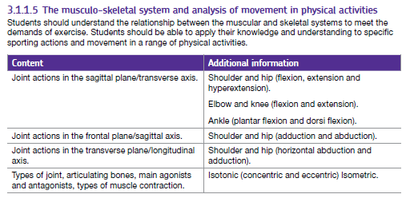  A Level – Cardiovascular system  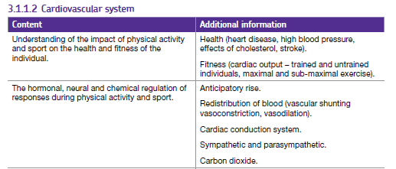  A Level – Neuromuscular system  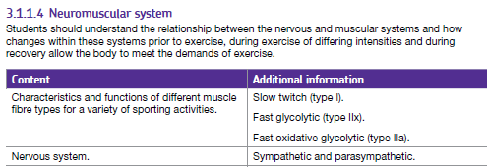  A Level – Respiratory system  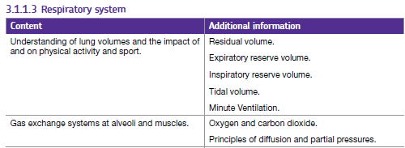
Summer Reading | 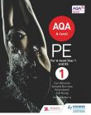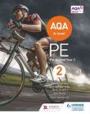  AQA A Leel PE 1 & AQA A Level PE 2  Authors: Carl Atherton, Symond Burrows, Ross Howitt and Sue Young (Editor Mike Murray)  PE Review (e-magazine)  • Sports rule books and coaching guides  • Sports Biographies/Autobiographies  Journals:  - Journal of Sports Sciences  - Journal of Sport & Social Issues  - All sports magazines will offer a view on performing, coaching, science, current issues or history of sport(s). They are therefore valuable wider reading material  - National newspapers. The sports pages report global events and the biggest issues  TV:  - Sky sports news  - Live sport – watch local, national and global events.  - Sports biographies and ‘day in the life of’ programmes give an excellent insight into the world of the elite athlete
Useful Websites/ Resources | - A Level website  https://www.aqa.org.uk/subjects/physical-education/as-and-a-level  - www.mypeexam.com  - www.sportengland.org  - https://www.uksport.gov.uk/  - www.brianmac.co.uk  - NGB websites o e.g. The FA www.thefa.com, The RFU www.rfu.com etc.  - Twitter  - American College of Sports Medicine www.acsm.org  - British Association of Sport and Exercise Sciences www.bases.org.uk  - Coachwise www.1st4sport.com  - Human Kinetics www.humankinetics.com  - Sport Science www.sportsci.org  - Sports Coach UK www.sportscoachuk.org  - Top End Sports www.topendsports.com  - Sports and Exercise Testing www.brianmac.co.uk  - Nutrition www.livestrong.com  - BBC Bitesize www.bbc.co.uk/schools/gcsebitesize/pe
Key Terms/ Glossary | Complete table below:  Tip use AQA website

Key word | Definition
Applied anatomy and physiology
Altitude training (traditional)
Anticipatory rise
Articulating bones
Arterio-venous oxygen difference (A-VO2 diff)
Axis
Cardiac conduction system
Excess post-exercise oxygen consumption (EPOC)
Indirect calorimetry
Lactate-producing capacity
Lactate threshold
Oxygen defecit
Plane
Receptors
Respiratory exchange ratio (RER)
VO2 max

